 | 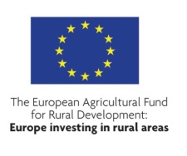 |  |  | 

RURAL PERTH AND KINROSS
AREA PROFILE
FOR THE LEADER
LOCAL DEVELOPMENT STRATEGY (2014-2020)



January 2014

This project was undertaken by Bill Slee and Jon Hopkins with Andrew Copus providing editorial review.

Statement of Publication’s Purpose:
This report has been produced for Perth and Kinross Council on behalf of Rural Perth and Kinross LEADER Local Action Group by staff at the James Hutton Institute in Aberdeen. It contributes to the evidence base on which the rural Perth and Kinross LEADER Local Action Group proposal for a Rural Perth and Kinross Local Development Strategy will be constructed under the 2014-2020 Scottish Rural Development Programme.

Mapping data included within this report reproduced by permission of Ordnance Survey on behalf of HMSO © Crown copyright and database right (2014). All rights reserved. Perth and Kinross Council, Ordnance Survey Licence Number 100016971.

Summary statistics associated with maps 1-26 were derived from Scottish Neighbourhood Statistics data: Scottish Neighbourhood Statistics © Crown copyright (2014), licensed under the Open Government Licence v2.0.

Summary statistics associated with maps 34, 36, 38, 40, 42 and 44 were derived from Agricultural Census data: data tables courtesy of Agricultural Census Analysis Team, Rural and Environment Science and Analytical Services, Scottish Government.

Contents
1. Introduction 4
1.1 The scope of this report 4
1.2 Leader principles 4
1.3 Rural Perth and Kinross- an introduction 5
2. Variations in Socio-economic conditions at data-zone level 6
2.1 Demography 6
2.2 Access to services 14
2.3 Deprivation and disadvantage 22
2.4 Housing 27
2.5 Incomes 33
3. Rural Land Use 34
3.1 Designated areas 34
3.3. Agricultural land use 40
3.4. Forestry 54
3.5. Sporting use 56
3.6 Renewable Energy 56
3.6. Access and recreation 57
4. Key issues in rural Perth and Kinross in the period 2014-20 57
4.1 Ageing 57
4.2. Mobility and service accessibility 57
4.3. Housing 58
4.4 Energy 59
4.5 Income and income distribution and rural deprivation 59
4.6 In-migration and immigration 59
4.8 Integrated land use 60
4.9 Local supply chains 60
4.10. Differential development over space 60
5. Concluding comments 61
Appendix 1 Copyright acknowledgements for maps………………………………………………………………………………63

Introduction

1.1 The scope of this report
This document contributes the evidence base on which the Rural Perth and Kinross LEADER Local Action Group proposal for a Rural Perth and Kinross Local Development Strategy will be constructed under the 2014-2020 Scottish Rural Development Programme. The study is positioned in an understanding of the current EU approach to the next LEADER programme and the current Scottish policy architecture and the Scottish Government’s aspirations as evidenced in the 2012 report from SRDP 2014-2020 LEADER Working Group to the SRDP Programme Manager of which the lead author of this report was a member.

Leader principles
Since the LEADER Community Initiative was launched in the early 1990s, the European Commission’s aspirations for LEADER remain broadly similar. The acronym LEADER stems from the idea to promote ‘Liaisons Entre Actions de Developpement de l’Economie Rurale’ (links between actions for the development of the rural economy) in a bottom up way, based around a Local Development Strategy and delivered through a partnership approach embracing a range of actors. Although the specific guidelines have changed over successive incarnations of LEADER, the ‘intervention logic’ of LEADER remains unchanged. The 2014-20 LEADER programme must embrace some of the EU strategic priorities for rural development which include:
- Fostering knowledge transfer and innovation
- Enhancing competitiveness
- Promoting food chain organisation & risk management
- Restoring, preserving & enhancing ecosystems
- Promoting resource efficiency & transition to low carbon economy
- Promoting social inclusion, poverty reduction and economic development
A further requirement of the new 2014-20 SRDP is that it should connect formally to other structural fund spending under the Common Strategic Framework embracing the ESF, the ERDF and the MFF. LEADER is one component of the SRDP. Other facets of the SRDP will also address the EU strategic priorities. The challenge to local actors is to develop a local development strategy which is congruent with the EU guidelines but addresses the specific needs of rural Perth and Kinross. At the same time, it will be a requirement that LEADER actions contribute to the National Performance Framework, which the Scottish Government has developed to frame its actions and connects to the Scotland-specific aspirations for the new RDP.
The new LEADER programme is underpinned by the application of six guiding principles which can be seen in Figure 1 below.
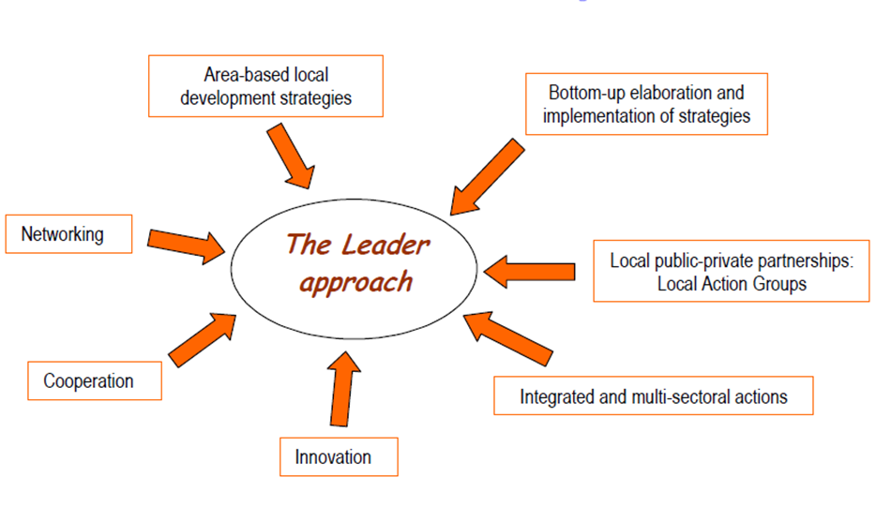
Figure 1 The six guiding principles of LEADER 2014-2020.
Para 1.2 of the LEADER report to the SRDP programme directorate states: “LEADER now operates in a more crowded policy field alongside other forms of locally based development partnerships which often pursue rather topic-specific activities. Climate Challenge Fund projects, community energy projects, local food sector projects and community land purchases all draw from a common set of core principles: that empowered local actors are able to nurture multi-sectoral sustainable development. Alongside such subject-specific local development partnerships, community planning partnerships also offer potential for enhanced service delivery across the public sector.”
The range of community-based development activities in Perth and Kinross extend beyond those specified in the quote above. There are 14 development trusts or community partnerships active to differing degrees in Perth and Kinross. Several of these are very active partnership-based organisations promoting local social and economic development in a variety of ways. LEADER interventions ideally need to engage with and strengthen local action and not to displace embedded processes and practices of community development.

Rural Perth and Kinross- an introduction
Rural Perth and Kinross has been subdivided by the Council into four areas which in many ways represent natural sub-regions based on distinctive biophysical and socio-economic conditions. These comprise: Kinross-shire; Strathearn; Highland Perthshire and Eastern Perthshire. Kinross-shire is characterised by its proximity to Perth and accessibility to Edinburgh. Strathearn has two major towns: Crieff and Auchterarder; it also has a significant retired population as well as being a major tourist destination. Highland Perthshire has a more scattered and less dense population, hill and upland farming and high landscape values and an important tourism industry and also includes small towns such as Pitlochry, Aberfeldy and Dunkeld. Eastern Perthshire contains the market centre of Blairgowrie/Rattray and, on the lower lands of the district, some of the best quality land in Scotland which is used intensively for horticulture and other arable crops.

Although rural Perth and Kinross is a relatively prosperous rural area compared to many parts of Scotland, many UK studies have indicated that even relatively prosperous rural areas can contain many poor households and high levels of fuel poverty. It is widely recognised that measures such as the Scottish Index of Multiple Deprivation (SIMD) are not especially good at identifying diffuse poverty and problems associated with poor and often singe person households. Indeed, the overall relative affluence of the area may make it even harder to attain a critical mass of demand for say, public transport or local service provision because the bulk of the population has high levels of personal mobility.

Variations in Socio-economic conditions at data-zone level

2.1 Demography
In this section, we first outline demographic change in rural Perth and Kinross. The overall population trend (Map 1) is one of considerable increase (significantly above the Scottish average over the period) but the trends show very considerable geographical variability.
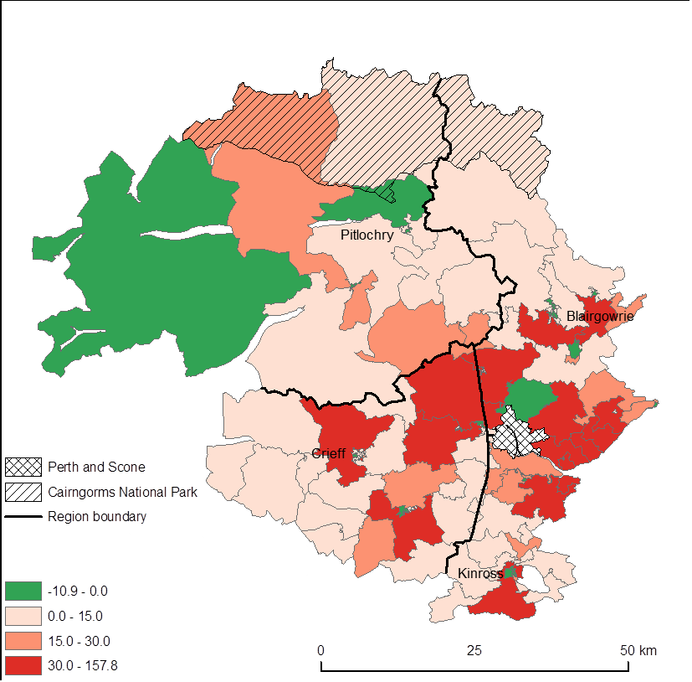
Map 1 Total population change (%), Perth and Kinross, 2001-2011. Green areas show declining population or no change in population. (For copyright and acknowledgements, see Appendix 1)
Overall summary: Rural Perth and Kinross = +14.1%, Scotland = +3.8%
The overall trend is one of a marked increase in almost all datazones, especially in peri-urban areas close to the major urban settlements, especially Perth. The few peri-urban exceptions to this are most likely to be a product of a reduction in household size. The remotest datazone in Perth and Kinross in the north west of the council area shows a decline, which is typical for remote parts of Scotland.
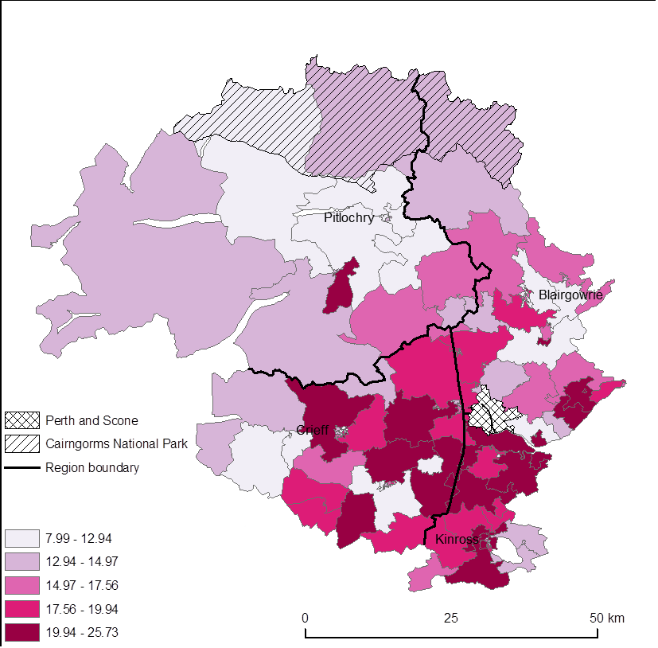
Map 2 Percentage of the population that are children, Perth and Kinross, 2011. (For copyright and acknowledgements, see Appendix 1)
Overall summary: Rural Perth and Kinross = 16.5%, Scotland = 17.4%
The percentage of children in the population is highly variable with most of remoter rural Perth and Kinross and the Blairgowrie area significantly below the Scottish average and some peri-urban areas around Perth, Kinross and Crieff above the Scottish average. Overall, the percentage is very close to the Scottish average.
Map 3 shows the change in the proportion of children in the population. While Perth and Kinross rural shows a decline greater than the average situation for Scotland, the red datazones all show a growth in the proportion of children which might be seen as sign of demographic health in those communities. The healthy communities are primarily peri-urban villages around the major urban centres with an outlier in Aberfeldy and one Pitlochry datazone.
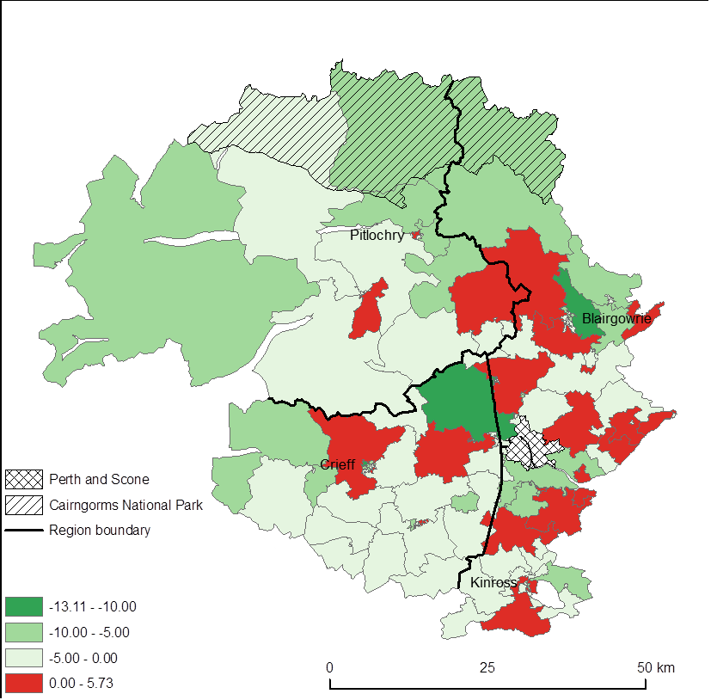
Map 3 Change in the percentage of the population that are children (percentage points), Perth and Kinross, 2001-2011. Red areas show increases in the percentage of the population that are children. (For copyright and acknowledgements, see Appendix 1)
Overall summary: Rural Perth and Kinross = -2.7 percentage points, Scotland = -1.8 percentage points
Perth and Kinross has a more elderly population than that for Scotland as a whole, with certain datazones in the Pitlochry area, Comrie and Birnam/Dunkeld characterised by very high proportions of elderly people (see Map 4). This broadly provides the (expected) mirror opposite of the areas where the proportion children is high. Of note is that there is one datazone (in Blairgowrie West) where almost half of the population is retired. The lowest proportion of population of retirement age in the study area is in the commuter villages around Perth, just south of Kinross and in the immediate hinterland of Crieff.

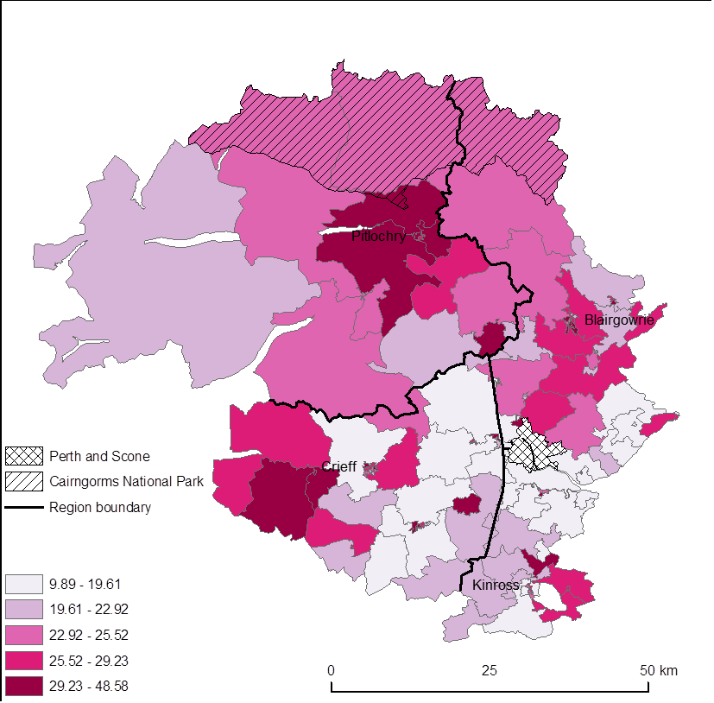
Map 4 Percentage of the population that are of pensionable age, Perth and Kinross, 2011. (For copyright and acknowledgements, see Appendix 1)
Overall summary: Rural Perth and Kinross = 24%, Scotland = 19.8%
Rural Perth and Kinross has a population that is ageing faster than the Scottish population as a whole, the proportion of the population of pensionable age is four percentage points higher than Scotland as a whole(see Map 4). The extent to which the high proportions area result of in-migration of households or to concentrations of care homes is not immediately discernible but it appears likely that at least some of the increase is a function of care home expansion in certain places.
The change in proportion of pensionable age is indicated in Map 6. There is no easy interpretation of the change, other than to note that there are many datazones which show a change in the proportion of people of pensionable age much greater than the Scottish average over the last decade (2001-2011) with the higher figures being both in peri-urban areas and in deeper rural parts of the study areas.

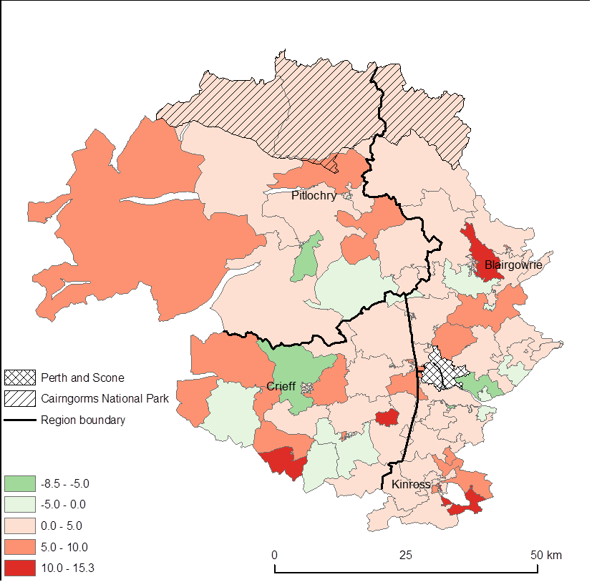
Map 5 Change in the percentage of the population that are of pensionable age (percentage points), Perth and Kinross, 2001-2011. Red areas show increases in the percentage of the population that are of pensionable age. (For copyright and acknowledgements, see Appendix 1)
Overall summary: Rural Perth and Kinross = +2 percentage points, Scotland = +1.2 percentage points
Map 6 shows the population of working age, with a pattern that reflects some of the evidence presented earlier. The rural Perth and Kinross average is below the Scottish average by around 2.5 %. The map shows a greater proportion of working age in Highland Perthshire than might be expected, with the significant exception of Pitlochry and its hinterland (where there is evidence of a high proportion of elderly households). Other areas with a low proportion of working age are the Comrie/St Fillans area and some datazones south of Kinross.

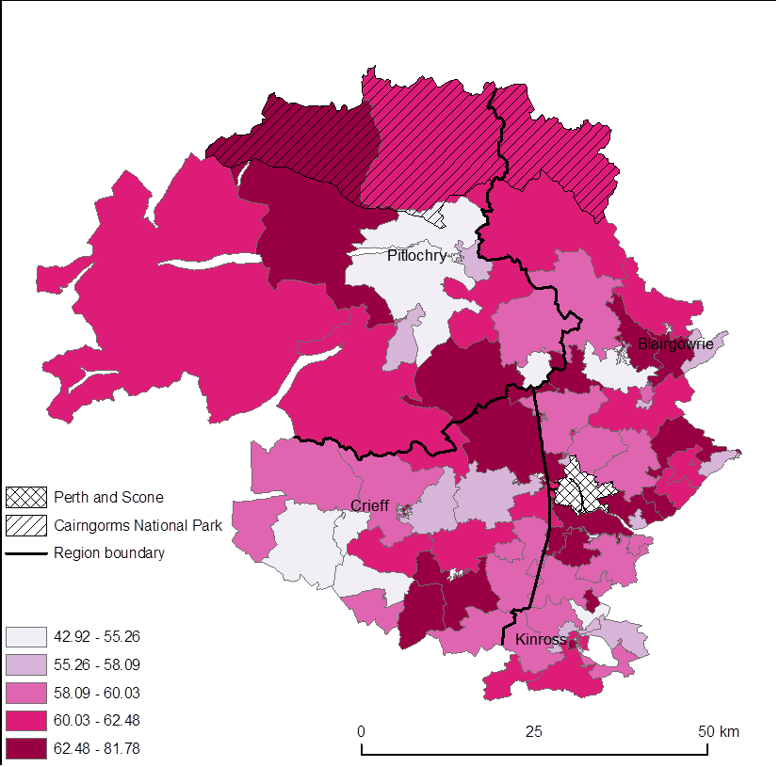
Map 6 Percentage of the population that are of working age, Perth and Kinross, 2011. (For copyright and acknowledgements, see Appendix 1)
Overall summary: Rural Perth and Kinross = 59.4%, Scotland = 62.8%
Map 7 below shows the change in the proportion of the population of working age. Rural Perth and Kinross and Scotland are identical with 0.6 % growth. The areas with positive growth in working age population show no consistent pattern across the study area, with adjacent datazones belonging to the upper and lowest quartile. There is no obvious explanation of the pattern across rural Perth and Kinross and the change in Perth and Kinross mirrors that in Scotland as a whole. Six communities showed a decline of more than 10%. Several of these were rather close to built-up areas including one in Kinross and one in Blairgowrie. One, in Aberruthven and Almondbank, showed a decadal decline in its working age population of more than 20%.

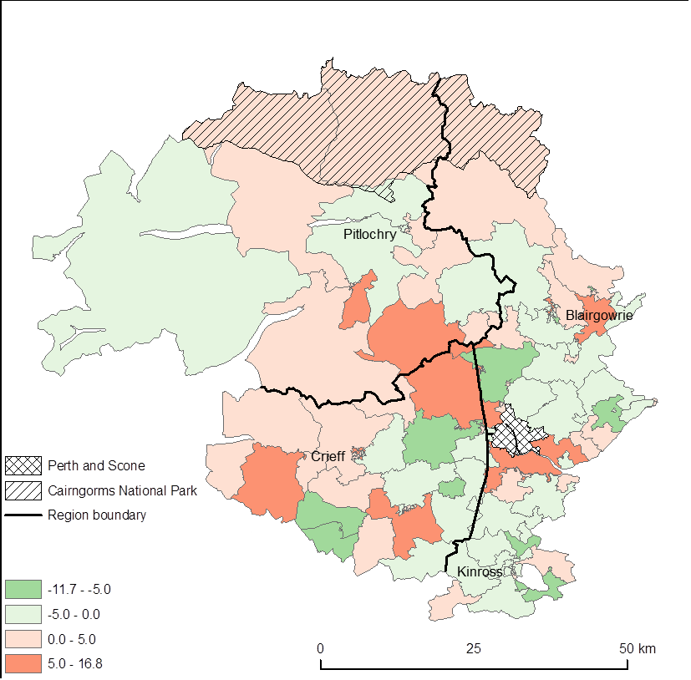
Map 7 Change in the percentage of the population that are of working age (percentage points), Perth and Kinross, 2001-2011. Red areas show increases in the percentage of the population that are children. (For copyright and acknowledgements, see Appendix 1)
Overall summary: Rural Perth and Kinross = +0.6 percentage points, Scotland = +0.6 percentage points

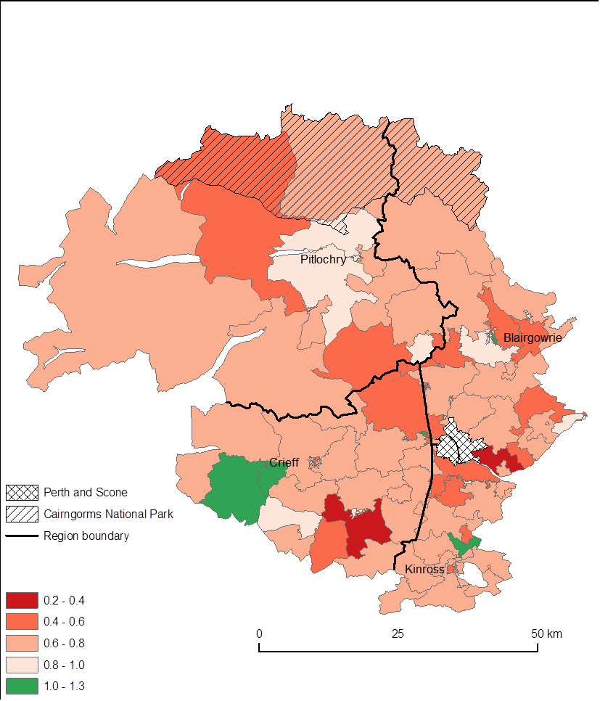
Map 8 Dependency ratio (the number of children and people of pensionable age divided by the number of people of working age), Perth and Kinross, 2011. (For copyright and acknowledgements, see Appendix 1)
Overall summary: Rural Perth and Kinross = 0.68, Scotland = 0.59
Rural Perth and Kinross has a higher dependency ratio than Scotland as whole. However as Map 8 shows there are significant variations over space with some rural areas having relatively low rates of dependents per capita, particularly some of the remoter Highland Perthshire datazones and some of those in the immediate hinterland of Perth. In rural Perth and Kinross, the highest dependency ratio is found in two large village/small town settings in Comrie and Blairgowrie-Rattray where over 40% of the population is above retirement age. It would appear that in the two worst performing datazones the poor performance is more a function of elderly people than children.

2.2 Access to services
In this section we explore access to services, looking at figures at a point in time and at change over time.
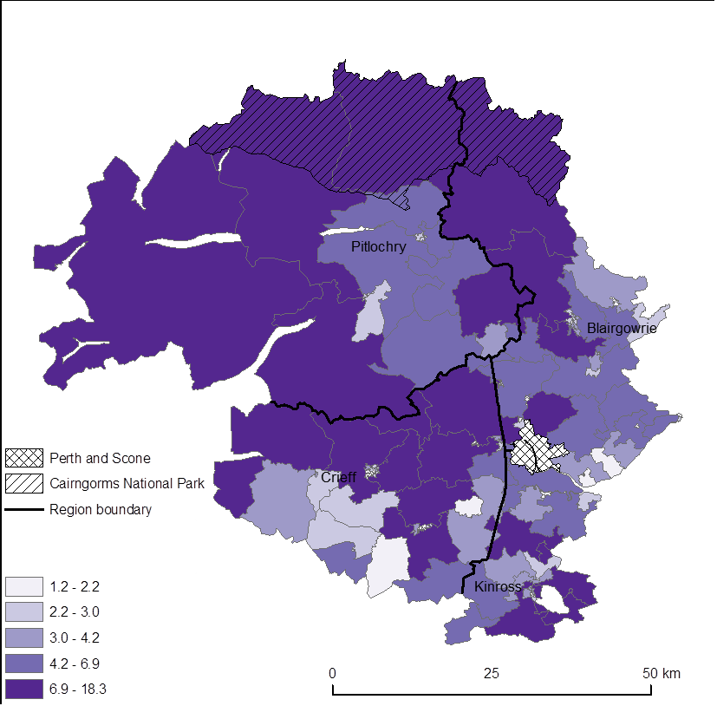
Map 9 Drive time to a Post Office (minutes), Perth and Kinross, 2012. (For copyright and acknowledgements, see Appendix 1)
Estimated means: Rural Perth and Kinross = 4.3 minutes, Scotland = 3.3 minutes
With few exceptions, most rural datazones show (map 9) a drive time to a post office in excess of the Scottish average, which would be expected for a council with a large rural area. The figure is expectedly low in settlements such as Crieff, Aberfeldy and Pitlochry. The low population density parts of Highland Perthshire and the northern part of Strathearn are all, as might be anticipated, associated with longer travel times.
Map 10 shows that the change in travel time to post offices presents a very different geography. In other words, a post office closure can dramatically lengthen the travel time to a post office and that closures in communities relatively close to larger centres are likely to have significantly negative effects on more immobile groups in the population. The deterioration in accessibility appears to be worse in northern Kinross and in the Eastern Perthshire area. It should be noted that percentage changes in urban areas may be large when actual times are still rather short.
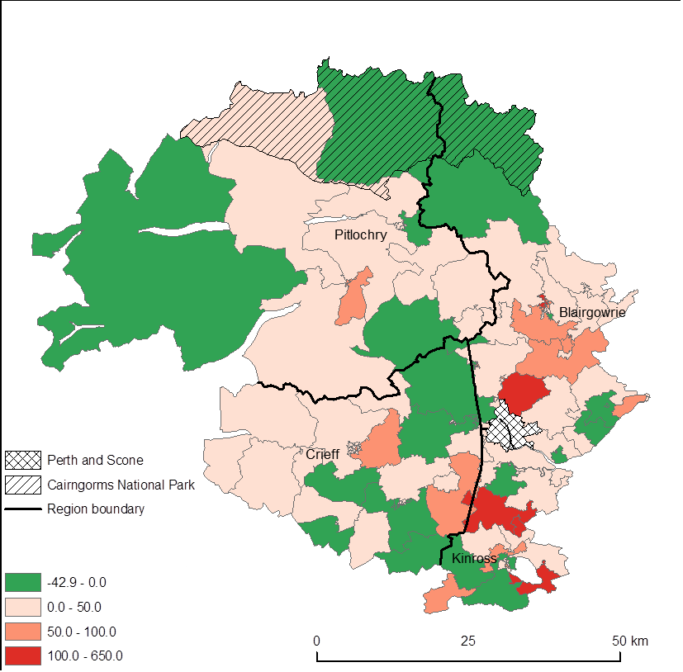
Map 10 Change in drive time to a Post Office (%), Perth and Kinross, 2003-2012. Green areas show shorter drive times or no change. (For copyright and acknowledgements, see Appendix 1)
Estimated means: Rural Perth and Kinross = +19.2%, Scotland = +16.5%
Map 11 shows drive times to shopping facilities. The drive time is about 40% greater than the Scottish average, but this might be predicted given the substantial area of lightly populated Highland Perthshire. However, the drive to shopping facilities is also rather long for many residents in the more densely populated parts of lowland Perthshire and may be a function of small settlement sizes without a critical mass of retail facilities.
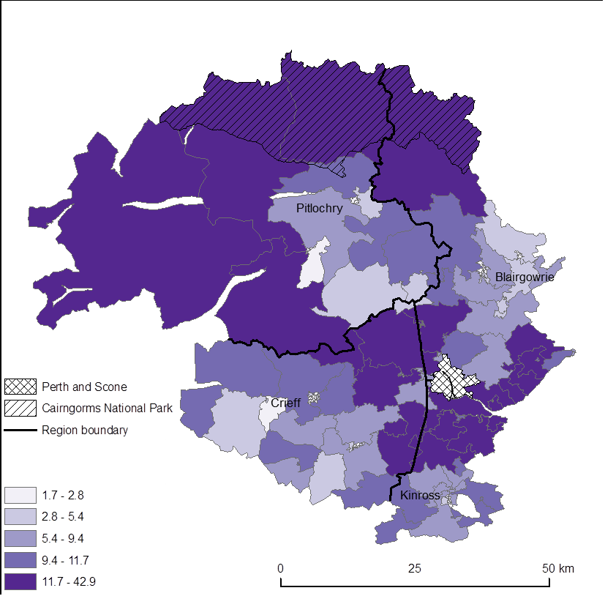
Map 11 Drive time to Shopping Facilities (in minutes), Perth and Kinross, 2012. (For copyright and acknowledgements, see Appendix 1)
Estimated means: Rural Perth and Kinross = 7.9 minutes, Scotland = 5.7 minutes
The change in the time required to drive to shopping facilities does show a distinct pattern in which the more remote areas have experienced increased drive times (Map 12). However, there are also some significant and not readily explicable changes in Strathearn with a worsening in some parts and an improvement in others. The shopping data is derived from an index (the CACI index, which is itself a proprietary composite index) the basis of which may have changed over time.
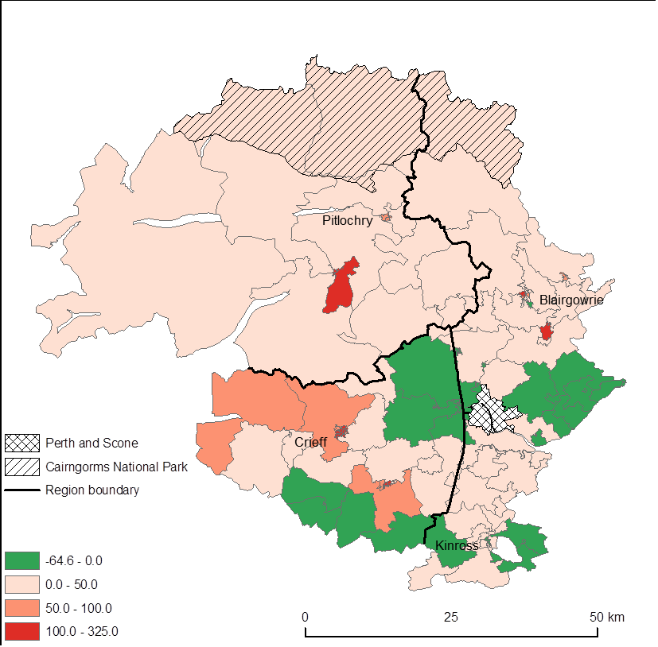
Map 12 Change in drive time to Shopping Facilities (%), Perth and Kinross, 2006-2012. Green areas show shorter drive times or no change. (For copyright and acknowledgements, see Appendix 1)
Estimated means: Rural Perth and Kinross = +4.8%, Scotland = +2.4%
Map 13 shows the time taken to access a post office by public transport. The figure is almost 50% greater than the Scottish average. Given that the drive time differential was less this could be indicative of a relatively weak public transport system. One datazone (in the Rannoch and Aberfeldy cluster) has a travel time by public transport to a post office of over 80 minutes.
Paradoxically, the improvements in travel time by public transport are mostly in the remoter area and the worsening of travel times is almost all in the peri-urban/commuter zone villages around Perth. Here the deterioration in accessibility by public transport is twice the Scottish average, this suggesting a relative decline in the quality of rural Perth and Kinross’ public transport system.
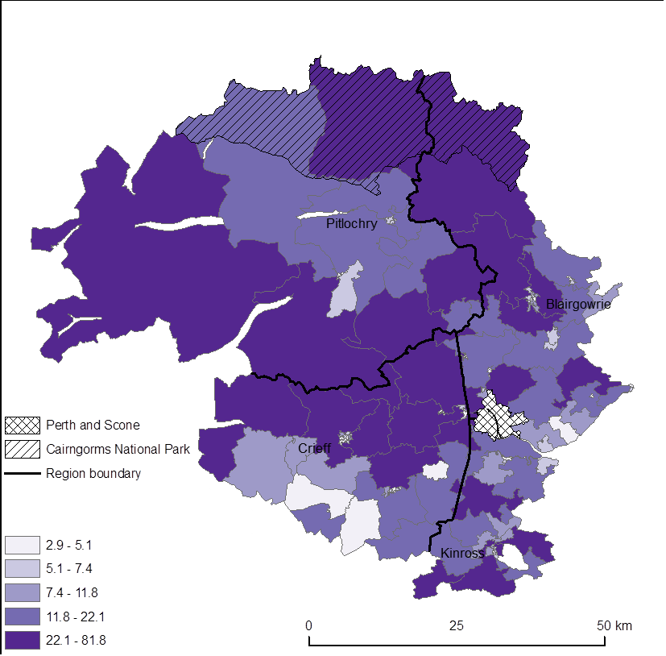
Map 13 Public transport time to a Post Office (minutes), Perth and Kinross, 2012. (For copyright and acknowledgements, see Appendix 1)
Estimated means: Rural Perth and Kinross = 13.4 minutes, Scotland = 9.2 minutes
Map 13 indicates time taken to access a post office by public transport. The extreme case is in the far north west of the region where it takes more than 80 minutes to access a post office by public transport. This is almost ten times the Scottish average and suggests that some households without access to a car will experience severe service deprivation in such areas.
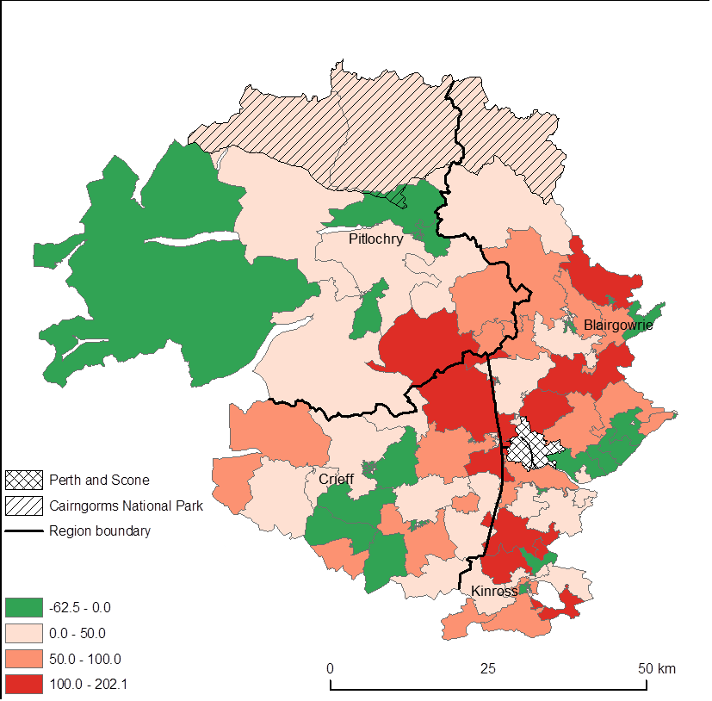
Map 14 Change in public transport time to a Post Office (%), Perth and Kinross, 2006-2012. Green areas show shorter travel times or no change. (For copyright and acknowledgements, see Appendix 1)
Estimated means: Rural Perth and Kinross= +22.1%, Scotland = +12.4%
Map 14 shows the change in time to access a post office by public transport between 2006-2012. The worst performing datazone in absolute time appears to have shown a substantial improvement. It is highly probable that declines in travel times in other communities reflect enhanced public transport. Where the situation has worsened, it is almost certainly a function of post office closures, although it is also possible in some cases that public transport frequency has also declined.

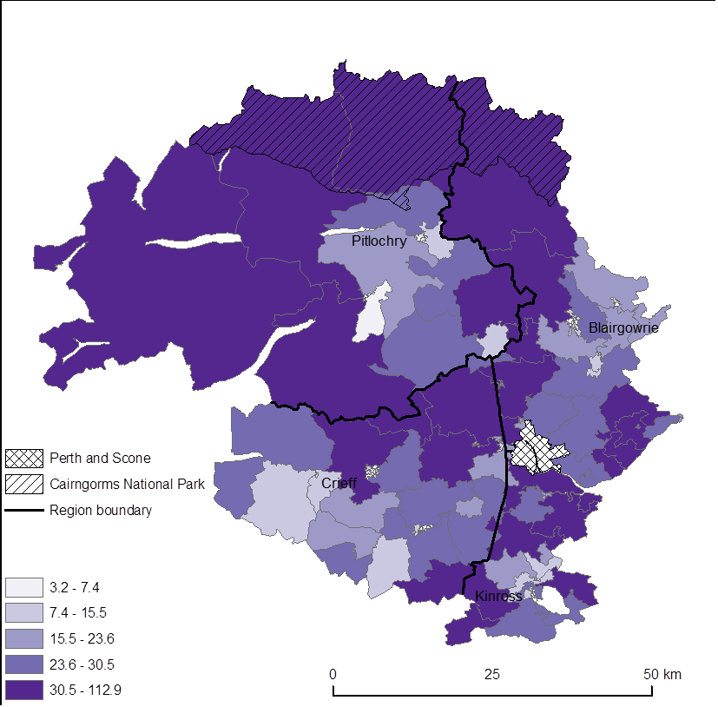
Map 15 Public transport time to Shopping Facilities (minutes), Perth and Kinross, 2012. (For copyright and acknowledgements, see Appendix 1)
Estimated means: Rural Perth and Kinross = 21 minutes, Scotland = 14.3 minutes
Map 15 shows public transport times to shopping facilities and could be seen as a proxy for access to shopping challenges to households without private mobility. The mean for rural Perth and Kinross is about 50% worse than for Scotland as a whole. It shows a broadly predictable distribution with Highland Perthshire (except the Pitlochry area) having rather long travel times and further clusters of rather long travel times in the east Perthshire uplands, the Firth of Tay villages in Eastern Perthshire and a significant number of datazones in Kinross.
Map 16 shows changes between 2006 and 2012 in public transport times to access shopping facilities. The map shows that rural Perth and Kinross dramatically underperformed against Scotland as a whole, the former experienced an increase in public transport time, whereas Scotland experienced a significant reduction.

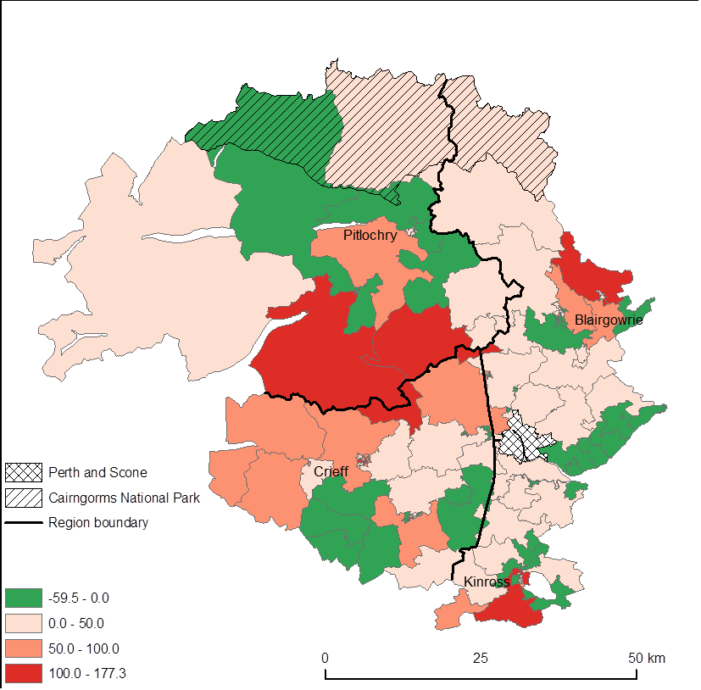
Map 16 Change in public transport time to Shopping Facilities (%), Perth and Kinross, 2006-2012. Green areas show shorter travel times or no change. (For copyright and acknowledgements, see Appendix 1)
Estimated means: Rural Perth and Kinross = +4.2%, Scotland = -12.8%
The changes in public transport to shopping facilities in map 16 show that whilst the situation for Scotland as a whole has improved considerably, that for rural Perth and Kinross has got rather worse. It is uncertain how much these figures are a product of definitions of shopping centres. However, none of the 20 datazones experiencing the greatest % decline had an absolute driving time of over five minutes, so the % change should be treated with caution. The greatest improvement has been in the Gleneagles area.

Deprivation and disadvantage
This section explores a number of dimensions of disadvantage and includes consideration of the summary indicator of SIMD.
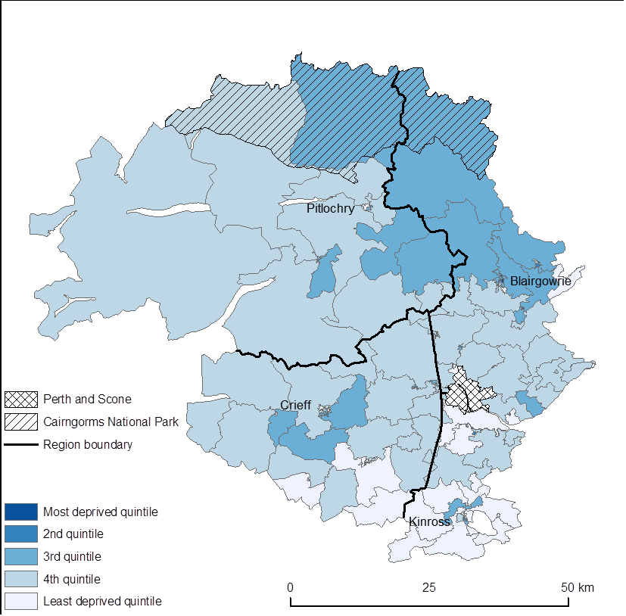
Map 17 Education, Skills and Training Deprivation Rank, Perth and Kinross, 2012. Ranks are based on all of Scotland. (For copyright and acknowledgements, see Appendix 1)
Median ranks: Rural Perth and Kinross = 4423.5, Scotland = 3253
Map 17 summarizes data on education skills and training deprivation. All 6505 Scottish datazones are mapped and the worst communities are low ranked and the best performing communities high ranked. In general, Perth and Kinross sits in the middle range of rankings with datazones immediately to the south of Perth and in Kinross showing the largest number in the top quintile. Eastern Perthshire has perhaps the greatest proportion of low ranked datazones in terms of educational and training deprivation. Three datazones in Eastern Perthshire, two of which are in Blairgowrie/Rattray are very low-ranked at 352, 373 and 867 respectively.
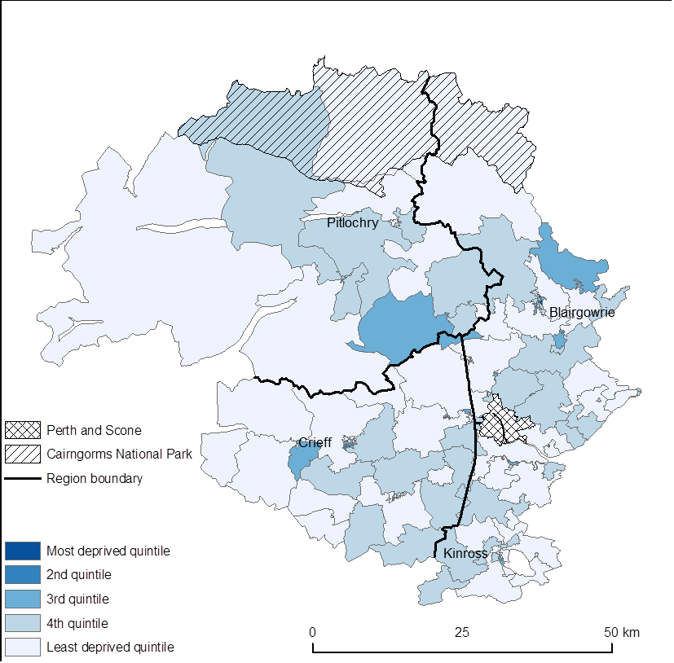
Map 18 Employment Deprivation Rank, Perth and Kinross, 2012. Ranks are based on all of Scotland. (For copyright and acknowledgements, see Appendix 1)
Median ranks: Rural Perth and Kinross = 4950.5, Scotland = 3253
The proportion of people from the resident working age population who are unemployed or who are not in the labour market due to ill health or disability constitute an indicator of disadvantage. Nowhere in rural Perth and Kinross scores particularly poorly, but some of the worst performing datazones are peri-urban in and around the market towns of Crieff and Blairgowrie/Rattray. Only two Perth and Kinross rural datazones are in the lowest 1000 in Scotland and both are in Blairgowrie/Rattray. However, there is no consistent and readily explicable pattern of employment deprivation , although it is noteworthy that no datazone in the Kinross sub-area falls below the 40th percentile rank.

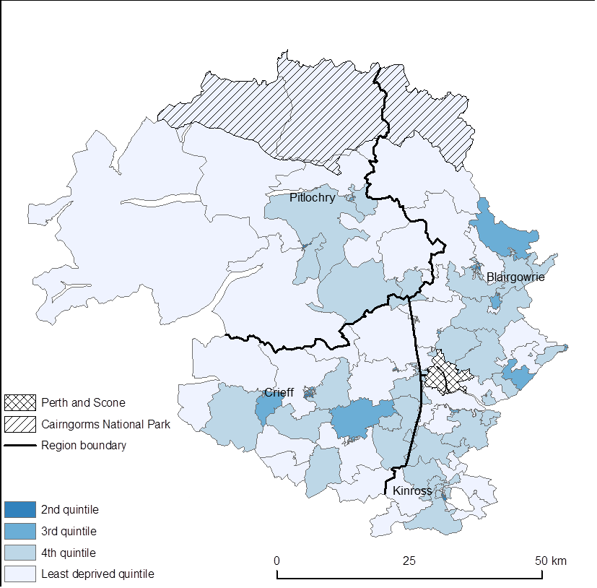
Map 19 Health Deprivation Rank, Perth and Kinross, 2012. Ranks are based on all of Scotland. (For copyright and acknowledgements, see Appendix 1)
Median ranks: Rural Perth and Kinross = 4652.5, Scotland = 3253
On average, rural Perth and Kinross suffers less health deprivation than the rest of Scotland (see Map 19). The lowest two (worst performing) datazones in terms of health deprivation are both in small towns, in Crieff and Blairgowrie/Rattray respectively, but none is in the worst performing quintile in Scotland.
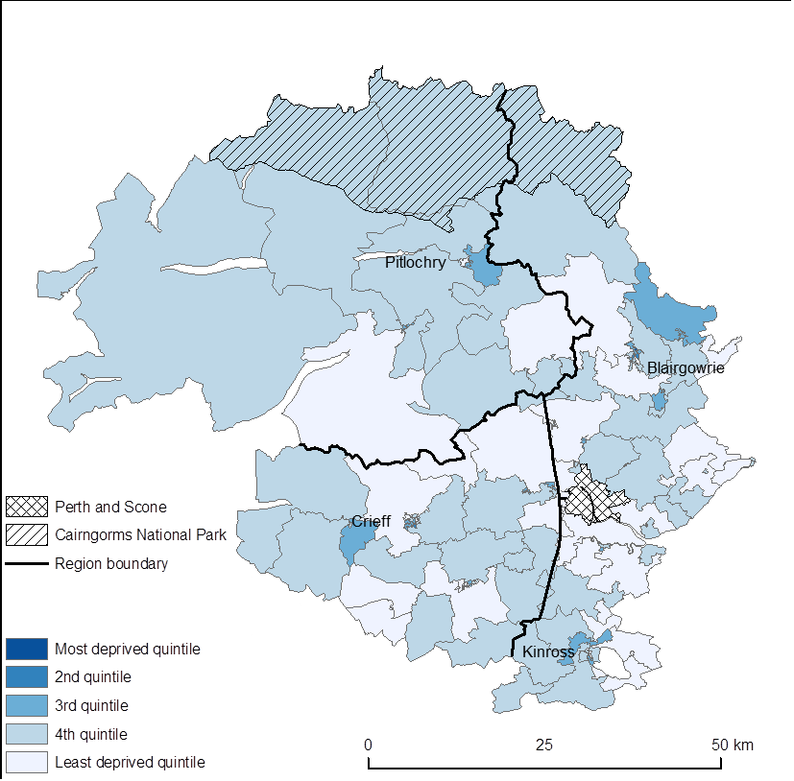
Map 20 Current Income Deprivation Rank, Perth and Kinross, 2012. Ranks are based on all of Scotland. (For copyright and acknowledgements, see Appendix 1)
Median ranks: Rural Perth and Kinross = 4733, Scotland = 3253
In terms of current income deprivation rural Perth and Kinross performs rather well compared to the rest of Scotland. Only one datazone (in Blairgowrie/Rattray) is in the lowest 1000. Over rural Perth and Kinross as a whole, most smaller rural settlement datazones have low levels of income deprivation.

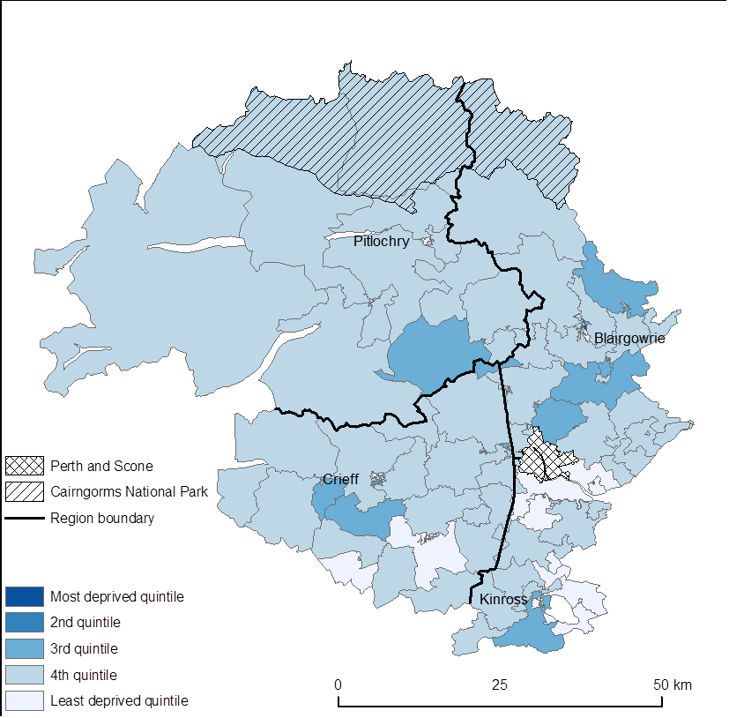
Map 21 Scottish Index of Multiple Deprivation (SIMD) Rank, Perth and Kinross, 2012. Ranks are based on all of Scotland. (For copyright and acknowledgements, see Appendix 1)
Median ranks: Rural Perth and Kinross = 4568, Scotland = 3253
Rural Perth and Kinross has an average Scottish index of Multiple Deprivation rank much lower than that of Scotland as a whole. However, it is recognised that there are serious weaknesses about measures of average disadvantage across datazones where there socio-economic wellbeing differs greatly between individuals. Where say 20% of the population is experiencing considerable poverty and disadvantage this will be masked out by more affluent members of the same datazone. Only in town and city datazones where the socio-economic profile is more homogeneous will low SIMD scores ‘kick in’.
The only two datazones in the worst performing 1000 in Scotland are in Blairgowrie/Rattray. Whereas one of these has improved since 2004, the other datazone has dropped into the bottom one thousand.

2.4 Housing
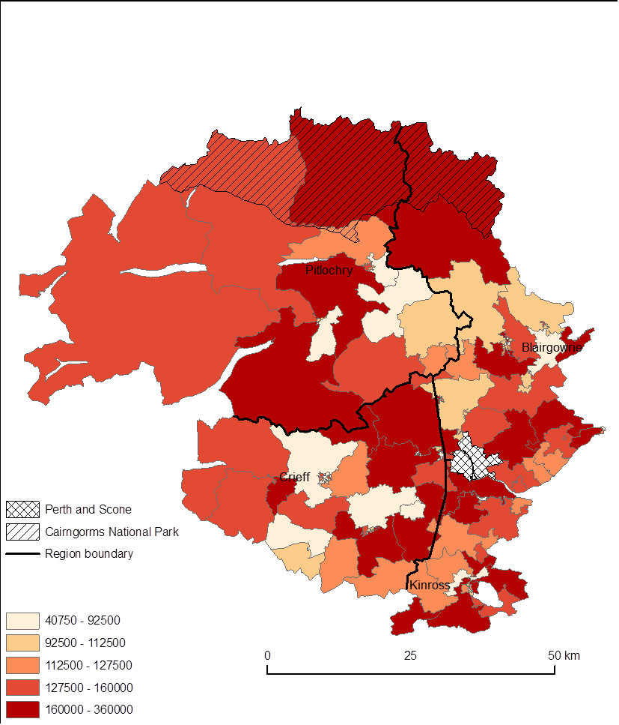
Map 22 House sales, lowest quartile price (£), Perth and Kinross, 2011. (For copyright and acknowledgements, see Appendix 1)
Estimated means: Rural Perth and Kinross = £127,842, Scotland = £104,122
Map 22 shows the lowest quartile price for homes in rural Perth and Kinross. The figure is about 20% higher than the Scottish figure which suggests that low paid or poor people will find it rather difficult to enter the housing market. However, there is considerable spatial variation around the mean Perth and Kinross figure with lower house prices found in and around Pitlochry and Aberfeldy, in Blairgowrie/Rattray, in and around Crieff and in parts of Earnside and Kinross.

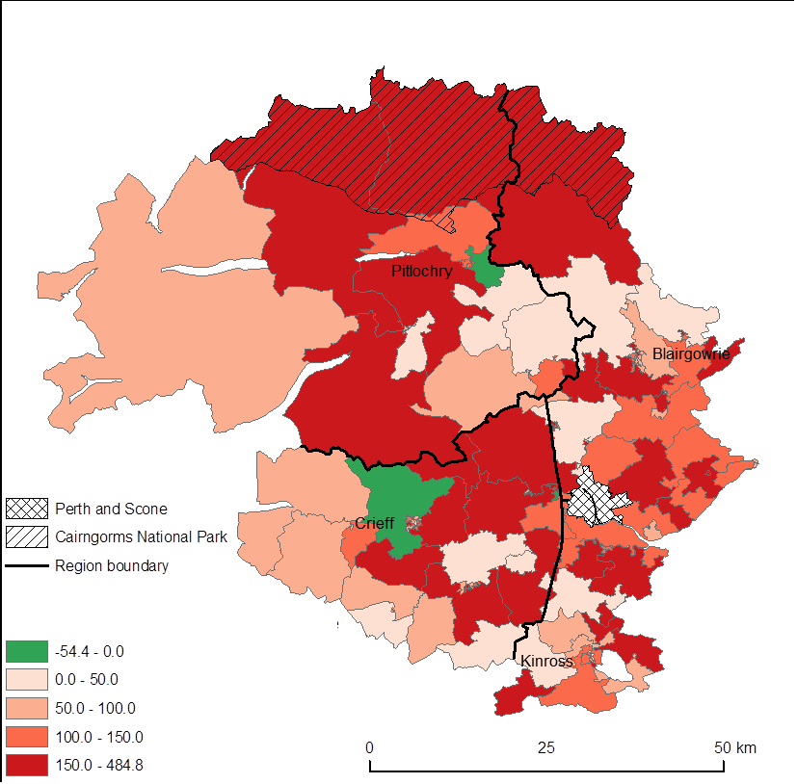
Map 23 Change in house sales, lowest quartile price (%), Perth and Kinross, 2001-2011. Green areas show lower prices, or no change. (For copyright and acknowledgements, see Appendix 1)
Estimated means: Rural Perth and Kinross = +114%, Scotland = +105.1%
Map 23 shows that over rural Perth and Kinross as a whole, house prices have risen faster than the Scottish average, but in a decade of low house price rises between 2001 and 2011, house prices rose significantly in many datazones, especially in the Highland Perthshire area. Higher than average rises also occurred in lowland Eastern Perthshire and in the Earnside datazones nearest to Perth. Pitlochry and Crieff bucked the general Perth and Kinross trend with house price declines in the lowest quartile.
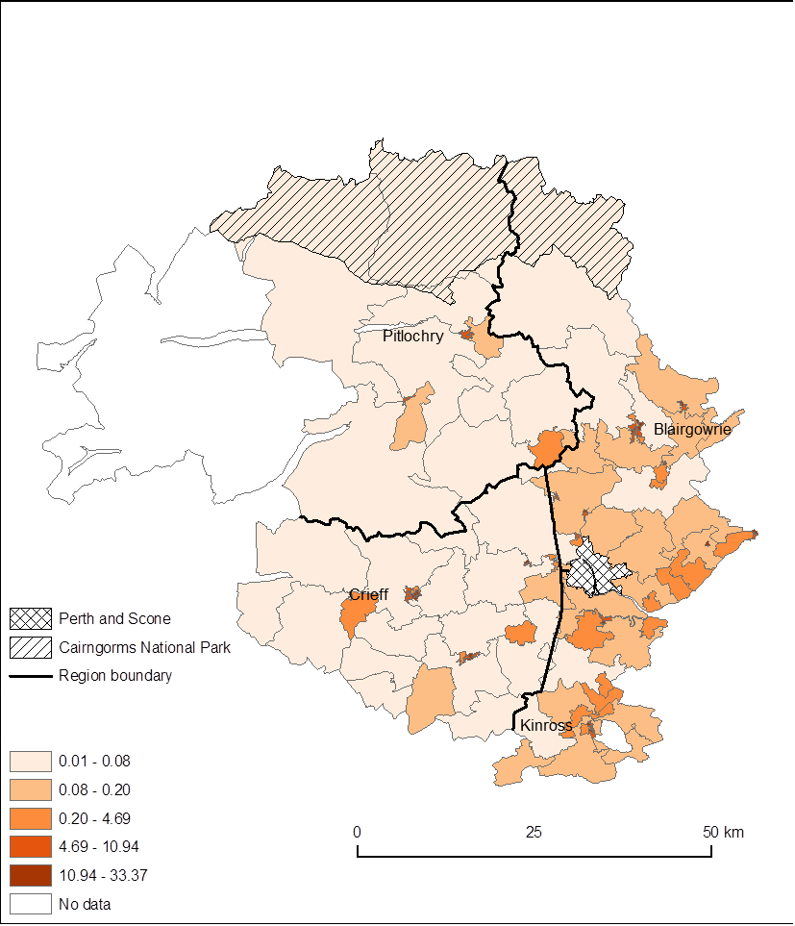
Map 24 Total number of dwellings per hectare, Perth and Kinross, 2012. No data available for datazone S01005140 (Rannoch and Aberfeldy). (For copyright and acknowledgements, see Appendix 1)
Overall summary: Rural Perth and Kinross = 0.09 dwellings per hectare, Scotland = 0.32 dwellings per hectare
Overall, as Map 24 shows, the density of dwellings and also the density of population is much less than in Scotland as a whole. The highest density in rural Perth and Kinross is in the towns and the density in more rural datazones is predictably significantly greater in the lowland parts of the area.

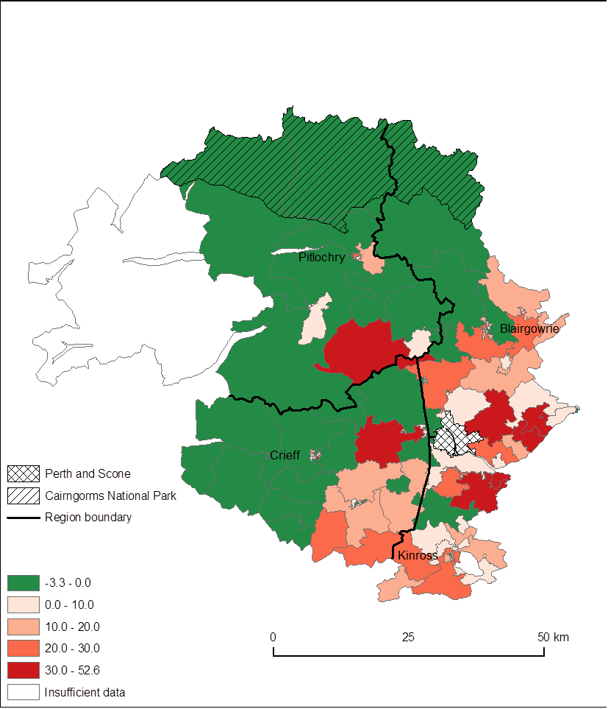
Map 25 Change in total number of dwellings per hectare (%), Perth and Kinross, 2003-2012. Green areas show decline in the number of dwellings per hectare, or no change. Datazone S01005140 (Rannoch and Aberfeldy) has insufficient data available for calculation. (For copyright and acknowledgements, see Appendix 1)
Overall summary: Rural Perth and Kinross = +11.2%, Scotland = +7.3%
With only two truly rural exceptions either side of the boundary, the density of dwellings increased in the more densely populated predominantly low-ground zone below the highland fault line and either stayed static or declined in the highland and upland zone to the north of the line (See Map 25).

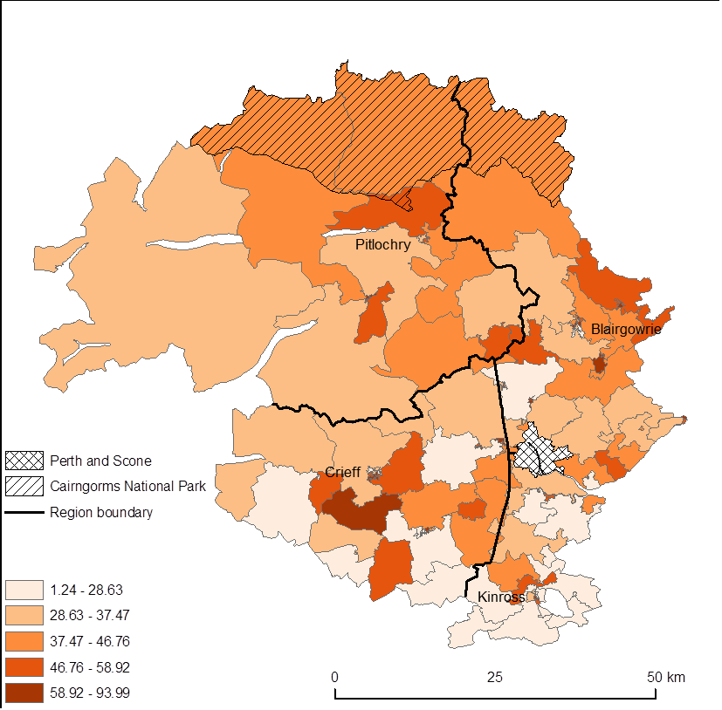
Map 26 Percentage of dwellings in bands A-C, Perth and Kinross, 2012. (For copyright and acknowledgements, see Appendix 1)
Overall summary: Rural Perth and Kinross = 43.8%, Scotland = 61.5%
Map 26 provides an alternative view of housing costs using the proxy of council tax. Rural Perth and Kinross has a figure much lower than the Scottish average. The advantage of this over sales is that it looks at the total housing stock. The map shows a concentration of band A-C homes in Strathearn, but with exceptions in the Comrie and Almondbank areas and generally high rates of low-banded homes in Highland Perthshire. Eastern Perthshire has a high proportion of low banded homes and the greatest concentration of higher banding is in Kinross.
An examination of Zoopla data on house prices shows that the average price of a home in Perth and Kinross (based on Zoopla’s Zed index) is currently £192,000, a rise of £10,000 in the last five years. This compares with a Scottish average of £244,000 which has increased 10% in the last five years. Blairgowrie with an average price of £192,000 at present has increased only 3% in the last five years. Pitlochry in contrast has an average price of £244,000 but again has only increased by 3% in the last five years. The city of Perth has lower average prices than any of the listed surrounding settlements. These figures contrast with small towns in Aberdeenshire which are almost always cheaper than prices in Aberdeen with the exception of Deeside towns. The Zoopla data are not wholly consistent with those from SNS.
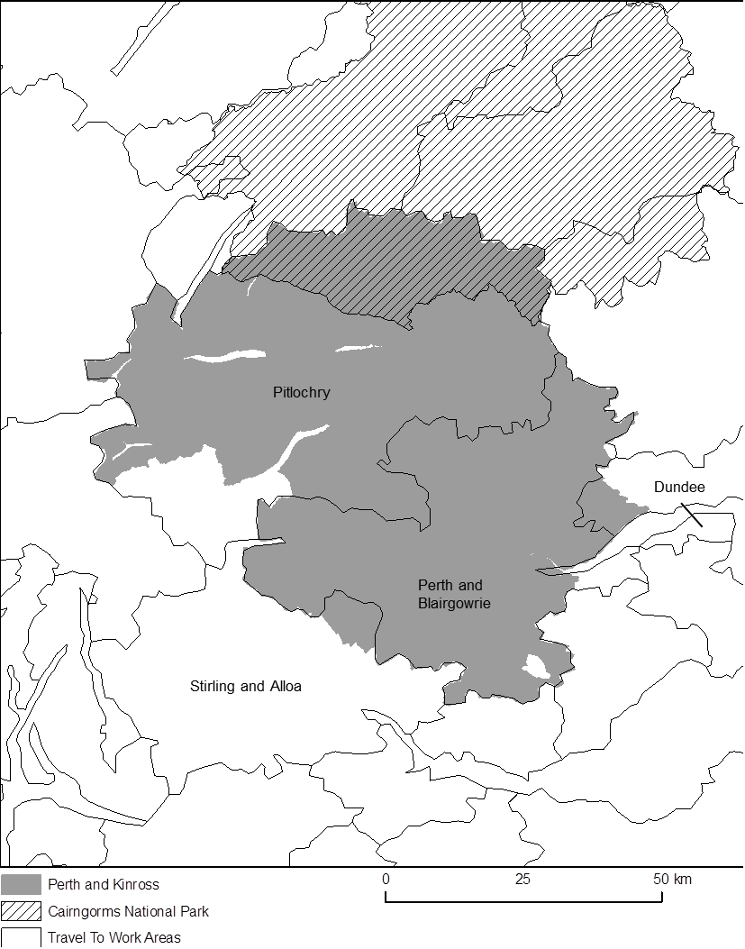
Map 27 Travel to Work area boundaries and the Perth and Kinross region. Labelled Travel to Work areas are those which are at least partially within Perth and Kinross. (For copyright and acknowledgements, see Appendix 1)

2.5 Incomes
Income data were available only for one point in time in SNS data and were not followed up. However, a detailed investigation of income variability has recently been undertaken by Bramley and Watkins (2013) which set out to ‘provide a robust and transparent set of estimates of household incomes and poverty for local and small areas of Scotland.’
Bramley and Watkins data suggest that Perth and Kinross Council as a whole ranks 5th highest in ‘equivalised’ household income before housing costs (See Figure 1). This suggests that there is no generic low income issue in the council area. In this study, we have not followed up the issue of poor households and housing costs but we recognise the relatively high cost of housing in Perth and Kinross and the impact that this has on the poorer households in the area.
Bramley and Watkins argue that it is important to recognise that in rural areas there are likely to be a higher proportion of poor people not on benefits. There is generally perceived to be a lower uptake of benefits in rural areas, not because of lack of need of support but because there is perceived to be an unwillingness to seek support.

Figure 1 Median Net Equivalised Income Before Housing Costs

Rural Land Use
Rural Perth and Kinross is characterised by considerable variations in land use which are a function of its geology and relief. The council area is bisected by the Highland Fault Line, the major geological boundary between the Grampian Mountains to the north and west and the fertile lowlands of eastern Scotland to the south and east. The fertility of the lowland areas is compromised by the presence of a number of ridges of igneous rocks north and south of the Tay estuary. Some of the land to the south of the Highland fault line is amongst the highest quality of agricultural use in Scotland, whereas substantial areas to the north and west of the council area are montane and upland. These underlying conditions create highly heterogeneous conditions for rural land use.

Designated areas
The land area of rural Perth and Kinross has many high level designations for protection of amenity, habitats and biodiversity. In terms of highest level designations for amenity: national parks, parts of rural Perth and Kinross are in two national parks, but are distinctly at the margins of the park. Indeed, in the case of the Cairngorms National Park, the area was added in relatively recently. A small area of the Loch Lomond and Trossachs National Park sits at the south western corner of Perth and Kinross (See Map 28). In the middle reaches of the major Tay tributaries a substantial area of Forestry Commission land has been designated as the Tay Forest Park. In general, the area is promoted for its high quality forests, which have significant heritage value in the Dunkeld-Atholl area and high amenity value in many parts of the study area.

There are two major National Nature Reserves in the council area on the Ben Lawers ridge to the North side of Loch Tay and Loch Leven and part of its adjacent shoreline. There are a large number of Special Protection Areas for Birds (SPAs) and Natura 2000 sites, all of which are also designated Sites of Special Scientific interest (See Maps 29.30,31,32). Most of the designations for nature conservation are mountain and upland (certainly in areal extent) and cover large areas of important montane bird habitat in the east of the Highland Perth and Kinross and some of the highest quality montane pastures in the UK, including the alpine arctic flora of the Lawers range. There are two important aquatic reserves: Loch Leven and the Tay estuary and almost all the river Tay and its tributaries are an SAC primarily on account of Atlantic salmon, although other highly valued biodiversity (lamprey and otter) are also cited. These environmental qualities are likely to be a considerable attractant to those recreationalists and tourists interested in the natural environment. In some cases, there are visitor centres associated with these designated sites, though the 40 year old Ben Lawers visitor centre was demolished in 2012.

The Tay catchment has inadvertently become an area with the largest UK population of European beaver. As a result of unplanned and unofficial releases there is now a population of nearly 150 beavers in the Tay catchment.
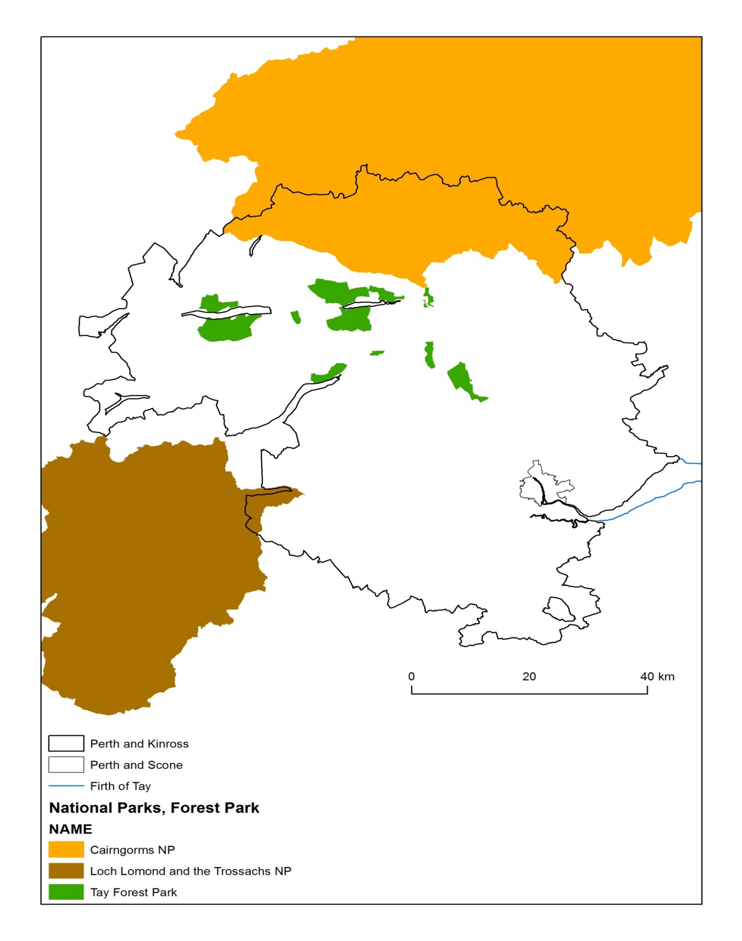
Map 28 National Park and Forest Park areas, Perth and Kinross. Only the Firth of Tay shoreline is shown. (For copyright and acknowledgements, see Appendix 1)
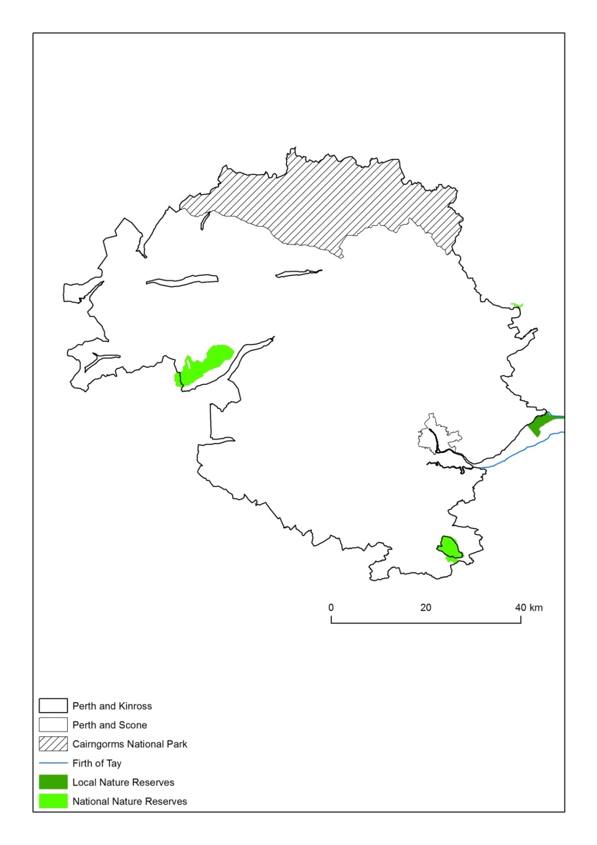
Map 29 Local and National Nature Reserves, Perth and Kinross, as of 13th December 2013 and 12th October 2012, respectively. Only the Firth of Tay shoreline is shown. (For copyright and acknowledgements, see Appendix 1)
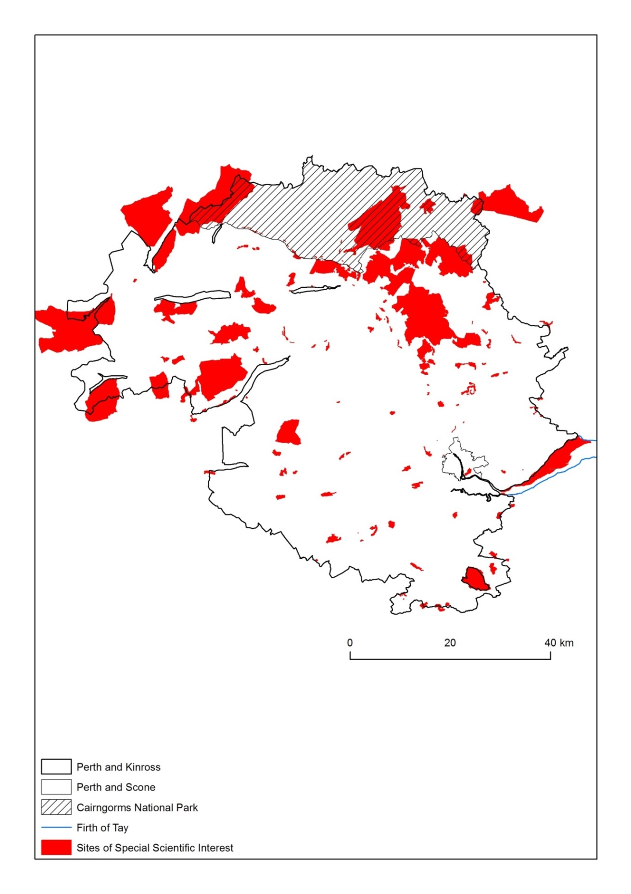
Map 30 Sites of Special Scientific Interest, Perth and Kinross, as of 8th November 2013. Only the Firth of Tay shoreline is shown. (For copyright and acknowledgements, see Appendix 1)
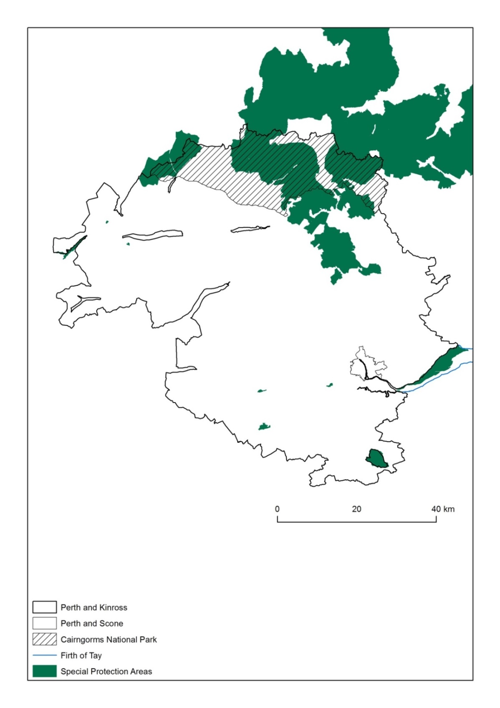
Map 31 Special Protection Areas, Perth and Kinross, as of 24th February 2012. Only the Firth of Tay shoreline is shown. (For copyright and acknowledgements, see Appendix 1)
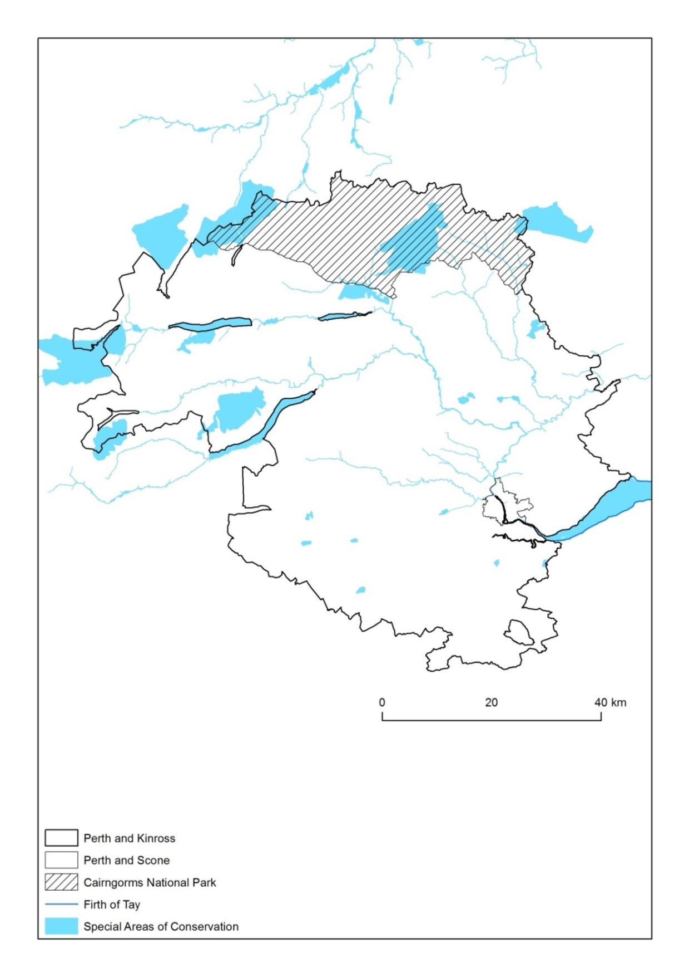
Map 32 Special Areas of Conservation, Perth and Kinross, as of 21st August 2013. Only the Firth of Tay shoreline is shown. (For copyright and acknowledgements, see Appendix 1)

3.3. Agricultural land use
Change within the farm sector is summarised in maps 33-44. We focus on changes in cropping and stocking, including changes in the important soft fruit sector, changes in the total farm labour force and changes in farm size. In all cases, our interest is on change and the likely implications of such changes.
The cropping area has always been concentrated in the lowland south and east of the region where natural conditions favour arable agriculture. However, many upland farms have grown small areas of arable land for spring barley production for home use or winter feed (such as turnips) for stock. Overall the cropped area has declined by 10% in a decade. The decline is concentrated in upland areas where a small amount of arable land was almost certainly good for wintering birds, such as finches. The decline in the upland parishes has been precipitous in many cases, with large areas having a reduction in excess of 40% over a decade.
The area under soft fruit, which was and remains concentrated in Eastern Perthshire has also declined overall, but it seems highly probable that the area of crops produced under cover has increased. Soft fruit production in polytunnels has become a technically sophisticated enterprise with the capacity to significantly lengthen the season of production and create a strong demand for seasonal labour. The decline in hectarage on the traditional core growing area has been partly offset by a significant growth in a small number of parishes. The region has strong infrastructural and research and advisory support for soft fruit production and a skilled population of specialist growers. It should be able to maintain competitive advantage.
Maps 37-40 look at the number of cattle and sheep and changes in those numbers. Cattle numbers are concentrated between the higher quality lowlands and the poorer mountain areas. Cattle numbers have declined by 13% over a decade, but the pattern of change is one of general decline but with some parishes with significant increases in cattle numbers. The areas of highest change are almost all from a low base, suggesting no major spatial reorientation of the sector.
Sheep numbers are concentrated in the hill and upland parishes in Perth and Kinross. The overall pattern is one of decline, with numbers falling by over 20% in the course of a decade. However, in some of the more upland parishes around Perth, there was a substantial increase in sheep numbers. The so-called ‘retreat from the hills’ is evident in Perth and Kinross, but the pattern of change reveals significant losses in some lowground parishes as well.
These changes in stocking are an entirely predictable response to changes in pillar 1 of the CAP which has seen the introduction of a largely decoupled support scheme, which means that income is to a much greater degree independent of levels of production. In areas where margins are tightest, it is an entirely sensible response to policy change to reduce stock numbers and ideally concentrate on quality. Whether destocking or reduced stocking has any significant environmental consequences depends on the particular biodiversity features of interest. For example, some alpine plants may prefer a low sward, and some waders such as lapwings also exhibit preference for grazed pastures. This suggests a minimum desirable level of grazing, though such grazing could come from wild rather than domesticated animals.

The intensity of agricultural employment varies significantly over rural Perth and Kinross. The caution about large parishes applies to this dataset as to the others. There is a surprisingly low intensity of farming workforce in some of the parishes adjacent to Perth. In terms of overall farm employment, including the labour of farmers and wives, there has been a marked redistribution of the farm workforce out of the hills and into Eastern Perthshire. This almost certainly reflects changes in the horticulture sector, but also a significant decline in the total farm workforce in the livestock sector in areas where other work opportunities may be more modest. Overall though, there has been an increase in the farm workforce.

Map 33 - Total area of crops and fallow land (hectares per parish), Perth and Kinross, 2011. Disclosive data is not shown. (For copyright and acknowledgements, see Appendix 1)

Map 34 – Change in total area of crops and fallow land (%), Perth and Kinross, 2000-2011. Disclosive data is not shown. (For copyright and acknowledgements, see Appendix 1)
Summary figure: Perth and Kinross = -12.7%

Map 35 - Total area of soft fruit (hectares per parish), Perth and Kinross, 2011. Disclosive data is not shown. Blank parishes had no soft fruit in 2011. (For copyright and acknowledgements, see Appendix 1)

Map 36 – Change in total area of soft fruit (%), Perth and Kinross, 2000-2011. Disclosive data is not shown. Blank parishes had no soft fruit in 2000. (For copyright and acknowledgements, see Appendix 1)
Summary figure: Perth and Kinross = -21.8%

Map 37 - Total cattle (number of animals), Perth and Kinross, 2011. Disclosive data is not shown. Blank parish had no cattle in 2011. (For copyright and acknowledgements, see Appendix 1)

Map 38 – Change in number of cattle (%), Perth and Kinross, 2000-2011. Disclosive data is not shown. Blank parishes had no cattle in 2000. (For copyright and acknowledgements, see Appendix 1)
Summary figure: Perth and Kinross = -13%

Map 39 – Total sheep (number of animals), Perth and Kinross, 2011. Disclosive data is not shown. Blank parishes had no sheep in 2011. (For copyright and acknowledgements, see Appendix 1)

Map 40 – Change in number of sheep (%), Perth and Kinross, 2000-2011. Disclosive data is not shown. (For copyright and acknowledgements, see Appendix 1)
Summary figure: Perth and Kinross = -21.5%

Map 41 – Total farm employees (occupier and spouse, if working, plus regular and casual staff if applicable), Perth and Kinross, 2011. Disclosive data is not shown. (For copyright and acknowledgements, see Appendix 1)

Map 42 – Change in number of farm employees (%, employees = occupier and spouse, if working, plus regular and casual staff if applicable), Perth and Kinross, 2000-2011. Disclosive data is not shown. (For copyright and acknowledgements, see Appendix 1)
Summary figure: Perth and Kinross = +27.6%

Map 43 - Average farm size (hectares, per parish), Perth and Kinross, 2011. Disclosive data is not shown. (For copyright and acknowledgements, see Appendix 1)

Map 44 – Change in average farm size (%), Perth and Kinross, 2000-2011. Disclosive data is not shown. (For copyright and acknowledgements, see Appendix 1)
Summary figure: Perth and Kinross = -2%

3.4. Forestry
Perth and Kinross has a long tradition of private and public afforestation. Its woodland cover sits on the Scottish average at 17% of the land area. The woodland estate is dominated by commercial conifers but there are also a large area of broadleaved woodlands, predominantly birch but including significant areas of oak, often intermixed with other species. Tree cover is densest in the middle quality lands of Perthshire, with the high moorlands and mountain tops above the tree line and the high quality farmland having a modest forest cover. Some of the earliest plantations of exotic conifers were planted on the Atholl estate in Perthshire which has some of the largest specimen trees in Scotland. The area is also associated with the chance hybridisation of European and Japanese larch. David Douglas, a noted 19th century plant collector, after whom Douglas fir is named, came from Scone. The hermitage near Dunkeld, a National Trust for Scotland site has some outstanding specimens of Doulas fir in a highly attractive setting. Made famous by a Burns poem, the Birks of Aberfeldy are an example of native woodlands in the region. There are extensive plantings of commercial timber on the upland estates and many policy woodlands around larger houses. Trees can be seen as an important part of the cultural heritage of the area and have been recognised as such in tourism promotional material.
The area has a significant national forest estate producing high quality softwoods primarily from Sitka spruce but with a range of other species also represented in the assortment, including larch, Norway spruce and Scots pine.
There are a number of small sawmills in the area and these produce a range of wood products from sleepers to pallets to garden furniture. On balance, it seems likely that there is a net export of unprocessed wood raw material from the council area although this is not directly measured in this report as Perth and Kinross missed out as sawmill capacity concentrated from the late 1990s onwards, with no major processing plant being developed in the council area.
Fourteen suppliers of woodfuel in various forms are listed in rural Perth and Kinross on one of the trade websites. With the recent introduction of the Renewable Heat Incentive, the scope for further development of wood supply chains seems a good prospect, especially where large houses are currently heated by oil and there are abundant home grown timber resources available. Some community groups in Perth and Kinross have actively pursued woodfuel initiatives. Rural Perth and Kinross has been very active in wood energy developments and there are some excellent examples of good practice which includes the Gleneagles Hotel which resulted in a cost saving of £380,000 (based on average 2009 oil prices).
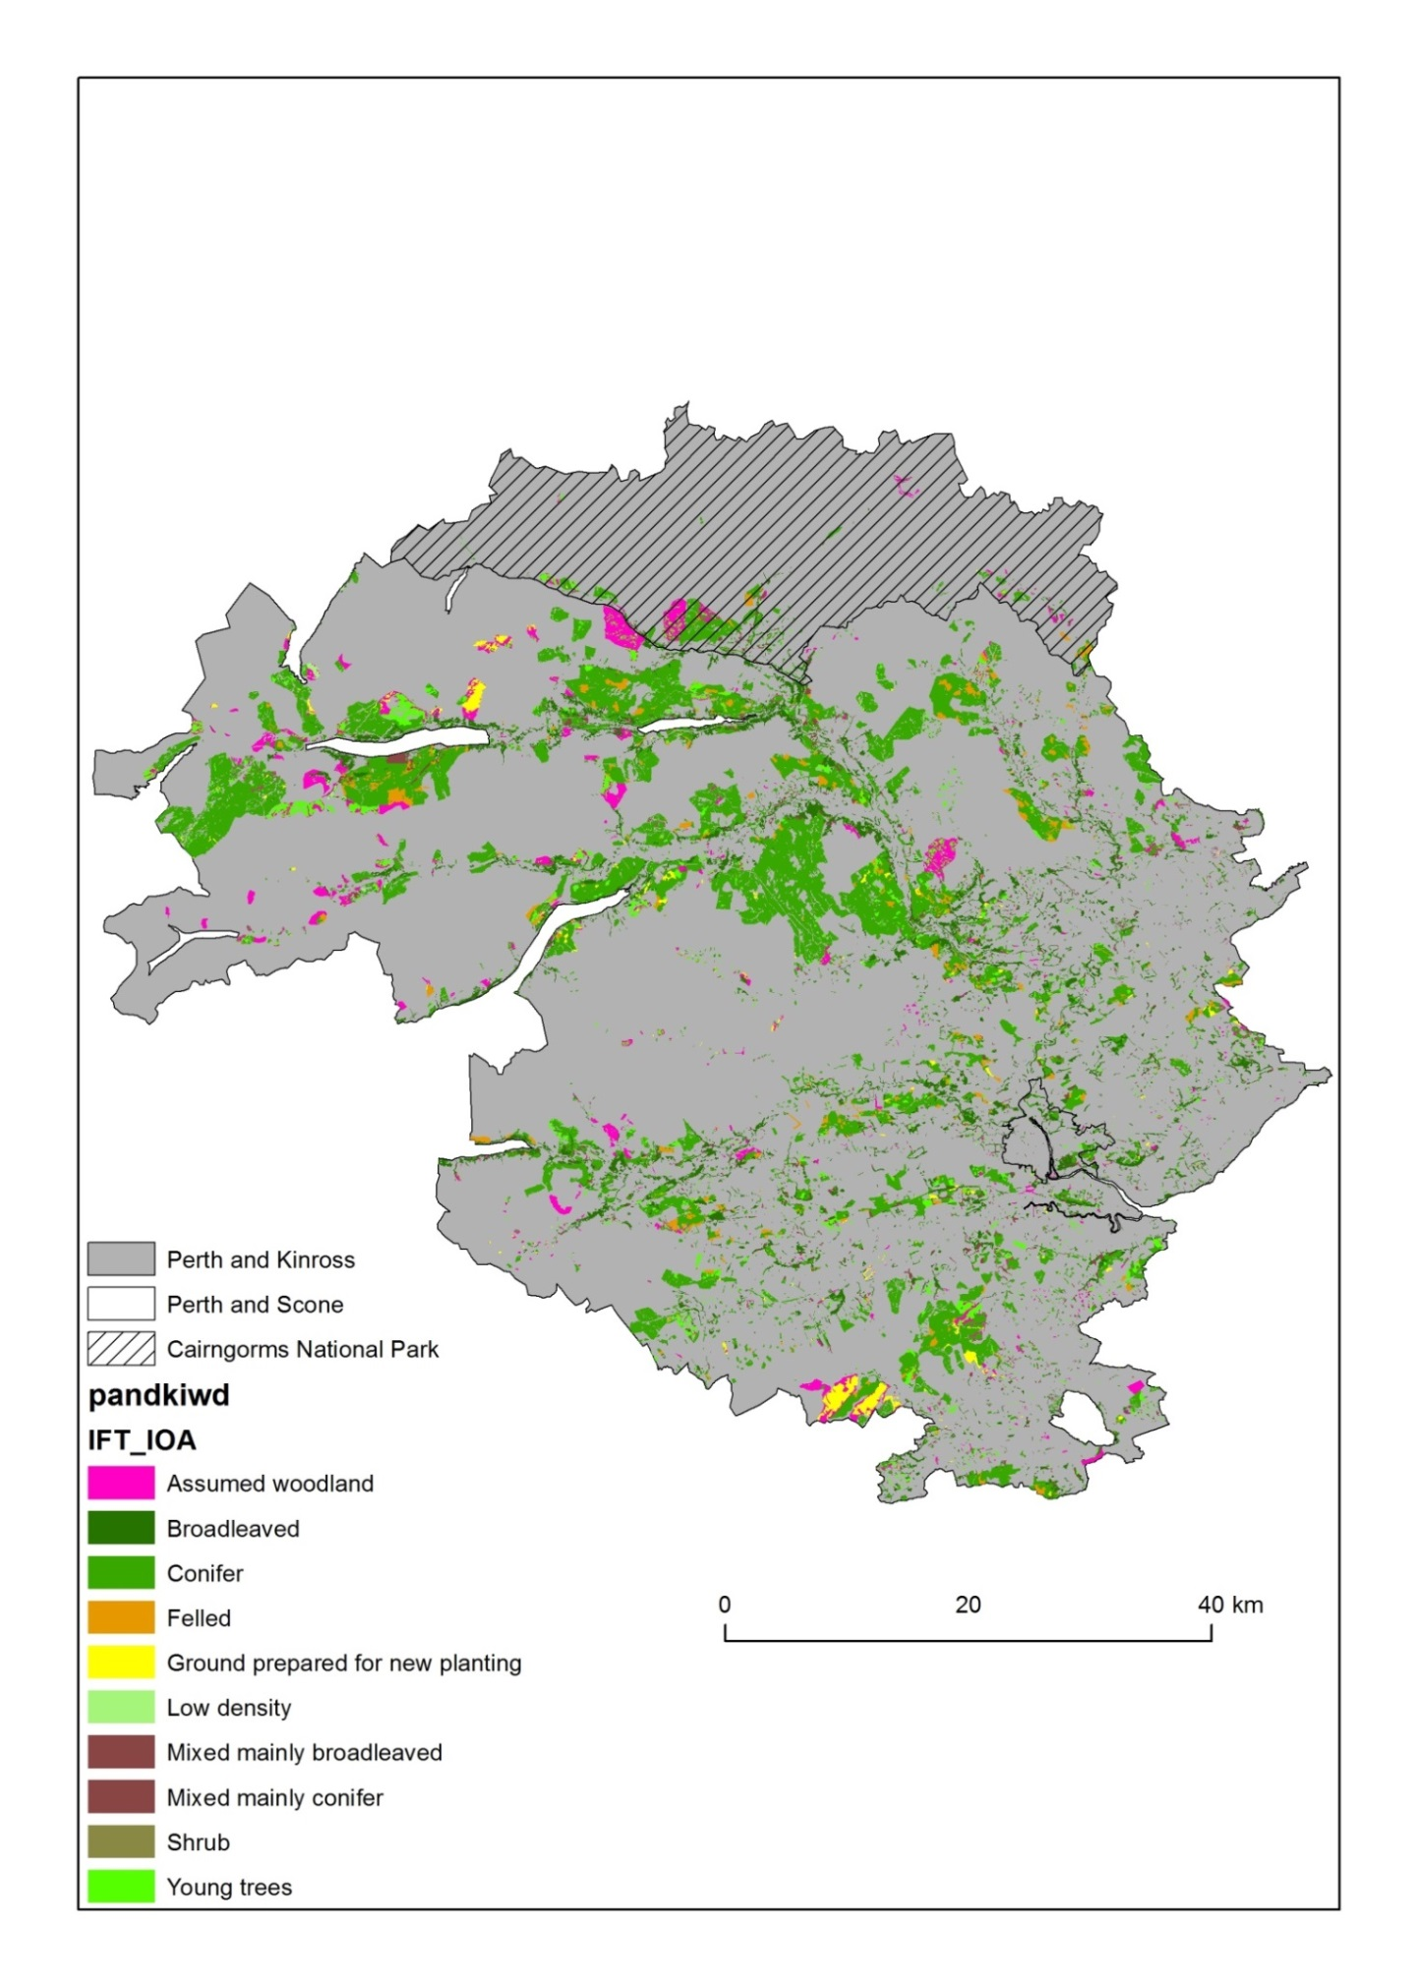
Map 45 Areas of woodland within the Perth and Kinross council area, based upon data from the National Forest Inventory Scotland, 2012. (For copyright and acknowledgements, see Appendix 1)
(combined categories)

3.5. Sporting use
Perth and Kinross has a substantial area of land used for sport shooting and one of the three major salmon rivers in Scotland. Much of the land based shooting is on mixed use land where there is an agricultural component, but some land will be predominantly shooting land. There has been an increasing trend towards let shooting and therefore the commercialisation of sport shooting. According to local expertise in the area, there are ‘reasonably effective local supply chains’ connecting to local demand. There is one significant processor of game products based in Pitlochry which sells direct and through country/farmers markets both within Perth and Kinross and further afield.

3.6 Renewable Energy
Perth and Kinross has a high potential for renewable energy. The council has recognised this and actively promoted renewable energy especially smaller scale renewables.
There is a long history of small scale hydro-power on estates and there are some larger hydro-electric schemes on the Tummel which generate just under 250MW of power and other schemes in other parts of the council area such as Breadalbane which add another 120MW of output. There have been a number of newly developed sites in the area. One new development in the area breached environmental regulations and led to significant fines to the construction company.
The higher parts of Perth and Kinross have good wind speed and there is significant technical potential for wind energy. Wind farm developments have proved particularly contentious, but the nearby Fintry development in Stirling with a community share has attracted considerable interest as a model for future developments.
Map 46: Wind farms, scoped, planned and installed in Perth and Kinross
(Source SNH 2013)
The significant forest estate in the region and its proximity to some of the more significant settlements creates an opportunity for wood energy businesses. The council has provided some pump priming of wood supply chains by putting wood heating schemes into secondary schools such as at Pitlochry High School. This sector is developing strongly.
Generally anaerobic digestion has developed rather slowly in the UK. It is not known if there are any examples in Perth and Kinross

3.6. Access and recreation
Perthshire has many high quality opportunities for outdoor recreation. The accessibility of the area to the major population concentration of central Scotland is likely to increase the demand. The major types of opportunity include water and waterside recreation; hill walking -there are nearly 30 Munros including some of the most iconic mountains in Scotland such as Schiehallion and ben lawers; forest recreation- the area is marketed as Big Tree Country’; and wildlife watching which includes sites such as the Scottish Wildlife Trust’s Loch of the Lowes visitor centre. There are numerous cycling trails listed on websites but perhaps surprisingly no major mountain bike trails development in the area.
The Enchanted Forest project has operated for ten years and has transitioned from publicly run event to a Community Interest Company. It runs for approximately three weeks each autumn and in 2013 it attracted 40,000 visitors.

Key issues in rural Perth and Kinross in the period 2014-20

4.1 Ageing
Rural Perth and Kinross has an ageing population. It is ageing faster than the Scottish average, which indicates either elderly person in-migration or young person outmigration. An ageing population can be a negative force in that it places increased demands on social services or it can be a positive force when retired people with high levels of social and human capital and with reasonable amounts of wealth become important actors in local development and use skills acquired during their working lives to support community-based projects.
The very high proportion of people of pensionable age in two or three datazones indicates either a concentration of care homes or high levels of elderly person in-migration to their own homes. Where the proportion of retired people is around 40% of the total this merits attention, because of the potential demands it places on voluntary or public support systems.
Given the high quality of the natural environment, the clear desire of people to move into Perth and Kinross and the fact that a significant number of these are elderly, there seems to be a strong case for exploring the scope to create customised housing developments which meet the needs of elderly people. Private companies do provide such developments, but there may also be an opportunity for co-operative models. Such developments could be associated with the provision of specialist services for elderly people, and, as in parts of Scandinavia become a platform for local development.

4.2. Mobility and service accessibility
Rural Perth and Kinross includes some relatively densely populated rural areas and some very lightly populated areas. For those living in the remotest communities, access to services can be a challenge, especially for those without access to private cars. Levels of car ownership are generally rather high, even for poorer rural households, which mitigates the problem but fuel costs in rural areas tend to be rather higher than in larger urban centres.
Access to services is most challenging where the public transport network is thin and timetables such that travel to and from market centres is difficult. Where there are small settlements at a distance from major bus routes along the A9 or A90, access to public transport may be particularly challenging for the mobility impaired.

Many rural areas operate informal schemes through which access-impaired households or individuals are helped by good neighbourliness. The extent of these is unknown and there is no guarantee that an access-impaired household or individual can draw on such support when needed, but a deeper exploration of just how challenging it is for isolated and non-car owning rural households to access basic services such as healthcare, food shop and post office might beneficially be undertaken.

4.3. Housing
Rural Perth and Kinross is typical of many rural areas. It contains some areas where the proportion of the housing stock which is old is rather high and areas in peri-urban and commuter villages where there is a much greater proportion of new stock.
Generally, private and publicly owned housing is better insulated than private rented housing. Fuel poverty levels are likely to be highest where there are high level s of private rented housing. A strategy is in place to address fuel poverty but, arguably, the steeply rising fuel prices of recent years will have increased the number of households in fuel poverty rather than reduced it as is the explicit intention of the Perth and Kinross Fuel Poverty Statement of 2011 (see Map 47).
Map 47: Fuel Poverty Index Rank for Perth and Kinross
Source Perth and Kinross Council, 2011

4.4 Energy
Rural Perth and Kinross has high potential for a range of renewable energies including water power, wind and wood energy, with a range from very large-scale installations to micro-scale installations. Most of the large-scale energy infrastructure is Scotland externally owned (although this is not technically the case in Perth and Kinross where Scottish and Southern Energy is based, which owns all the large scale hydro-electric capacity).
From a rural development perspective, local private, so-operative or community (trust) ownership is considered to be a valuable means of generating local income (especially for local development trusts) and can provide a diversified income source for farms and estates.
However, renewable energy developments can also be socially divisive and generate strong opposition from some groups. This applies especially to wind but is also applicable to some hydro-electric developments, especially where impeded migration of salmonds is seen as problematic by fishing interests.

4.5 Income and income distribution and rural deprivation
Rural Perth and Kinross is relatively prosperous compared to many parts of rural Scotland, but one of the consequences of a generally rather high level of income is that disadvantaged groups may find that they are even more disadvantaged. High levels of car ownership reduce the availability and affordability of public transport; high demand for housing for commuting, retirement or second home reduces availability to poorer households and bids up the price.
Rural poverty is characterised by its diffuse nature (hence its non-appearance on SIMD which picks up concentrations of disadvantage) and the tendency for it to be compounded by local economies that are geared to a generally high level of affluence.

In-migration and immigration
We do not have detailed evidence at SNS level of in-migration, but Perth and Kinross has a rapidly growing population which, given the relatively high average age, indicates that it must be arising from in-migration rather than natural change.
The Eastern Perthshire area makes use of a very significant seasonal agricultural labour force, many of whom come from Eastern Europe. The labour-intensive nature of most fruit picking places demands on accommodation. A recent Joseph Rowntree publication (Scott et al. 2012) which included survey work in Perth and Kinross and four other study areas concluded:
‘The central message is that low-wage migrant workers in the UK continue to experience exploitation; that this exploitation occurs both within the workplace and through the provision of substandard accommodation; that employers and employment agencies are culpable; and that competitive pressures may drive some of the exploitation observed.’
Clearly different parts of rural Perth and Kinross experience very different types of in-migration, from migration for retirement, to migration into the region for reasonably priced homes (especially in Kinross for access to Edinburgh) to seasonal migration for work in hospitality, catering, food or farming industries.

4.8 Integrated land use
The Scottish Land Use Strategy appeals inter alia for enhancing the opportunities for synergy between different land uses, and seeking to enhance the blend of ‘ecosystem services’ including public goods like biodiversity, landscape and flood management as well as ensuring that the provisioning services of food timber and energy are delivered. These synergies can span two productive uses such as between forestry and agriculture, through shelter belts, or forestry or farming and hydropower. There are a number of practitioners of agro-forestry in the council area who would argue that there are distinct benefits to woodland grazing systems. There are strong arguments for considering whether floodplain and headwater planting can reduce flood risk in flood-prone settlements, as has been implemented in pilot schemes in some parts of Scotland.
The Land Use Strategy also seeks to reduce land use conflicts. Conflicts can arise for a variety of reasons, including disagreements about certain land uses such as renewable energy, game disturbance by walkers, and threats to biodiversity on more intensive sport shooting estates. Various strategies can be put in place to minimise conflict and enhance opportunities for synergy.

4.9 Local supply chains
Perth and Kinross Council has been actively promoting the development of local food supply chains. It is inevitable that much of the intensive field vegetable and soft fruit production which is strongly concentrated in Eastern Perthshire will be geared to a large degree to national supply chains. However, there is still scope to have a vibrant local food sector. Perth and Kinross have several farmers’ and country markets and a significant number of suppliers of speciality foods. Not every community has the critical mass to develop farmers markets, but there is also scope for direct sales and farm shops, with Perthshire having some excellent exemplars of good practice in direct retailing of food.
Local food and wood energy chains can help retain value in the community, connect to the significant tourism industry thereby helping to green the tourism product, and help create an identity for Perth and Kinross which is consistent with Scottish food industry strategy and builds on the considerable range of food products produced in the region.

4.10. Differential development over space
Social and economic development is rarely uniform over space and such variations in socio-economic wellbeing operate at different scales, from households, to neighbourhoods, to districts, to regions. As indicated above, rural Perth and Kinross is relatively prosperous compared to some parts of rural Scotland. The most deeply rural areas have seen modest demographic decline, with low profitability and falling numbers of stock on hill and upland farms and sheer remoteness likely causal influences on that decline, and their economic performance is relatively poor, but relative disadvantage of rural socio-economic conditions is most clearly evidenced in the Blairgowrie/Rattray area, where performance is poor on a range of indices, certainly against a rural Perth and Kinross benchmark and even against a Scottish benchmark. Some datazones in the Crieff area also exhibit relatively poor performance.

Some of the differences are likely to be structurally determined- that is they are a product of structural forces in the economy - such as the closure of major industries where such industries have been a major part of local economies. Such forces often trigger a wider cycle of socioeconomic decline. Such an argument has been used in relation to the decline of hill farming districts in a recent SAC report and the mill town or coal mining community problem.
However, behind these negative socio-economic forces are a number of positive socio-economic trends such as the desire of affluent people to live or spend leisure time in rural areas. This brings an injection of wealth and especially where associated with permanent in-migration can be seen to have a beneficial local multiplier. Such an ingress of wealth can have a downside on poorly paid rural households, because of issues such as declining public transport and relatively high house prices (or rentals), but the alternative of depopulation and rural decline may be even more negative.
A further factor in rural wellbeing may well be the strength of social capital and the capacity for bottom-up community activity. There is good evidence of community activity in a many rural Perth and Kinross communities. Some of local development trusts are highly active. There are also a number of support schemes such as the Climate Challenge Fund that local communities can bid into and hopefully draw down support for energy savings initiatives. As is the case with community development trusts, the capacity of communities to create vibrant futures will be at least in part influenced by their capacity to bid successfully for external funding, whether it is Leader money or support from other projects.

Concluding comments
Rural Perth and Kinross has considerable strengths from a socio-economic/rural development perspective. It is favourably located with respect to commuting. It has an attractive and diverse rural landscape which produces attractive living and recreational space. Its population is overall increasing although some rural areas have experienced modest declines.
Its rural economy is relatively robust. There are few parts of the council area that fall outwith travel to work areas of Perth and Pitlochry and the attractiveness of the region means it has become a residential choice for some commuters to Edinburgh and Dundee.
The area has a strong identity as a place for tourism, but it is a mixture of high quality tourism and lower value tourism. Quality improvements that connect to the natural resource base and local suppliers would add value to the tourism sector and strengthen linkages with other sectors.
The areas of greatest disadvantage are some of the small towns and possibly some sub-areas within these towns, where socio-economic performance is poor against a range of criteria. Unpacking the SNS data reveals some deep-seated pockets of disadvantage and poverty.
The environment is a major attractant in Perth and Kinross. There are some very high level designations and important nature reserves. However, the area is mostly ‘not a national park’ and the nearby national parks (which just come into Perth and Kinross) may offer a stronger draw for some overseas and UK tourists.

The significant number of good hill and mountain walking opportunities are an important attractant but the lack of a high quality mountain biking destination may mean the area has missed out on a rapidly growing segment of activity tourism. However, the Big Tree label is a useful selling point and the Enchanted Forest event has been successfully handed over to a Community Interest Company.
Perth and Kinross’ farm sector is diverse and some elements of it are leading-edge, especially the soft fruit sector, but it has also shown capacity for diversification into for example direct sales and farm tourism. Although the farm sector has experienced some reduction in stock and workforce, especially in the Highland Perthshire area, the farm sector is essentially robust and the overall farm workforce growing.
The forest sector is diverse and also contributes significantly to green infrastructure. Although rural Perth and Kinross has no major wood processing facility in terms of large sawmills, it has developed its wood energy sector rapidly and there are some strong SMEs in the region providing wood energy, including some large scale plants such as that at Gleneagles. There is almost certainly capacity for growth in wood energy systems.
Across the piece, there are some very good examples of successful dynamic adaptive communities and businesses. Rural Perth and Kinross’ challenge is to identify the best means of taking these examples of good practice and rolling them out more widely, recognising that the deep-seated disadvantage of some places will create a long-term need for capacity building for local empowerment.

Appendix 1: Copyright acknowledgements for maps

The following table details the acknowledgements for maps 1 to 45 within this document.
Maps | Acknowledgements
1,3,5,7,8,10,12,14,16,23,25 | Contains data derived from Ordnance Survey data © Crown copyright and database rights (2014). Ordnance Survey Licence number 100016971. Contains data derived from Scottish Data Zone boundary data: © Crown copyright. Data Zones 2011. Scottish Government. Contains Ordnance Survey data © Crown copyright and database right (2014). Contains data derived from map within Perth and Kinross Community Planning Partnership (2013) Community Plan/Single Outcome Agreement 2013-2023 (page 8). Contains data derived from Scottish Neighbourhood Statistics data: Scottish Neighbourhood Statistics © Crown copyright (2014), licensed under the Open Government Licence v2.0.
2,4,6,9,11,13,15,17,18,19,20,21,22,24,26 | Contains data derived from Ordnance Survey data © Crown copyright and database rights (2014). Ordnance Survey Licence number 100016971. Contains data derived from Scottish Data Zone boundary data: © Crown copyright. Data Zones 2011. Scottish Government. Contains Ordnance Survey data © Crown copyright and database right (2014). Contains data derived from map within Perth and Kinross Community Planning Partnership (2013) Community Plan/Single Outcome Agreement 2013-2023 (page 8). Contains Scottish Neighbourhood Statistics data: Scottish Neighbourhood Statistics © Crown copyright (2014), licensed under the Open Government Licence v2.0.
27 | Contains data derived from Ordnance Survey data © Crown copyright and database rights (2014). Ordnance Survey Licence number 100016971. Contains data derived from Scottish Data Zone boundary data: © Crown copyright. Data Zones 2011. Scottish Government. Contains Ordnance Survey data © Crown copyright and database right (2014).
28 | Contains Ordnance Survey data and data derived from Ordnance Survey data © Crown copyright and database rights (2014). Ordnance Survey Licence number 100016971. Contains data derived from Scottish Data Zone boundary data: © Crown copyright. Data Zones 2011. Scottish Government. Contains Ordnance Survey data © Crown copyright and database right (2014).

29-32 | Contains data derived from Ordnance Survey data © Crown copyright and database rights (2014). Ordnance Survey Licence number 100016971. Contains data derived from Scottish Data Zone boundary data: © Crown copyright. Data Zones 2011. Scottish Government. Contains Ordnance Survey data © Crown copyright and database right (2014). Contains data derived from Scottish Natural Heritage Protected Areas data: Copyright Scottish Natural Heritage Contains Ordnance Survey data © Crown copyright and database right (2014).
33-44 | Contains data derived from Ordnance Survey data © Crown copyright and database rights (2014). Ordnance Survey Licence number 100016971. Contains parish geographies data: (Copyright Scottish Government) Contains Ordnance Survey data © Crown copyright and database right (2014). Contains data derived from Agricultural Census data: data tables courtesy of Agricultural Census Analysis Team, Rural and Environment Science and Analytical Services, Scottish Government.
45 | Contains data derived from Ordnance Survey data © Crown copyright and database rights (2014). Ordnance Survey Licence number 100016971. Contains data derived from Scottish Data Zone boundary data: © Crown copyright. Data Zones 2011. Scottish Government. Contains Ordnance Survey data © Crown copyright and database right (2014). Contains data derived from National Forest Inventory Scotland data: Contains, or is based on, information supplied by the Forestry Commission. © Crown copyright and database rights (2014). All rights reserved. Ordnance Survey Licence number 100021242.

LEADER Working Group (2012) SRDP 2014-2020 LEADER Working Group: A Report to the Programme Manager SRDP
It is of importance to note that some village and urban datazones are not highly visible in map form. This applies particularly to Crieff and Blairgowrie Rattray. Datazones normally have between 500-1000 households.
All Perth and Kinross except Perth and Scone datazones
Bramley G and Watkins D., (2013) Local incomes and poverty in Scotland, Scottish Government.
Although caution should be taken in interpreting maps as large parishes will have more stock
Scott, S. et al. (2012) Experiences of forced labour in the UK food industry, Joseph Rowntree Trust
SAC, Farming’s Retreat from the Hills (2008) and Thomson, S., Response from the hills: Business as usual or a turning point? An update of “Retreat from the Hills” (2011)

