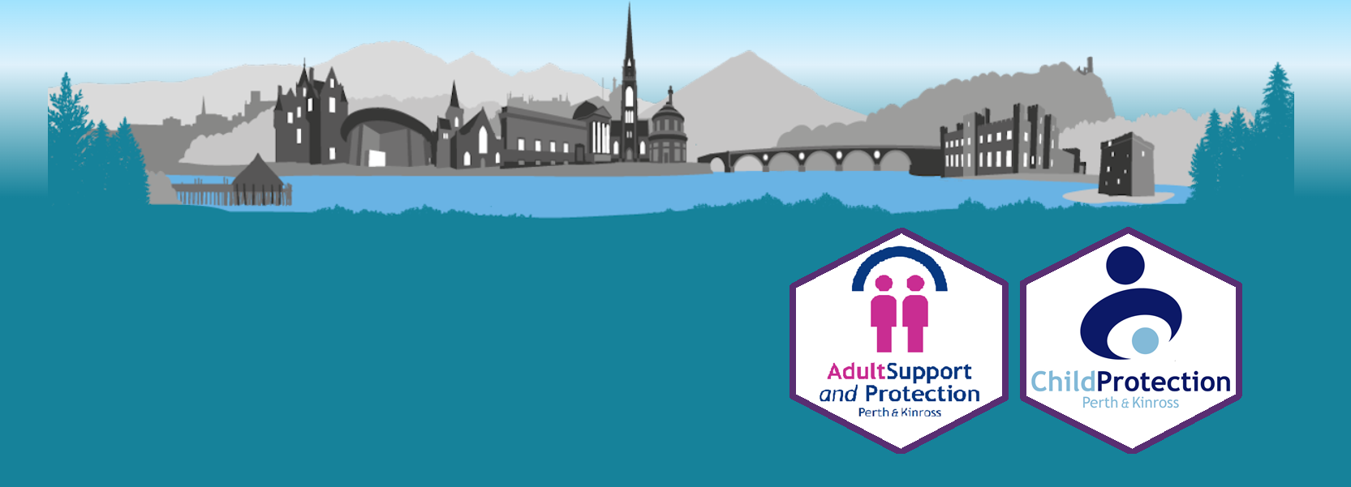

Safeguarding information
for Volunteers

What is Safeguarding?

We want Perth and Kinross to be the safest and best place in Scotland for children, young people, adults, and families to live, work and play. Safeguarding is what we do to protect the health, well-being, and human rights of individuals. Safeguarding allows children, young people, and adults to live free from abuse, harm, and neglect.

All professionals have a duty to protect vulnerable children, young people and adults, however it is actually everyone’s job.

As a volunteer it is important that you understand how to spot the signs of abuse and neglect and how to report any concerns that you may have.

What is Child Protection?

Child abuse in Scotland is considered when someone causes (or does not prevent) significant harm to a child. The abuse can be physical, emotional, or sexual. This includes child sexual exploitation, child trafficking, online abuse and witnessing domestic abuse. It can happen once or over a period of time and could happen within and outside the family. Physical and emotional neglect is child abuse. This is when a parent or carer does not look after a child properly, for example:

- failing to meet a child's basic needs, such as not providing food, warmth, clothing, a home or supervision appropriate for the child's age
- failing to meet a child’s emotional need for love and affection
- failing to get medical or mental health care

More about child protection here in Perth & Kinross can be found at:
https://www.pkc.gov.uk/childprotection

What is Adult Protection?

In Scotland, we consider an adult to be at risk when it is considered that they are:

- unable to safeguard their own well-being, property, rights or other interests
- at risk of harm (including physical, sexual, financial, or emotional harm, self-harm, neglect or self-neglect) and
- because they are affected by disability, mental disorder, illness or physical or mental infirmity, are more vulnerable to being harmed than adults who are not so affected.

You can find more about Adult Protection here in Perth & Kinross at:
https://www.pkc.gov.uk/asap

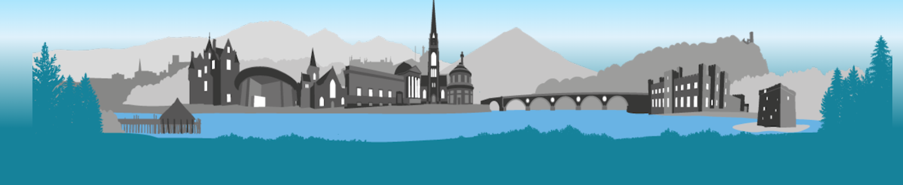

What I need to do

You need to know how to report your concerns. If you are worried about a child, young person, or adult you may wish to talk to them, listen calmly and reassure them that it is not their fault and encourage them to tell you what has happened. If you are unable to speak to the person directly that is okay, however it is important that you tell someone about your concerns.

If you believe a person to be at immediate risk of harm or in need of emergency medical attention, call the emergency services on 999. Otherwise, if you are worried about:

- a child or young person, please call social work on 01738 476768
- an adult, contact the Access Team on 0345 3011120.

For both child and adult protection concerns out with normal office working hours (8.45am – 5pm, Monday - Friday) phone: 0345 3011120

