|  |
| --- |
| **Mobile Toilet Application Form**  **(Please complete fully in block capitals)** |



1. **Organisation or Group**

|  |  |  |  |
| --- | --- | --- | --- |
| **Organisation / Group:** |  | | |
| **Address:** |  | | |
| **Town:** |  | **Postcode:** |  |
| **Telephone:** |  | **Mobile:** |  |
| **Email:** |  | | |
|  |  | | |
| **Contact details for named individual responsible for units / delivery** | | | |
| **Name:** |  | | |
| **Address:** |  | | |
| **Town:** |  | **Postcode** |  |
| **Telephone:** |  | **Mobile:** |  |
| **Email:** |  | | |

1. **Event Details**

|  |  |  |  |  |  |  |  |
| --- | --- | --- | --- | --- | --- | --- | --- |
| **Name of Event:** | |  | | | | | |
| **Have you applied before?** | |  | | | **Date** |  | |
| **Expected daily attendance** | |  | | | | | |
| **Location of event:** | |  | | | | | |
| **Is this a PKC owned site?** | |  | | | | | |
| **If yes, please confirm permission has been granted.**  **Please Visit** [Organising outdoor events - Perth & Kinross Council (pkc.gov.uk)](https://www.pkc.gov.uk/article/15345/Organising-outdoor-events) | | | | | | | |
| **Delivery details:** | |  | | | | | |
| **Start Date** |  | **Start time** |  | **Finish Date** |  | **Finish Time** |  |

1. **Charity Fundraising**

|  |  |  |  |  |
| --- | --- | --- | --- | --- |
| **Are you collecting for a charity**  **and donating funds** | Yes |  | No |  |
| *Details* | | | | |
| **Charity Number** |  | | | |
| *Are you charging entry for this event. If so, please provide details of charges* | | | | |

1. **Quantity of Units Applying For**

|  |  |
| --- | --- |
| ***Please use the chart overleaf to determine number required. If you are requesting more than 3 units, please refer to point 8 overleaf.***  ***\*please note allocation is dependant upon funding and units available*** | |
| **Standard units:** |  |
| **Disabled Units:** |  |

|  |  |
| --- | --- |
| **Applicant’s Signature:** |  |
| **Applicant’s Name (Blocked Capitals):** |  |
| **Date:** |  |

**Please return this form, arriving at least one calendar month in advance of event.**

Preferably by email to: [CommunityWasteAdvisers@pkc.gov.uk](mailto:CommunityWasteAdvisers@pkc.gov.uk)

Or alternatively by post to: Community Waste Team

Perth and Kinross Council

Communities – Waste Services

Pullar House

35 Kinnoull Street

Perth, PH1 5GD

Further advice can be obtained from: Community Waste Team on 01738 476476

**Office Use**

**Community Waste Team**

|  |  |
| --- | --- |
| **Standard Units Required:** |  |
| **Disabled Units Required:** |  |
| **Date Application Received:** |  |
| **Authorised by::** |  |
| **Date passed to Procurement:** |  |
| **Any additional comments:** |  |

**Waste Services Procurement Team**

|  |  |  |  |
| --- | --- | --- | --- |
| **Standard Units Ordered:** |  | **Date:** |  |
| **Disabled Units Ordered:** |  | **Date:** |  |
| **Supplier:** |  | | |
| **Authorised by::** |  | | |
| **Date:** |  | | |
| **Any additional comments:** |  | | |

|  |
| --- |
| **CRITERIA FOR PROVISION OF TEMPORARY MOBILE TOILET UNITS FOR COMMUNITY EVENTS**  Specified below are the criteria that groups or organisations must fulfil in order to be eligible for consideration to be supplied with temporary mobile toilet units for public events.   1. The application must be from a properly constituted organisation. 2. There should be a named contactable individual who will be responsible for the units on site, act as a Health & Safety link and be present at delivery and uplift. 3. The application must be made no less than one calendar month prior to the event taking place. 4. No free allocations for any event of less than 2 hours duration, except in exceptional circumstances. Free allocation will be for a maximum of 2 days. 5. If there are existing operational public toilets on site then mobile toilets will not be supplied. 6. A group or organisation will not be allocated units more than twice in a financial year. 7. The event must not be intended to make profits for anything other than that of a charity or the community. 8. If the organisation requires more than 3 units, then an application must be made in writing to the Head of Environmental and Consumer Services detailing reasons for special request. 9. Cleanliness of the toilets is to be the responsibility of the organising Committee. 10. Please note allocation is dependent upon funding and units available. |

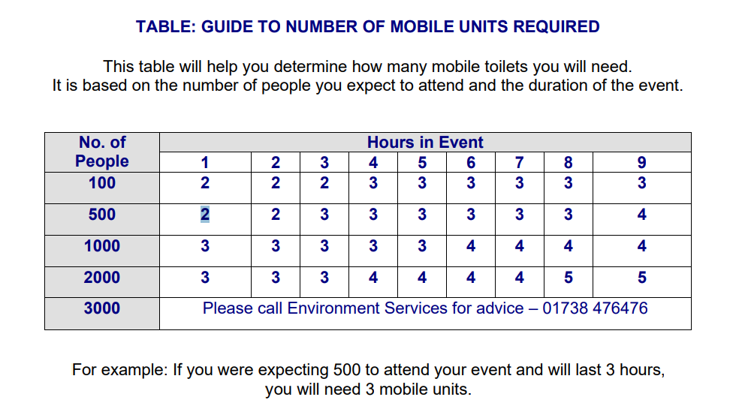

|  |
| --- |
| ***HOW WE USE YOUR PERSONAL INFORMATION***  *The information provided by you will be used by Perth & Kinross Council to assess eligibility and entitlement to mobile toilet units for your event. The information may be shared with the service provider.*  *The Council may check information provided by you or information about you provided by a third party, with other information held by us. We may also get information from certain third parties or share your information with them in order to verify its accuracy, prevent or detect crime, protect public funds or where required by law.*  *For further information, please look at our website www.pkc.go.uk/dataprotection email dataprotection@pkc.gov.uk or phone 01738 477333.* |