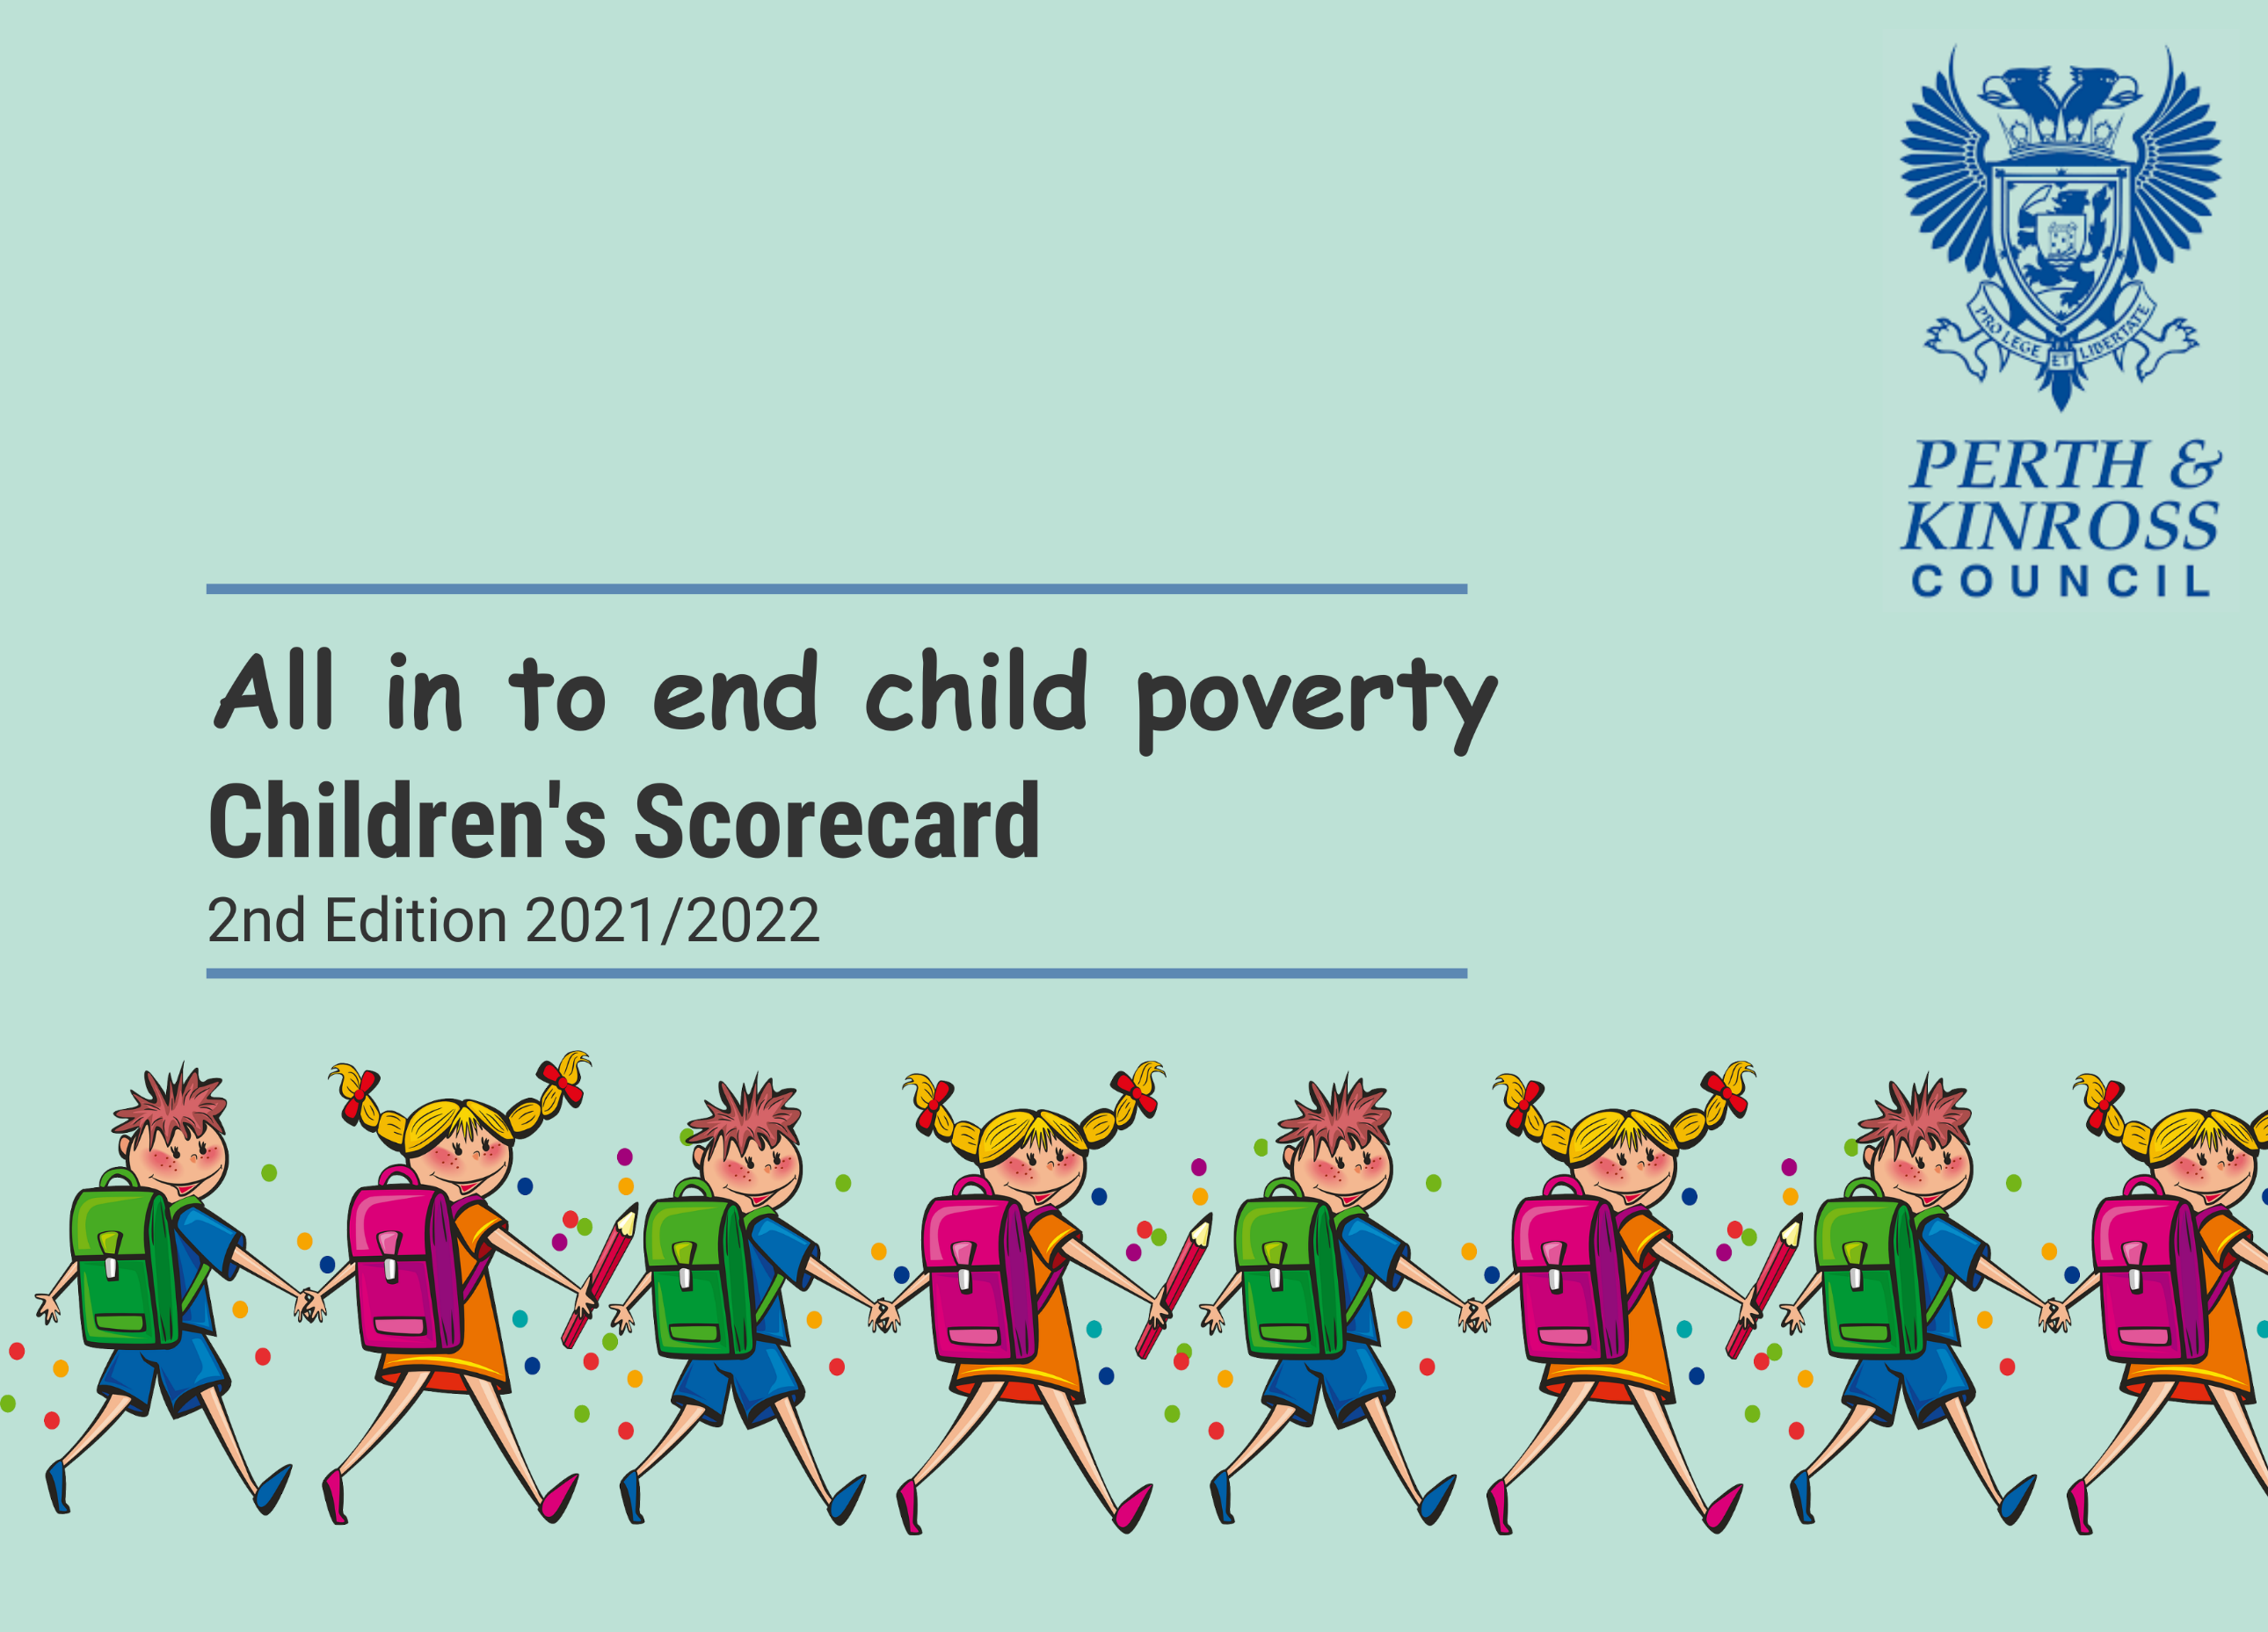

Background 3
What parents told us about poverty and their experience of our services. 4
Parental Experience of PKC Services 5
Section 1 - How our services responded 7
Section 3 - Measuring Child Poverty 29
References 35

Background

The Scottish Government set 4 ambitious interim and long-term targets to address the challenge of reducing child poverty.

The Scottish Government asked local authorities to consider how they can help achieve the child poverty targets by acting to
• Increase income from employment
• Reduce the essential costs of Living
• Increase income from social security and other benefits in kind.

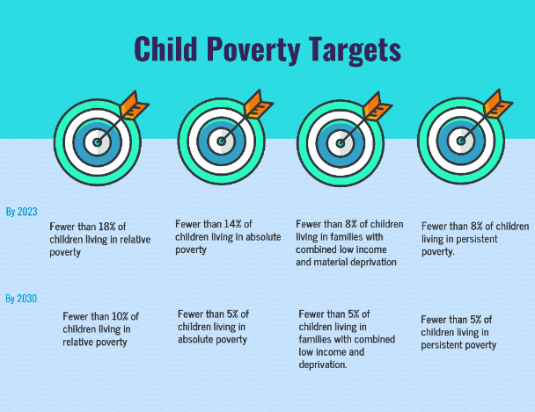
In response to this request, Perth and Kinross Council decided to go directly to parents and families affected by poverty to ask what help and support they needed to increase family income and reduce essential costs.

PKC commissioned research on the lived experience of families affected by poverty in Perth and Kinross. The research was conducted by the Poverty Alliance and the Scottish Poverty and Inequality Research Unit at Glasgow Caledonian University. The research was conducted between May and June 2021 and the report published in November 2021.

Parents identified areas where Perth and Kinross Council was doing well to meet their needs - and areas where they would like to see us doing something better or differently. We used this information to develop the first iteration of the Perth and Kinross Offer for children and families affected by poverty.

The Children's Scorecard identifies areas of accomplishment and areas of challenge. It will help us to evaluate our approaches to child poverty – and our delivery of the Perth and Kinross Offer for children and families affected by poverty.

This second year of the Children's Scorecard reports against the baseline established in 2020/2021. It sets out clearly those areas where progress has been achieved - and those areas where challenges remain.

What parents told us about poverty and their experience of our services.

Family experience of poverty
Intense poverty exists. There is evidence of abject poverty in Perth and Kinross. Sometimes, such poverty has is a passing intensity, which may be triggered by unforeseen circumstance (e.g., breakdown of a household appliance; loss of employment; change in family arrangements). Intense poverty may subside, rather than disappear, becoming an enduring challenge of seasonal pinch points, e.g., increased living costs during summer when children are not in school for part of the week, or in winter when energy bills are higher, and Christmas brings additional expense.
Family support. For those with access to it (which does not apply to all families experiencing poverty), the support provided by families – at critical stress points and in everyday life – is acknowledged and highly valued. Families are a key source of childcare support, and a resource that is drawn on in times of crisis.
Time pressure. Time pressures are reported by many families experiencing poverty. The challenges of managing children’s lives and the challenges of combining work and family life are the primary sources of this stress. Cost of living. Housing, transport, and food expenditure is reported to place strain on family budgets, particularly in rural areas.
Cumulative impacts. Many of the challenges faced by families experiencing poverty are encountered by other families. However, the difficulties in facing these challenges on a low income – without the ability to drawn on a safety net of financial resource – exacerbate these problems. Similarly, the cumulative impact and interaction of these problems impacts on family life.
Stigma. Many of the families described issues related to stigma, with narratives indicating stigmatisation was even experienced when accessing support.

Living in Perth and Kinross
Good place to live. On the whole, Perth and Kinross as a region, and the localities within, are viewed positively by families experiencing poverty. Opportunity for ready access to leisure, formal and informal, is widely appreciated.
Luck. Families experiencing poverty in Perth and Kinross often used the descriptor ‘luck’ to rationalise positive experiences. This conveys a sense of gratitude for what they have, and an acknowledgement that others may not be as fortunate as themselves. It also suggests that a sense of rights and entitlement does not prevail.
A Perthshire trade-off. Many families experiencing poverty accept or understand poor provision – for example in housing, or rural transport – as part of the price to be paid for where they live.

Parental Experience of PKC Services

Referrals work. There is much evidence of effective cross referral and integration of support pathways. Where this works, it is not received as being ‘passed on,’ but rather as being directed to the right source. Successful referrals were reported within services, and across services. Positive impacts of this included being connected to support in a timely manner which was critical for prevention of intensification of problems.
Key individuals. Many parents experiencing poverty made reference to a key individual who provided them with critical support and/or who ‘made things happen’. These interventions were often understood as someone going ‘above and beyond’ duty, rather than delivering routine service. These sources of key support were found across a range of service areas.
Individuals, Departments, and the Council. Although people experiencing poverty did not always praise individuals or specific departments/services, on the whole, there was much more evidence of positive than negative appraisal of service rendered. In contrast, “the Council” tended to be viewed more negatively.
How services are delivered. The way in which services are delivered is important. There were several examples of people experiencing poverty reporting that staff had shown a lack of empathy toward them or had failed to appreciate the situation in which they found themselves. Poor communication was noted for some, and public information was found to be lacking.
Utilising local sources of information. It was striking how many parents, turned to local sources for information about what was available to them. These local sources were not Council-led but were often informal groups that had emerged utilising platforms, such as Facebook or WhatsApp.
Housing. It was acknowledged that there was a housing shortage and that there was a long waiting list for Council housing. The lack of availability was leading people to accept whatever was offered, which was not always ideally suited to their needs, for example, some were living further away from family support, or living in accommodation without sufficient bedrooms.
Childcare. Childcare was a particular challenge for those in-work. Although all were aware of entitlement, availability did not always dovetail with need, and available provision often required additional cost to either access the provision, or to pay for additional hours beyond universal entitlement. Childcare was constraining opportunities to access paid employment.
Education. Schools were viewed positively and were often acknowledged as a source of wider information beyond education. School meals were not viewed to be meeting all children’s needs.
Leisure. Children were widely reported to be actively engaged in leisure and sporting activities outside of school. Families also reported utilising the local environment for seasonal ‘incidental’ leisure.
Transport. Transport services were viewed positively in the city of Perth. In contrast, the availability and cost of transport in rural areas was often criticised. There was understanding of the difficulty in delivering rural transport. Many families in rural areas reported the necessity of having access to a car.
Poor provision generates costs. Providing a service does not always lead to needs being met. Notably, with regards to housing, childcare and school meals, perceived inadequacies in provision led to family spend, e.g., paying extra for heating, paying for packed lunches where school meals do not meet children’s needs.
Poor provision generates work. Service inadequacies creates work for others. There is a need for systems thinking to reduce the overall workload, which would also be less time-consuming and stressful for services users. This does not only imply a shift of workload between organisations, but also leads to a shift of workload within organisations (for example, Welfare Support offering routine advice on availability/entitlement, as this information cannot be accessed independently with ease).

Section 1 - How our services responded

Wellbeing
Parents asked for
- Help for families with issues around mental health or wellbeing
- Timely support for mental health for children and young people experiencing stress/distress.
Indicators
- Information for families on sources of wellbeing and mental health support
- Funding for programmes or interventions to support the mental health and wellbeing of children and young people.
- Number of families with 0–2-year-olds in nursery provision
- Evidence of family centred, multidisciplinary working across social work, learning disabilities, addiction, and substance misuse
- Learning from social needs screening project is captured.

Indicator | Performance 2020 – 2021 | Desired Performance 2021/2022 | Actual Performance 2021 – 2022 | RAG Status
Information for Families on sources of wellbeing and mental health support | Parent Portal contains information on how to support wellbeing and where to go for help. | Parent Portal contains information on how to support wellbeing and where to go for help. | This has not been achieved. Work on delivering a comprehensive and accessible source of information has now commenced.
Funding for programmes or interventions to support the mental health and wellbeing of children and young people. | £50,000 to fund Home Start support for mental health of parent and children at home. Aberlour and Barnardo's funding. | Increase support available to children and young people experiencing wellbeing challenges | Funding for mental health and wellbeing support for young people was increased to £166,000. 220 families have received support
Number of families with 0–2-year-olds in nursery provision | 150 qualified (eligibility criteria) and 42 SFCF places | Increase the number of families entitled to a place, to access a nursery provision | All 199 children who were eligible received a placement.
Evidence of family centred, multidisciplinary working across mental health, learning difficulties, domestic violence, and addiction | Unborn Baby Multi Agency Support Group identifies pregnant women who need additional support. | Increase in referrals from partner agencies out with NHS Tayside. | Referrals increased from 7 to 8.
Learning from social needs screening project is captured | Learning from social needs screening project is captured | Social needs screening following all child concern reports identifies and addresses the impact of poverty on those families where there has been a child concern report raised. | This project has been put on hold. There will be a social needs screening workshop held in the summer of 2023 with colleagues involved in the Child Protection Committee.

Stigma and Dignity
Parents asked
- To be treated with empathy and understanding
- That service providers understand it can be difficult for parents to admit they are struggling to make ends meet and ask for help.

Indicators
- All Frontline Workers and Service Managers to complete Child Poverty Training
- Where possible to streamline requests for Council concessions
- Initiatives taken to reduce stigma promote dignified entry points for help and support.

Indicator | Performance 2020 – 2021 | Desired Performance 2021/2022 | Actual Performance 2021 – 2022 | RAG Status
All Frontline Workers and Service Managers to complete Child Poverty Training | A Child Poverty Training Programme with experiential learning is in development. | All locality frontline workers and managers complete course | Training programme under development for roll out next year
Where possible to streamline requests for Council Concessions | A working group has been established to look at streamline of Council concessions | Streamlining of Council Concessions is maximised. | Free school meals and school clothing grants streamlined
Initiatives taken to reduce stigma and promote dignity | The Council takes a Cash 1st approach to promote dignity. Further work is required in this area to identify dignified entry points for all help and support provided whether in cash or kind | Cash 1st approaches on a range of benefits from etc  - Crisis Grants  - Community Care Grants  - Discretionary Housing Payments  - Financial Insecurity Funding  - Tenancy Sustainment Fund | Client financial gain £5,335,311 secured by Welfare Rights team; £3.62m in Cash First distributed
* Cash First for this purpose is defined as a range of measures geared towards income maximisation and reducing in-kind support.

Crisis Support
Parents asked for
- Accessible information on sources of help and support for parents in crisis - money, welfare benefits, in-kind support
- Help accessing support in times of crisis when they are experiencing stress
- Key worker approaches - where one person helps source support across a range of organisations
- Help with form filling and navigating the welfare benefits system
- Cash First Approaches Welfare Benefits Checks/Money Advice offered to Council employees
- Support for Foodbanks and Community Groups offering in-kind or crisis support.
Indicators
- Accessible information is provided on where to get help across a range of print, digital and social media platforms
- Families to be offered welfare benefits check
- Key Worker and Social Prescribing Approaches deployed
- Cash 1st Approaches deployed where possible
- Welfare Benefits check/ Money Advice to be offered to all PKC employees
- Funding and support for Community and Third Sector Groups offering crisis support to families.

Indicator | Performance 2020 – 2021 | Desired Performance 2021/2022 | Actual Performance 2021 – 2022 | RAG Status
Accessible information is provided on where to get help across a range of print, digital and social media platforms | Feeling the Pinch (Winter) and struggling to feed the Family (Summer) awareness campaigns provided across print, digital and social media platforms. Winter Feeling the Pinch achieved 250,000 hits. Struggling to Feed the Family lea | Cost of Living Crisis public awareness campaign focussing on benefits, energy efficiency, food and crisis support planned | Cost of Living campaign: https://www.pkc.gov.uk/costofliving  Cost of Living Advice - Food Support
l families will be offered a welfare benefits check. | Data cited in this column last year was applicable to 2021-22 | Data cited in this column last year was applicable to 2021-22 | At present our data collection methods do now allow us to measure how many families have taken up this offer. Overall client financial gain of £5.3m was achieved across all households.
Key Worker and social prescriber approaches deployed | 6 Social Prescribers funded via H&SCP to provide support to vulnerable clients | Social prescribing and social needs screening is in place across Perth and Kinross | All 23 GP's surgeries have access to a social prescriber. In a snapshot week in Oct 2022, 7 social prescribers were supporting an average of 20 clients each.
Welfare Benefits/Money Advice to be offered to all PKC employees | Welfare Benefits advice is offered to all employees. | Welfare Benefits advice is offered to all PKC employees | Welfare Benefits advice is offered to all employees on an ongoing basis.
Funding and other support for Community and Third Sector Groups providing crisis support to families. | £20,000 to Perth Foodbank; £256,000 provided for Eating Well Living Well and Community Food Initiatives. Food Co-ordinator Post funded to support community and emergency food provision. 17 Breakfast Clubs operate across PKC. £17,100 to Pink Saltire and £20,000 shared between 3 Gypsy/Traveller groups | Funding and Support to Third Sector Organisations supporting families affected by poverty increases | £170,142 was provided in funding for emergency and community food.  43 community groups received financial support for Living Well and Community Food Initiatives.  19 people were trained via the Community Cook-It skills training programme.

Housing
Parents asked for
- Increased supply of affordable housing
- Ensure houses are let in a good state of repair
- Improved Communications.

Indicators
- Number of new affordable houses built
- Number of affordable homes let from PKC own stock
- Number of families housed with affordable rents guarantee
- Take-up of Tenancy Sustainment Fund
- Number of families housed with Rent Bond Scheme
- Satisfaction rates at Settling-in Visit.

Indicator | Performance 2020 – 2021 | Desired Performance 2021/2022 | Actual Performance 2021 – 2022 | RAG Status
Number of new affordable houses built | 183 built between April 21 and Jan 2022 | 600 affordable homes built by 2027 | Delivered 310 new affordable homes We exceeded our Local Housing Strategy Target of 150 Affordable Homes by 160.
Number of affordable homes let from PKC own stock | 600 voids were let between April 21 and January 2022. There has been an increase in the number of lets (15.5%) which is due to the new build programme and the vacancy chains this creates | Increase in number of houses available for let arising from new build programme and vacancy chains it creates | There were 826 ‘general needs’ lets and 46 ‘supported housing’ lets
Number of families housed with affordable rents guarantee | 157 houses have been let with the affordable rents guarantee - 54 of which were supported with grant funding via the EHI scheme. | This figure cannot be predicted as it is demand-led. | 175 houses have been let with the affordable rents guarantee
Take-up of Tenancy Sustainment Fund | 216 referrals have been either approved or partly approved. 100.49% of the budget has been paid with a further 12.88% committed | Ensure the budget is me | £200,000 has been paid in Tenancy Sustainment payments to 558 households to clear arrears and reduce
Number of Families housed with Rent Bond Guarantee Scheme | 143 households have been rehoused with the Rent Bond Guarantee Scheme . | This figure cannot be predicted as it is demand-led. | 175 households have been rehoused with the Rent Bond Guarantee Scheme
Satisfaction rates at Settling-in Visit | 642 Settling-In visits were due to be undertaken between April 21 and Jan 2022. The completion rate for the year to date is 79% | Target 90 | 793 settling in visits were completed between April 21 and March 22. 70% were satisfactory

Education
Parents asked for
- Information about help available to struggling families
- Information on how to access help around school costs with assurance that these will be handled discretely and sensitively Improvements in the quality of school meals
- Affordable after-school provision to support parental employment.
Indicators
- Availability of information to support families via print, social media, and web-based tools
- Schools inform parents on how to request support providing clarity and reassurance that all requests will be handled sensitively
- Increased Take-up of school meals across all ages
- Number of affordable after school and wraparound childcare places
- Further engagement with partner provider nurseries to meet commitment to Living wage
- Cost of the School Day considered and enacted by all schools.

Indicator | Performance 2020 – 2021 | Desired Performance 2021/2022 | Actual Performance 2021 – 2022 | RAG Status
Availability of information to support families via print, social media, and web-based tools | ‘Struggling to feed the Family’ leaflet distributed prior to summer holidays  Information on Fuelled for Fun, School Holiday Programme and emergency food provision shared with parents. | Information on support available for parents and families is shared before each holiday period signposting parents to help with food, fuel, holiday activities, access to mental health support and other issues of concern | Struggling to feed the family leaflet  Cost of Living campaign: https://www.pkc.gov.uk/costofliving  Cost of Living Advice - Food Support
Schools inform parents on how to request support providing clarity and reassurance that all requests will be handled sensitively | information on how individual schools provide this has not been gathered | Parents are informed on how to ask for help with costs associated with school and it is explained how requests will be handled | We are working with all of our schools and settings to provide guidance and support on reducing the costs of the school day but have more work to do to ensure these messages are consistent and clearly communicated, including matters relating to the confidential handling of information.
Increased take-up of school meals across all ages | 8249 pupils are registered for free school meals (73.5% of Primary and 9.2% of Secondary Pupils). 66% of those registered for free school meals took them on the register day. | Increase number of pupils taking up a free school meal. | Pupils Registered and Taking Free Meals (Primary) (includes all stages P1-P7 where UFSM exists): 4,796 (68.4%) Registered: 7544 (73.4%) Pupils Registered and Taking Free Meals (Secondary): 364 (64.9%) Registered: 705 (9.2%)
Number of affordable after school and wraparound care places | 3 Out of School Care Clubs, 3 Kids Clubs, 3 Wraparound Care Services and 6 Holiday Care Services are provided | Increase number of children using after school and wraparound care places | 498 free sessions were created in 7 holiday Kids Clubs and Wraparound Care services over Summer and October holiday periods, each session offering up to 7 hours of free childcare, lunch, and snacks for children within the 6 priority family types
Further engagement with partner provider nurseries to meet commitment to Living Wage | All partner provider nurseries show commitment to meeting Living Wage | Confirmation that funded providers are paying the real living wage or when they intend to be paying as per contractor commitment and funding allows. | 76% of Funded Providers are paying the Real Living Wage to all staff supporting the delivery of funded ours of early learning and childcare for 3–5-year-olds.

Childcare
Parents asked for
- Increased access to accessible and affordable childcare
- Flexible childcare options to support parental employment
- Accessible information on available childcare options, places, and costs.

Indicators
- Number of communities supported to develop their own childcare solutions
- Number of childcare places provided by PKC
- Number of childcare places available across public, private and third sectors
- Number of childminders working in partnership with PKC.
- Development of Childcare Information Website.

Indicator | Performance 2020 – 2021 | Desired Performance 2021/2022 | Actual Performance 2021 – 2022 | RAG Status
Number of communities supported to develop their own solutions | Out of School Care - Pitlochry; 8 Safe Start Services delivered across Perth & Kinross. | Communities interested in developing their own provision are well supported by the central ELC team to progress towards set up. | 4 communities supported to develop childcare solutions.
Number of childcare places offered by PKC | 51 ELC settings are provided with capacity for approximately 2000; Third sector provides 34 settings with capacity for approximately 1000; Childcare provision includes 12 kids’ clubs offering 401 places and 3 WAC settings offering 124 places. | Flexible childcare solutions are offered to parents across all ELC communities in Perth & Kinross. Children settle well and make good progress in their learning and development. Parents are happy with the level of provision and child experience. | 5538 childcare places offered by PKC
5538 childcare places offered by PKC | 5538 childcare places offered by PKC | There are sufficient childcare places across Perth and Kinross to support parental employment | 6394 childcare places (LA and Third Sector) Private places not known
Number of childminders in partnership with PKC | 20 childminders offer 30 places | Flexible childcare places solution available to all parents across ELC communities in Perth and Kinross. Children settle well and make good progress in their learning and development. Parents are happy with the level of provision and child experience. | 18 childminders are now in partnership with PKC.
Childcare Information Website | Parents can use the "Find my nearest Childcare" via the Perth and Kinross Council website | Parents have easy access to information they need regarding childcare. Development of web-based one stop information point encompassing childcare. | 3,955 parents used the 'Find my Nearest Childcare' website in a 12-month period

Transport
Parents asked for
- Improved transport links in rural areas to support parental employment patterns
- Affordable local transport options.
Indicators
- Take-up free bus passes for under 22s
- Information on discounted tickets/travel
- Increase in the number of community transport schemes - especially within rural areas
- Support for Community Transport Groups
- Establishment of on-demand responsive transport schemes.

Indicator | Performance 2020 – 2021 | Desired Performance 2021/2022 | Actual Performance 2021 – 2022 | RAG Status
Take-up of free bus travel passes for under 22s | 4000 applications processed between January and March 2022. | 26,000 bus passes issued to all aged 5 - -21-year-olds | 01/01/22-31/03/22: 5912 cards issued
Information on discounted tickets and travel schemes in Perth and Kinross | This is not something currently undertaken by Perth & Kinross Council. | Information on discounted travel tickets will be obtained from Stagecoach and provided to the public via our Cost-of-Living public information. | Not actioned
Increase in the number of community transport schemes, especially in rural areas | PKC provide support to the Community Transport Forum. We provide £14,000 of funding towards community transport schemes. | PKC provide support to the Community Transport Forum. We provide £14,000 of funding towards community transport schemes. | Due to COVID there was not the appetite in communities to establish new groups, however the situation is looking more promising for 2022/23
Support for Community Transport Groups | PKC currently support 25 community transport providers. | Increase the number of community transport providers | As above
Establishment of demand responsive transport schemes | 2 Demand responsive transport schemes operating in West Kinross-shire and Kinlochrannoch. | To increase the number of demand responsive transport schemes in deep rural areas. | As above

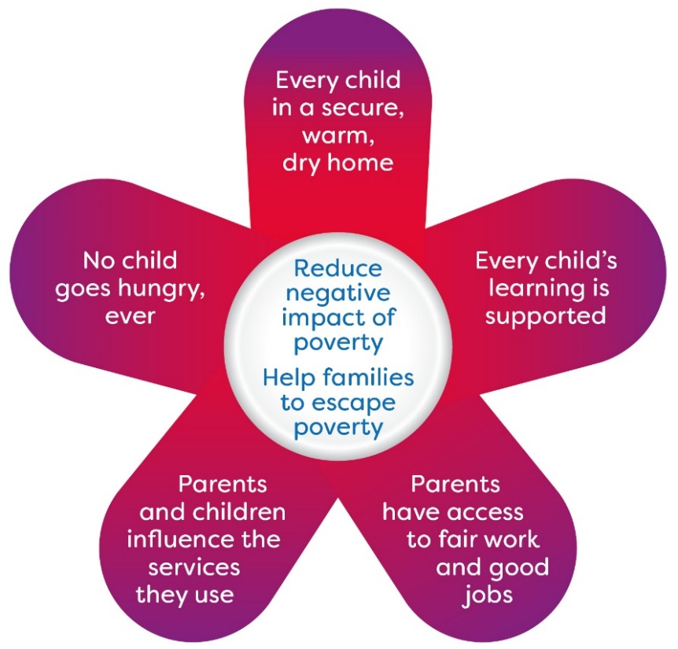

Section 2 - The Perth and Kinross Offer for Struggling Families

We want to work with our partners and communities to tackle inequality and provide better outcomes for individuals, building stronger more resilient communities.
- We will redesign services based around what we hear from communities.
- We will work more closely in communities and strive to deliver a one Council approach to Child Poverty.
- We will empower more decision making in communities with budgets and resources.

This first iteration of the Perth and Kinross Offer for Families Affected by Poverty has been informed by initial consultation. We will deepen our engagement with families affected by poverty and with the community organisations which currently support them.

The Offer will develop over time as communities, businesses and citizens engage in our crusade against child poverty.

This section of the Children’s Scorecard provides a highlight report on actions taken to fulfil the Perth and Kinross Offer for Struggling Families.

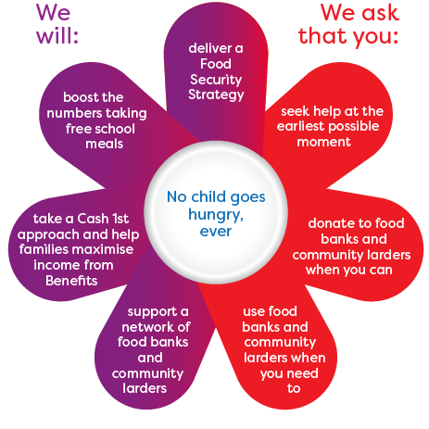
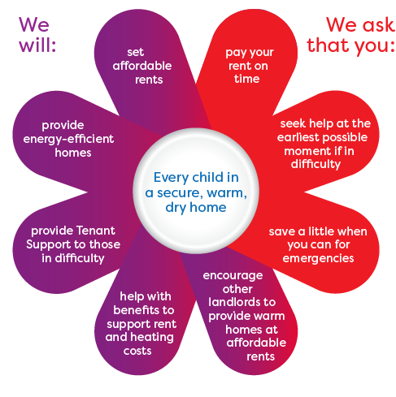
- 87% of tenants can afford our average rent levels without any need for additional assistance from Housing Benefit or Universal credit.
- Our rent levels are 23% lower than other Housing Associations
- Home First enabled us to reduce the number of homeless applicants waiting for a house by 90%
- Our digital inclusion project provides a device, 12 months data and digital skills training.
- We provided £60,000 to SCARF to provide energy efficiency advice and a further £10,000 was provided to NHS Tayside to fund the development of an information app for frontline workers on tackling fuel poverty.
- £915,907 was invested via the Home Energy Efficiency Programme to improve 108 homes.

- £170,142 was provided to community projects to support local people who were struggling with food poverty.
- 5101 school pupils benefitted from free school meals (registered and taking free school meals).
- £16,795 was provided from the Financial Insecurity Fund to help families with school meals debt.

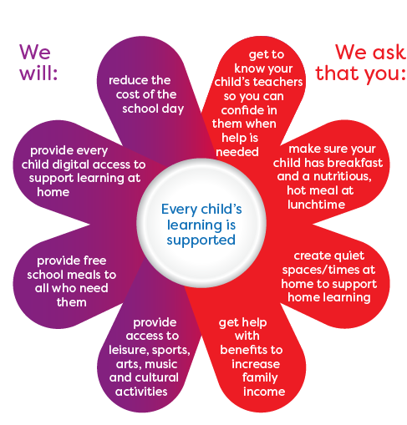
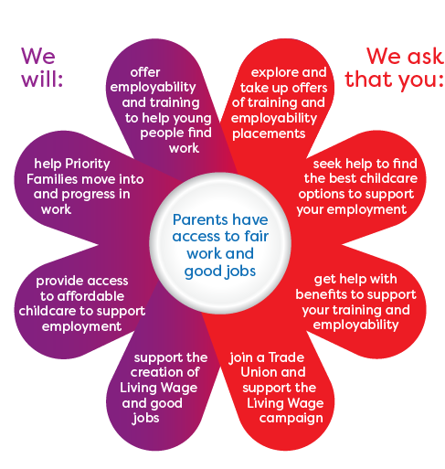
- 817 people engaged with council funded or operated employability projects/programmes.
- 290 people progressed into and/or sustained in employment as a result of council funded or operated employability projects/programmes.
- 140 people supported through our wage incentive job creation schemes in to and/or sustaining employment.
- In 2021/22: Primary Pupils Registered and Taking Free Meals (includes all stages P1-P7 where UFSM exists): 4,796 (68.4%) Registered: 7544 (73.4%) Secondary Pupils Registered and Taking Free Meals: 364 (64.9%) Registered: 705 (9.2%)
- All Children accessing their 1140 hours of funded Early Learning and Childcare are offered a funded meal and a healthy snack.
- In partnership with Scottish Schools Pipes and Drums Trust and local communities, we are delivering new free tuition and instrument hire for 270 young people .
- 269 families were provided with child home safety equipment

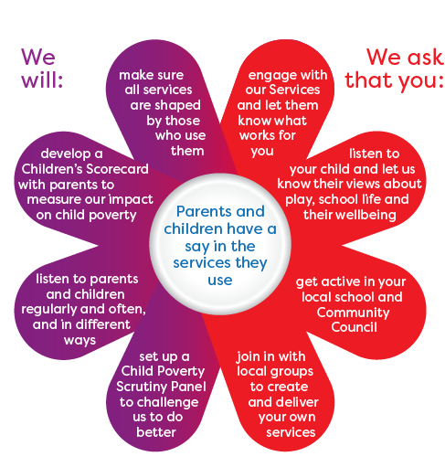
The Children’s Scorecard measures how what the services have done to respond to feedback received from Priority Parents who told us what mattered to them.

A Health and wellbeing Census was taken, and emerging priorities included mental health, substance use, relationships, sexual health, bullying and food poverty.

The Anti-Poverty Taskforce was established to champion the reduction of poverty and associated stigma and to engage with people with lived experience to ensure their voices were heard.

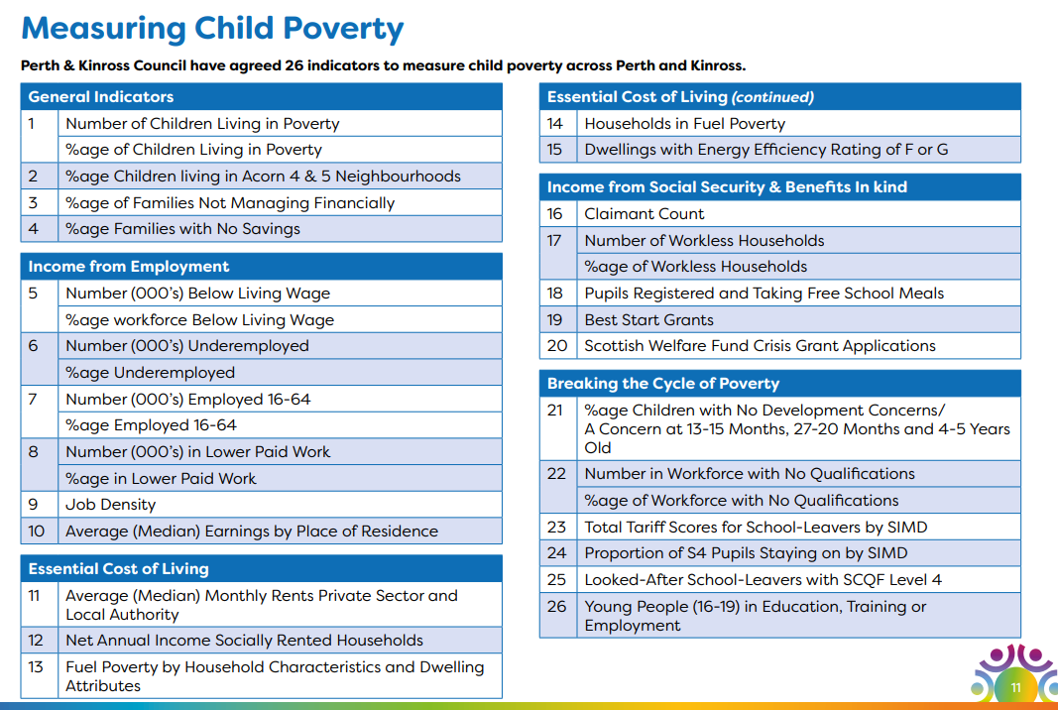
Section 3 - Measuring Child Poverty

This year's Measuring Poverty report is incomplete as some of the statistics that we would normally use to measure child poverty are not available as they have not been updated since 2019/2020. Covid19 and subsequent lockdowns have disrupted the collection of data. The data that is available in the main was collected before the impact of the Cost-of-Living Crisis was felt and is therefore slightly out of date. Nevertheless, the Indicators cover the scope and extent of poverty, and help to identify if we are making progress on helping families Maximise Income from Employment Reduce the Cost of Living Maximise Income from Social Security and Benefits In-kind. It also helps to identify if we are successful in breaking the cycle of poverty.

Notes to Statistics

The last two years must be regarded as outlier years – 2020/21 because of Covid19 (impact on gathering data and impact on incomes/expenditure/lifestyle) and 2021/22 because of the Cost-of-Living crisis Impact on incomes and expenditure).

However, the following is noted:-
- Child poverty figures and percentages of children living in relative poverty have remained stable. During this period of serious disruption and economic turbulence, this is no doubt due to the measures deployed by the UK and Scottish Governments, and Perth and Kinross Council’s significant efforts around income maximisation, cash first approaches and other mitigation measures.
- The number and percentage of employees across Perth and Kinross earning less than the Living Wage as defined by the Living Wage Foundation has significantly reduced, which is welcome news.
- There has been a slight reduction in job density, meaning fewer people are chasing available jobs.
- Median earnings increased by 8.8% in the last year, this would have enhanced the ability of families to cope with the Cost-of-Living crisis where inflation reached 10.4%. There has been little movement on the gender pay gap.
- During the 3-year period private sector rents increased by 26% compared with a 9.6% increase in local authority rents (based on 2-bedroom house).
- Until the Scottish Household Survey reports in 2024, we will not know the impact of the increases in energy costs on the number and percentage of households in fuel poverty.
- The number of workless households increased significantly during the Covid pandemic, and subsequently reduced, however it is still 10% above the pre-covid rate.
- There has been a significant increase in the number of applications to the Scottish Welfare Fund which is an indicator of financial stress.

 | General Indicators | 2019/2020 | Previous Figures (2020/21 – unless otherwise stated) | 2021/2022
1 | Number of children living in poverty | 5400  (After housing costs) | 5155 (After housing costs)  (2019/2020 – figures unreliable for 2020/21 due to Covid 19) | 5155 children are estimated to be living in poverty (before housing costs). The figure after housing costs is likely to be 5560.(The after-housing costs figure will be confirmed later in the year).
 | Percentage of children living in poverty | 22%  (After housing costs) | 22.6% (After housing Costs)  As above | 18% of children were estimated to be living in poverty - before housing costs. The figure after housing costs is likely to be around 21%.
2 | Percentage of children living in Acorn 4 and 5 neighbourhoods |  |  | 34% of children are living in Acorn 4 and 5 neighbourhoods. (6171 children
3 | Percentage of families not managing financially | 6%  (2019/2020) | N/A (Scottish Household Survey not conducted since 19/20) The 2022 SHS is not expected to be available until late 2023/early 2024. | N/A (Scottish Household Survey not conducted since 19/20) The 2022 SHS is not expected to be available until late 2023/early 2024.
4 | Percentage of families with no savings | 18%  (2019/2020) | As above | As above

 | Income from Employment | 2019/2020 | 2020/2021 | 2021/22
5 | Number (000’s) earning below Living Wage | Estimates considered unreliable due to small sample sizes | 13,000 | 8
 | Percentage earning below Living Wage | As above | 16.5% | 12%
6 | Number (000’s) of people underemployed | 6300 |  | N/A (Scotland’s Labour Market Report not available)
 | Percentage of people underemployed | 8% | 8% | As above
7 | Number (000’s) of people employed 16-64 | 74800 |  | 73,900
8 | Number (000’s) in lower paid work | Not available | 24,000 | Discontinued statistic
9 | Job Density (ratio of total jobs to population aged 16- 64) | 0.89 | 0.77 | 0.84
10 | Average Median Earnings by Place of Residence – Gross weekly pay excluding overtime – for all workers (full and part-time) | All - £458.6  Women £ - 382.6  Men - £535.1  (April 2020) | All - £475.3  Women £452.4  Men £521.7  (April 2021) | All - £517.5  Women £454.5  Men £626.9  (April 2022)

Gender Pay Gap
Calculated as average hourly pay, (excluding overtime)
 | 2019 | 2020 | 2021 | 2022
All | 13.18 | 13.37 | 14.0 | 15.87
Women | 12.41 | 12.77 | 13.72 | 14.36
Men | 14.31 | 14.36 | 14.71 | 16.66
Gap (%age of male earnings) | 13% | 11% | 7% | 14%

 | Essential Cost of Living | 2019/2020 | 2020/2021 | 2021/2022
11 | Average (Median) Monthly Rates Private Sector and Local Authority - (2 bedroom) | £564 – Private Sector pcm  Local authority £296.48 | Private sector £573 pcm  Local Authority £300.69 | Private Sector £709 pcm  Perth & Kinross Council £325 pcm PKC Rents 23% lower than other social landlords. Perth & Kinross Market Rents Summary PKC average rents
12 | Net Annual Income Socially Rent | No longer available | N/A (Scottish Household Survey) | N/A (Scottish Household Survey)
13 | Fuel Poverty by Household Characteristics and Dwelling Attribute | 22.3% | As Above | As above
14 | Households in fuel poverty | 25% (17,000 hhs) | As above | As above
15 | Dwellings with Energy Efficiency Rating F or G | 4%  (3000 hhs) | As above | As above

 | Income from Social Security and Benefits in-kind | 2019/2020 | 2020/2021 | 2021/2022
16 | Claimant Count | 1850 | 2815 | 2470 (2.7%)
17 | Number of Workless Households | 4000 | 6000 | 4,400 (Jan-Dec 2021)
18 | Pupils registered and taking Free School Meals (Primary) |  | 5007 (47.6% of Primary Pupils)  548 (7.5% Secondary Pupils) | 4,796 (68.4%
19 | Best Start Grants | 1855  £580,294 disbursed  (Cumulative to May 2020) | 3600 with £1,521,671. disbursed  (Cumulative to May 2021) | 4700 applications approved £1,803,996 disbursed  cumulative (to May 2022)
20 | Scottish Welfare Fund Crisis Grant – applications awarded | 3420 payments of £342,463  (June 2020) | 3540 payments of £452,265  (June 2021) | Volume: 3460  Payments of £460,834

 | Breaking the Cycle of Poverty | 2019/2020 | 2020/2021 | 2021/2022
21 | Percentage of children with no developmental concerns/a concern at 13- 15 months, 27-20 months, and 4-5 years old |  | 13 – 15 months – 78.7%  27-30 months – 79%  4-5 years 75.5% | N/A (Latest figures are for 2020/21 – update due for 2021/22 in April 23)
22 | Number in the workforce with no qualifications |  | 6300 | 4,100
 | Percentage of the workforce with no qualifications |  | 7% | 4.6%
23 | Total Tariff Scores for School-Leavers by SIMD |  |  | SIMD Q1 – 593  SIMD Q2 693  SIMD Q3 974  SIMD Q4 1035  SIMD Q5 1263
24 | Proportion of S4 pupils staying on by SIMD (%) |  |  | SIMD 1 – 70%  SIMD 2 – 77%  SIMD 3 – 86%  SIMD4 – 89%  SIMD 5 90%
25 | Looked-after school leavers with SCQF Level 4 |  |  | 20.21 Figures show 76% of looked after young people with SCQF at level 3 and 62% at level 4
26 | Young People (16-19) in Education, Training or Employment |  |  | 94%

References
General Indicators
Number and %age Children Living in Poverty Mid-2021 Population Estimates Scotland | National Records of Scotland (nrscotland.gov.uk)
Poverty and Income Inequality in Scotland 2019-22 (data.gov.scot)
Children in low-income families: local area statistics, financial year ending 2022 - GOV.UK (www.gov.uk)
Child Poverty Statistics - End Child Poverty Data derived from Scottish Household Survey is not currently available for 2021/2022
Income from Employment Indicators
Earnings Below the Living Wage Reliable measure of families in poverty Source: ASHE https://www.gov.scot/publications/annual-survey-of-hours-and-earnings-2019/
Scotland's Labour market Report is not currently available.
https://www.gov.scot/publications/regional-employment-patterns-scotland-statistics-annual-population-survey-2018/
Employment Reliable measurement of employment rates within local economy https://www.nomisweb.co.uk/reports/lmp/la/1946157428/report.aspx#tabempunemp Lower Paid Work
Lower paid work is a key driver of in work poverty https://www.nomisweb.co.uk/reports/lmp/la/1946157428/printable.aspx
Workless households for regions across the UK - Office for National Statistics
Job Density Indicates ratio of job seekers to pop aged 16 - 64. https://www.nomisweb.co.uk/reports/lmp/la/1946157428/printable.aspx
Median Gross Weekly Earnings Measures whether wages are increasing, stagnant or decreasing over time https://www.nomisweb.co.uk/reports/lmp/la/1946157428/printable.aspx
Essential Cost of Living Indicators
Rents Housing costs are a determinant of family disposable income and poverty https://www.gov.scot/publications/private-sector-rent-statistics-2010-2019
Income of Social Renters Important measurement of affordability of social rented housing https://www.gov.scot/publications/social-tenants-scotland-2017/
Fuel Poverty Energy Efficiency of Homes is an important driver of fuel poverty Source: Scottish House Condition Survey 2016 -2018 https://www.gov.scot/publications/scottish-house-condition-survey-local-authority-analyses/
Income from Social Security and Benefits In-kind Claimant Count Indicates no and %age people living on benefit - useful real time indicator to track changes https://www.nomisweb.co.uk/reports/lmp/la/1946157428/printable.aspx
Workless Households Workless Households are at greatest risk of poverty https://www.nomisweb.co.uk/reports/lmp/la/1946157428/printable.aspx
Ec J Annual 202122 P1 title (pkc.gov.uk)
Free School Meals Important Measurement of Child Poverty https://www.gov.scot/publications/school-healthy-living-survey-statistics-2019/pages/2/
Breaking the Cycle of Poverty To be added Statistics given are for 2021/2022 unless otherwise stated.
Perth_and_Kinross_Council_SOI_V4_-_Signed_1.pdf (pkc.gov.uk) – Fuel Poverty figures
Job Density – ONS From NOMIS 20.4.23
Best Start Grant and Best Start Foods: high level statistics to 31 May 2022 - gov.scot (www.gov.scot)

