Lead Professional | Relation to Child/Young Person | Contact details
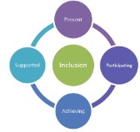

School logo
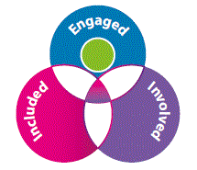
Child and Young Person Planning (Education)
Name:

Date Updated:

Section D –
Detail the additional support that is being provided by another service (Add additional tables as required for each need.) Coordinated Support Plan

Identified Need
Educational Objective
Additional Supports |  | Who? | Date started | Frequency and planned end date | Updates, review, and Impact (date)

Identified Need/Educational Objective
Additional Supports |  | Who? | Date started | Frequency and planned end date | Updates, review, and Impact (date)

