**Professional Curiosity**

**BACKGROUND**

All professionals who work with children and / or adults should be aware of their responsibilities and alert to the needs of vulnerable children.

Identifying abuse and neglect can be challenging, however professionals who are *curious* and inquisitive about family circumstances and events are better placed to effectively identify risk of potential or actual harm.

**1**

**QUESTIONS FOR SELF-REFLECTION,**

**SUPERIVSION AND TEAM MEETINGS**

* Am I curious and inquisitive about what I am seeing?
* Am I open to new information?
* Do I have enough information?
* Do I feel confident / assertive enough to ask difficult questions and challenge what I am being told?
* Am I prepared to change my mind?
* Am I making time for supervision and critical reflection?

**7**



**01**

**02**

**07**

**7**

**MINUTE BRIEFING**

**03**

**06**

**04**

**05**

**PROFFESSIONAL CURIOSITY**

**IS SUPPORTED BY**

* Building open, honest and transparent relationships with families.
* Confidence to ask sensitive/ difficult questions, triangulate information and challenge what we are being told.
* Being aware of disguised non-compliance.
* Remaining child focused.
* Having safe environments where children (and families) can express themselves and be heard.
* Identify and exploring what is not discussed as much as what is.
* Thinking critically, using sensitivity and being persistent.
* An openness to other perspectives / willingness to trying different approaches.
* Access to supervision and / or specialist advice.

**6**

**WHAT IS IT?**

Professional Curiosity is the capacity to explore and understand what is happening within a family, rather than making assumptions or accepting things at face value. It is being ‘***respectfully uncertain’***.

It involves enquiring deeper and using proactive questioning and sensitive challenge. By gathering and triangulating information from various sources, it helps us remain open minded and to think critically.

Professional curiosity is a combination of looking, listening; asking direct questions; checking out and reflecting on information received.

**2**

**THINKING THE UNTHINKABLE**

It is natural for a practitioner to want to believe the best of a family, and “thinking the unthinkable” does not mean assuming or believing the worst. It means keeping an open mind and being able to think objectively about the evidence presented. Be prepared to accept information that does not fit with previous assumptions and assessments. Look beyond the obvious and see the whole picture. Be aware of:

**Confirmation Bias** – When we look for evidence to support our pre-held view and ignore new information that refutes it.

**Knowing but Not Knowing** – the sense that something is not right but not knowing exactly what or what to do about it.

**Disruption and aggression** from families or others can undermine professional confidence and divert us.

**Dealing with Uncertainty** – contested accounts, vague or retracted disclosures, deception and inconclusive medical evidence are common in safeguarding & child protection practice.

**4**

**WHY DOES IT MATTER?**

Learning reviews highlight the need for staff to be alert to the risk of fixed thinking and perceptual bias. Munro (2005) commented on the extraordinary lengths to which some abusive parents go in their efforts to deceive practitioners through **disguised non-compliance**.

The review following Daniel Pelka’s death stressed the need for professionals to “think the unthinkable” rather than accept parental versions of what is happening at home.

Assessments are fallible, and contexts constantly changing. Therefore, professionals need to remain curious and critically review their judgements on an ongoing basis.

**3**

**BARRIERS TO CURIOSITY**

* Losing focus on the child through over-identification with parents/carers.
* Over-optimism not supported by evidence.
* Making assumptions.
* Frequent changes of case worker leading to ‘Start Again Syndrome’.
* Complexity and pressure of work.
* Not accessing or poor supervision.

**5**

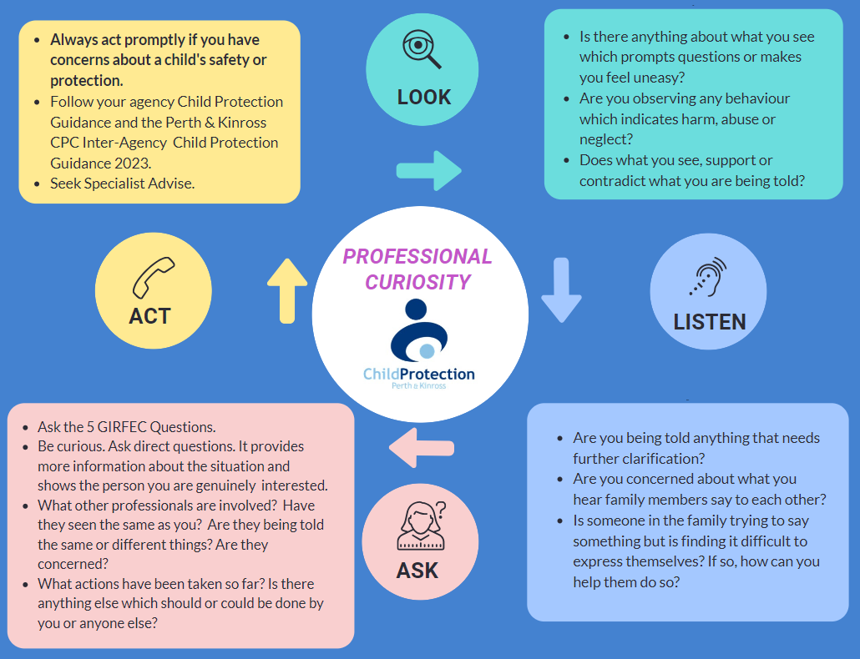

**PROFESSIONAL CURIOSITY REFLECTIVE LEARNING ACCOUNT**

After reviewing the 7-minute briefing, this form can be used to record learning reflections and actions. It can be used in groups, teams, 1-1 supervision discussions or by individual practitioners.

|  |
| --- |
| **How does the information in this 7-minute briefing link with your practice?** |
| Click or tap here to enter text. |
| **What did you learn from the 7-minute briefing and associated guidance?** |
| Click or tap here to enter text. |
| **How did you change or improve your practice as a result?** |
| Click or tap here to enter text. |
| **How is it relevant to the professional standards, behaviours, values and / or codes of practice and conduct you require to meet?**  e.g. [SSSC Codes of Practice](https://www.sssc.uk.com/the-scottish-social-services-council/sssc-codes-of-practice/) (2024); The [Health and Social Care Standards](https://www.careinspectorate.com/images/Health_and_Social_Care_Standards.pdf) (2017); The [GTC Scotland Code of Professionalism and Conduct](https://www.gtcs.org.uk/documents/code-of-professionalism-and-conduct) (2021) or the [NMC Code](https://www.nmc.org.uk/globalassets/sitedocuments/nmc-publications/nmc-code.pdf) (updated 2018). |
| Click or tap here to enter text. |

**PERTH & KINROSS CPC * SEPT 2024**

PROFESSIONAL CURIOSITY 7 MINUTE BRIEFING

Adapted with thanks and recognition to NHS Tayside Public Protection Service & West Lothian CPC