Perth and Kinross community planning partnership logo

Local Child Poverty Action Report   
2023/24 and   
Local Child Poverty Action Plan 2024/25

6th Edition

Contents

Contents 2

Executive Summary 3

Introduction 4

Context 7

Spotlight on Innovation and Good Practice 11

Supporting People – Addressing Need Programme (SPAN) 11

Infant Food Insecurity Pathway 12

Futures for Families 13

Area based Needs Analysis 14

Health and Work 15

Aberlour - Tayside Hardship Project 16

NHS Tayside Anchor Strategy 17

The Big Hoose 18

Appendix 1 – Child Poverty Delivery Plan 2022-2026 25

Strategic Aims 25

Objectives 25

Our Approach 26

Executive Summary

**Since the introduction of the Child Poverty Targets in 2017 significant resources and energy have been devoted to tackling child poverty in Perth and Kinross.**  **Child poverty rates and numbers have remained relatively stable with 5,750 children living in poverty (21.7% 2022/23) compared to 5,914 (21.9% 2021/22).**

**Perth and Kinross reflects the national trend with poverty rates similar despite resources being devoted to tackling child poverty. As in 2017, in 2024 22% of children are living in poverty.**

**While child poverty rates have not reduced significantly, the fact that they haven’t increased from the effects of the global pandemic COVID-19 followed by a Cost-of-Living crisis could be viewed as evidence of positive impact of the action being taken.**

**However, it is a matter of concern that few now have a serious expectation that the poverty targets set out in the Child poverty Act (Scotland) in 2017 will be achieved by 2030.**

**It is not just that we need to redouble our efforts, we also need to re-examine our approach to tackling poverty and invest in those areas where greater outcomes could be made.**

**We are currently collaborating with the Fraser of Allander Institute and the Improvement Service to more rigorously evaluate our efforts and to generate a body of evidence to determine actions which would have the greater impact to alleviate poverty.**

**We have secured just over £1.3 million to invest in the Supporting People – Addressing Needs programme (SPAN) which provides a platform for the integration of services across income maximisation, employability and wellbeing. It will deliver a tailored offer to each family affected by poverty. This will be assessed to measure the impact of moving families from crisis and emergency to sustainable livelihoods.**

**Poverty is the biggest equality issue in Scotland today with 1 in 5 of our children having their opportunities and life chances constrained by the financial circumstances into which they were born.**

**Thomas Glen**  
Chief Executive, Perth and Kinross Council

**Nicky Connor**

Chief Executive, NHS Tayside

Introduction

This report has been jointly produced by Perth and Kinross Council and NHS Tayside and reflects the wider collaboration with our Community Planning Partners and a deepening engagement with our key stakeholder groups.

It is our sixth Child Poverty Action Report and includes actions taken to implement our Child Poverty Delivery Plan 2022-2026.

The Child Poverty Delivery Plan aligns with [Best Start, Bright Futures: tackling child poverty delivery plan](https://www.gov.scot/publications/best-start-bright-futures-tackling-child-poverty-delivery-plan-2022-26/) of the Scottish Government which covers the same period. It connects to and will deliver a rights-based approach as set out in the [UN Convention on the Rights of the Child](https://www.unicef.org.uk/wp-content/uploads/2019/10/UNCRC_summary-1_1.pdf) with reference to those articles which relate to child poverty:

* Article 3 (best interests of the child)
* Article 6 (life, survival and development)
* Article 12 (respect for the views of the child)
* Article 26 (social security)
* Article 27 (adequate standard of living).

It is underpinned by [GIRFEC (Getting It Right For Every Child)](https://www.gov.scot/policies/girfec/) the national approach in Scotland to improving outcomes and supporting the wellbeing of children and young people by offering the right help at the right time. It supports children and their parents to work in partnership with the services that can help them. The GIRFEC approach is child-focussed and uses the [SHANARRI](https://www.gov.scot/policies/girfec/wellbeing-indicators-shanarri/) wellbeing indicators, to identify need and measure progress.

It also aligns with the Scottish Government’s No One Left Behind approach to employability support. In particular, the growing emphasis on supporting parents into work, and to increase their earnings in work.

It will contribute to the delivery of [Scotland's Promise to care experienced children and young people](https://thepromise.scot/what-is-the-promise/) that they will grow up loved, safe and respected and relates to the delivery of [Plan 21-24](https://thepromise.scot/resources/2021/plan-21-24.pdf) which requires organisations to demonstrate how they are ensuring that they play a part in mitigating the impacts of poverty.

It flows from the [Perth and Kinross Corporate Plan 2022/23 - 2027/28](https://www.pkc.gov.uk/article/23059/Corporate-Plan-Priority-Tackling-poverty) which has Tackling Poverty as a corporate priority and the [Perth and Kinross Community Plan 2022-2032](https://www.pkc.gov.uk/media/40553/Community-Plan-Local-Outcomes-Improvement-Plan-2022-2032/pdf/LOIP_2022-2032.pdf?m=638049792076130000) adopted by our Community Planning Partners which sets Reducing Poverty as a strategic priority.

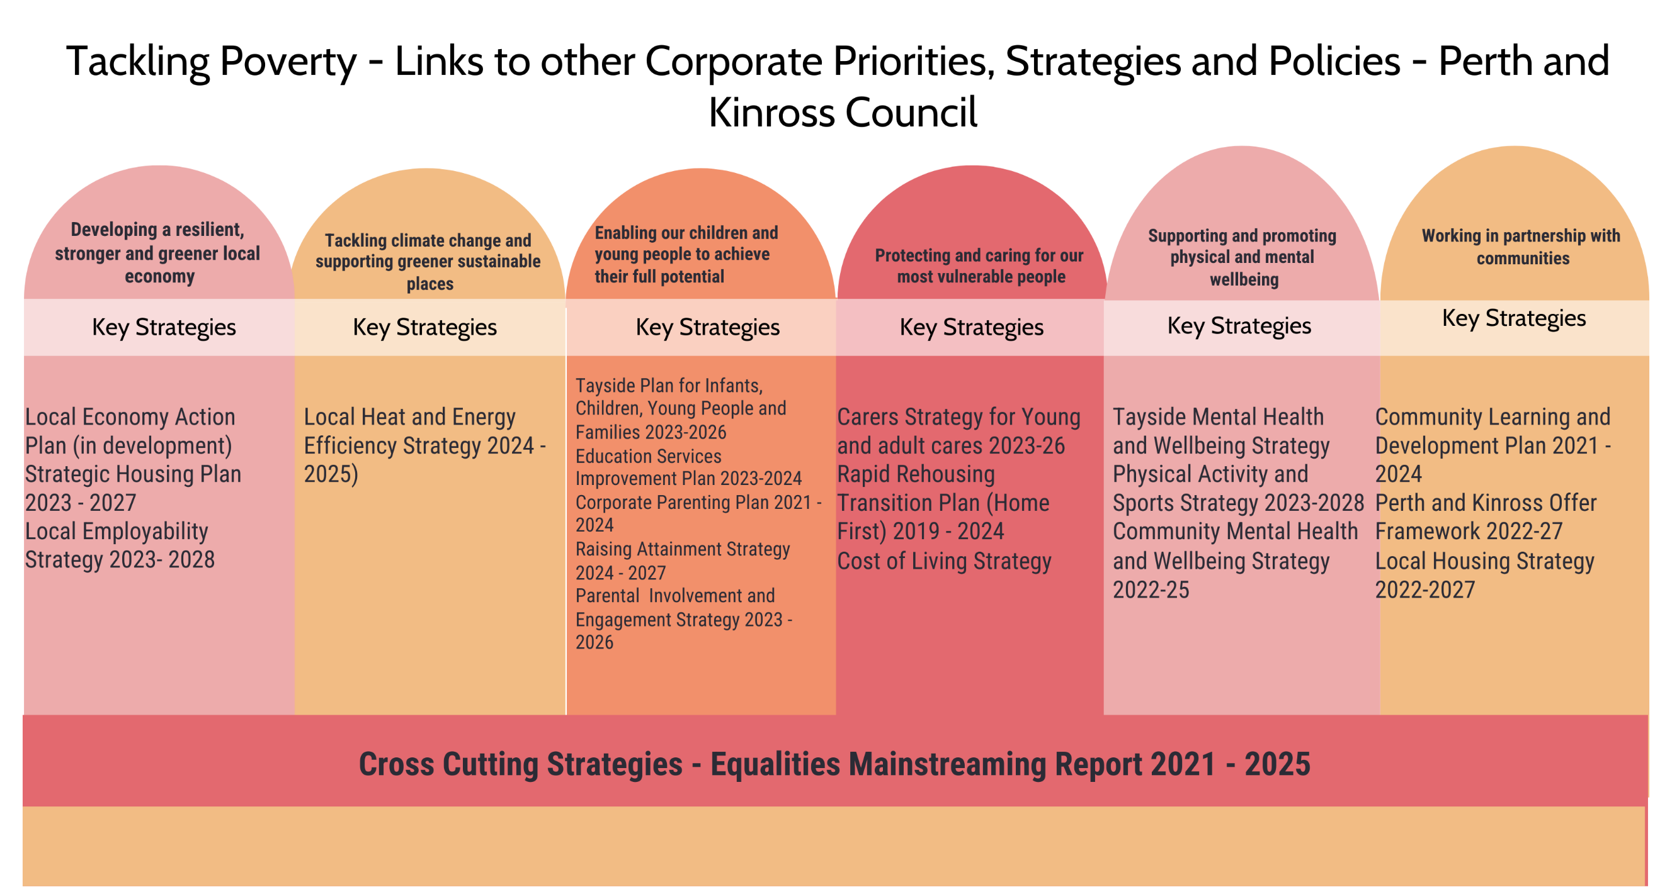

Community Learning and Development Plan 2021-2024

Local Housing Strategy 2022-2027

Context

Perth and Kinross Council have agreed 26 indicators to measure the extent and impact of child poverty across Perth and Kinross. These indicators are:

* General context information
* income from employment
* the essential cost of living
* social security and benefits in kind and
* breaking the cycle of poverty

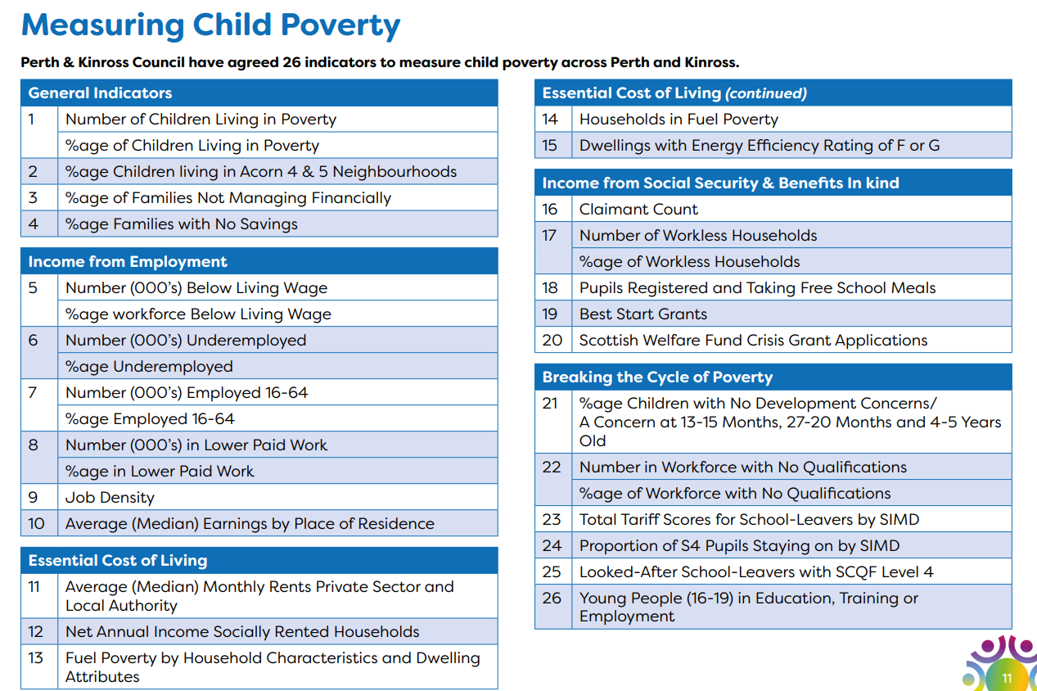

Post-Covid-19 several of the statistics previously used to measure progress in these areas have been discontinued and the Scottish Government have developed their own dashboard of statistics to measure progress towards attainment of the child poverty targets. Perth and Kinross Council have also revamped their own performance indicators.

The Perth and Kinross Children’s Scorecard and Measuring Child Poverty project have been updated accordingly to align with the Scottish Government dashboard, the available data around income from employment and benefits and cost of living and PKCs performance data.

(Insert link to Children’s Scorecard once approved at full council)

This year the Children’s Scorecard reveals that child poverty rates and numbers have reduced from 5,914 to 5,750 children living in poverty (21.7%). This reflects the static nature of child poverty in Scotland as a whole. (It should be noted that this data comes from a relatively small sample of households through the Scottish Household survey and therefore carries a significant margin of error).

The scorecard includes the findings of the Early Learning and Childcare bi-annual survey which included for the first time a section on parents from Priority Groups and social needs screening (a set of questions to help frontline workers identify signs of poverty in a household). The responses were:

* 44% of parents belonged to a Priority Family group
* 10% were lone parents
* 2% were from a minority ethnic group
* 1% were mothers under 25
* 3% had a disabled family member
* 20% had more than 2 children
* 6% had a child under 1.

The Social Needs Screening questions reinforced the findings from the research undertaken by the Scottish Poverty and Inequality Unit in “Lived experience of child poverty in Perth and Kinross” that “ **Intense poverty exists**. *There is evidence of abject poverty in Perth and Kinross. Sometimes, such poverty has a passing intensity, which may be triggered by unforeseen circumstance (e.g., breakdown of a household appliance; loss of employment; change in family arrangements)*.”

The survey found that

* 43% of parents with children in early years education sometimes or always have difficulty making ends meet in the days/week before payday.
* Someone went hungry in 9% of households with children in early years education in the last year because there was not enough money for food
* 12% of households with children in early years education lack access to the internet/devices to support learning from home for all their children
* 25% of parents with children in early years education struggle to heat their homes
* 5% of parents with children in early years education consider themselves at some risk of becoming homeless
* 11% of parents with children in early years education have missed a medical or other appointment, work or getting things for daily living because they lack access to transport.

**What we did to tackle child poverty in 2023/24**



**Survive and Thrive**

**Dignified Living**

**Work**

**What we did to tackle child poverty in 2023/24**

Anti-Poverty Task Force commissioned Perth and Kinross Tacking Poverty Strategy and third sectors

**2**

Projects were funded to provide Gypsy Travellers with cost-of-living support over the last 2 winters

**94%**

Of pupil equity funding spent within planned timescales

**100%**

Of PKCs schools are engaged with the Mental Health Ambassadors Programme

**2662**

Children accessed support or services funded via Community Mental Health Plan

**£521,076**

Funding to support positive mental wellbeing in children and young people

**13**

Schools joined phase 4 of the Nurturing Relationships whole school programme

**55**

Parents supported into flexible employment and **7** into self-employment

**53**

Families issued with digital hardware devices

**42**

Moved into jobs after completing HGV/LGV skills academy

**25**

Rural jobs for young people created using employment incentives

**181**

New families engaged in the Future for Families project

**292**

People supported into employment

**4135**

Successful applications made for Scottish Welfare fund crisis grants

Closing the Gap tool was used to help 17,254 pupils overcome barriers to attainment.

Survive & Thrive

Dignified Living

**2205**

Households benefitted from energy advice and measures to reduce bills

**2,556**

Applications received for the Council’s Financial Insecurity fund of £664,000

**£807,000**

Was provided in community care grants to 1042 applicants

**£8.5 million**

Generated in verified benefit gains by the Welfare Rights Team.

**£270,813**

Was provided for summer food and activities (fuelled for fun)

**£250,000**

Was provided to 94 community organisations for warm spaces, food and warm home packs

**10%**

Lower rent than neighbouring local authorities

**566** Tenants in financial crisis supported through Tenancy Sustainment fund

**173**

Affordable homes were delivered

**72%**

of under 22s now have free bus passes bus service

**300**

Funded strong start 2 places funded

**3413**

childcare places provided across public and third sector

**Survive and Thrive**

**Dignified Living**

**Work**

* Work with the Local Employability Partnership to improve access to employment and representation in the NHS workforce amongst priority groups
* Support parents who want to become self-employed childcare providers to gain qualifications
* Support parental employment through the Futures for Families project to support parents into skills and employment outcomes that will increase their earning potential
* Meaningfully engage with business community under the Futures for All Recruitment Incentive project to create new, flexible and sustainable jobs for priority parents and people with employment barriers.

Dignified Living – support to families to lead dignified lives and meet their basic needs

* Develop a joined-up approach to crisis intervention which is underpinned by Cash First including a new referral management system
* NHS Tayside will increase the number of health-placed income maximisation referrals to welfare/energy advice services. This will include new work where children are severely disabled or have complex needs
* NHS Tayside will identify performance indicators that can s how effected responses are implemented, monitored and reported through existing systems.
* Work will be progressed through the Tayside Child Poverty network, Addressing Inequalities in Maternity Services and will identify areas where approaches will reach priority families
* Work with partner organisations to put in place robust referral pathways around health and wellbeing support for parents and their children
* Work to maximise the impact of Pupil equity funding on children experiencing educational disadvantage because of poverty
* Ensure there is continued promotion of evidence-based interventions to target aspects of literacy, numeracy and health and wellbeing
* Embed the use of the Closing the Gap tool to create a holistic planning and impact measurement tool
* Report regularly, analysing progress, to the Raising Attainment Board
* Develop and implement a refreshed Raising Attainment Strategy for 2023 - 2026
* Work in partnership with local community organisations to deliver Fuelled for Fun programmes to provide activities and food to school age children during school holidays
* Work with Tayside Contracts to increase the uptake of free school meals
* Work with Gypsy Traveller families to support their child’s development, expanding on the provision of starter sacks.
* Implement the Perth and Kinross Corporate Parenting Plan 21-24
* Accelerate delivery of 1050 affordable homes over 5 years
* Buy back 40 former council houses
* Provide support to community-led housing initiatives
* Invest £4 million to upgrade Gypsy Traveller site with new energy efficient accommodation
* Analyse data relating to the uptake of Council concessions and plot unmet need to local school catchment areas
* Target income maximisation, employability offers and social prescribing to schools with the greatest levels of unmet need
* Develop locality based, multi-disciplinary teams to support and connect parents and families to services
* NHS Tayside will promote the Warmth Matters app and website to enable frontline workers to signpost people to a range of services and support
* Work in partnership with Perth and Glenochil Prisons to provide an accelerated welfare rights service to people on release from prison
* Identify and promote best practice on delivering the real Living Wage, championing the benefits to local employers.
* NHS Tayside will use its strategic influence to tackle poverty and health inequalities
* Ensure the new Economic Action Plan contains actions to tackle child poverty
* Extend childcare to support parental employment through wraparound care, community childminding and strong start2

**What are we going to do to tackle child poverty in 2024/25?**

Work - providing opportunities and support needed to enter, sustain and progress in work

Spotlight on Innovation and Good Practice

## Supporting People – Addressing Need Programme (SPAN)

The Programme partners and elements are:-

* Perth Citizen Advice Bureau (CAB) – Money Talk Service (enables clients to manage and improve their financial circumstances) and Cash First Partnership
* Perth and Kinross Council – Social Needs Screening Tool (to identify unmet need), Support and Connect (to empower frontline workers to connect families to help and support) and Building Resilient Families (to empower priority parents)
* Children’s Services Planning Partnership – Universal Whole Family Support Service.

The programme elements were determined following feedback from parents from Priority family groups. The parents expressed

* A strong preference for cash-first approaches,
* A strong preference for a one-stop access point to a range of services and support for families experiencing financial challenge

Parents made

* A clear link between poverty, stress and mental health and wellbeing challenges for both parents and children and
* Identified access to affordable childcare and transport as barriers to employment.

The SPAN programme has leveraged £1.3m for poverty mitigation measures which integrate income maximisation, employability and wellbeing.

Infant Food Insecurity pathway 
Social needs screening
Support and connect
Building resilient families and communities
Cash first partnership
Money talk plus
Universal whole family support service

**Infant Food Insecurity Pathway**

## Infant Food Insecurity Pathway

In response to NHS Tayside’s Public Health Team undertook engagement with health colleagues, social work, community food providers and advice providers across Tayside to identify current issues and scale of the problem of infant food insecurity.

Scoping work found that there was a lack of robust data measurements that could show the extent of the problem but there were anecdotal reports of families reducing formula intake, diluting formula to extend the tin or using opened or out of date first stage formula, adding thickener agents or moving onto a follow-on formula that is not nutritionally suitable for the age of the infant.

Public health staff participated in a short life working group that was led and facilitated by Scottish Government to produce a toolkit that will aid services and staff, across sectors. The toolkit is being used to develop a local Tayside Infant Food Insecurity Pathway that was put out for consultation and feedback in May 2024.

Training for frontline staff will support the pathway and a project brief is being considered by Dundee University Medical School and Duncan and Jordanstone College of Art and Design to develop a resource that will increase training capacity across the third sector and community organisations who work with families.

Training outcomes will be increased awareness of pathway of support, increased knowledge on safe formula feeding, increased knowledge (and application) of the ‘Code’ around promotion and marketing of first formula feed and for **c**onsistent approaches to be taken across community food providers when supporting families with infants facing food or financial insecurity.

Training will complement the offering already in place to health visiting, Family Nurse Partnership staff and midwives to increase knowledge and confidence on raising the issue of money worries and the money maximisation pathways already embedded across these services.

A monitoring or feedback form is also being developed with the pathway to help measure implementation of the pathway and provide some baseline data.

## Futures for Families

**Futures for Families** is a coordinated and multi-agency approach to tackling child poverty through employability and skills, supporting parents in the 6 priority groups. Our aim is to provide holistic, client-centred support, ensuring the barriers parents face are addressed and navigated with the use of mixed provision and flexible funding. The programme is financially supported by Scottish Government (£305k) and Perth and Kinross Council (£335k) to ensure flexibility of options when supporting our clients. Our experienced Key Workers create actions plans to design pathways with clients, to ensure they receive appropriate support at the right time for them and their family. Our offers include:

* Support for childcare costs for parents entering employment/self-employment (3 months)
* Grants for those entering else employment to fund transitionary period
* Elev8 Training and Equipment Grants up to £4,500
* Funding for digital hardware and connectivity, providing internet contracts, laptops and iPads to clients in need
* Funding for incentivised employment, creating new jobs in local small businesses
* Funded travel to and from employment and skills interventions

We deliver this service in conjunction with partners, including with Business Gateway to engage with parents in their self-employment journeys. The service is delivered with other family-centred and community learning provision in targeted areas of need.

**Here is how our programme supported one of our single parent clients**

Barry, 48, engaged with the team in April after being made homeless with his 8-month-old little girl. With our support we were able to supply him with an iPad and pay for a Project Management qualification, which he completed by June Along with his Key Worker Barry developed a business case for self-employment, and secured our Self-Employment Grant, which enabled him to launch his business and start generating income again. He has since moved off UC benefit.

***“Financially, I’m pleased to say that the business is going well, and the grants have allowed me to travel and take meetings throughout Scotland. It has grown to a point where I will be able to stop claiming UC in October. This has been a major milestone for me, and I couldn’t have reached it without the assistance and kind support from you. Mentally, I feel in a better place now and I feel much more optimistic about the future. Your support has been invaluable in helping me get to this point.”***

## Area based Needs Analysis

A series of data maps have been developed which use public data (Children in Low Income Families), household income data with council data which was then mapped to the catchment areas of local primary schools to identify those areas where people were experiencing significant financial challenges and map that to the uptake of council concessions.

The data will be contextualised at a meeting with Primary Headteachers and from this a targeted list of primary schools will be identified for action by the emerging locality based multi-disciplinary teams. The information generated will enable Perth and Kinross Council to target areas where there is significant financial hardship and lower than anticipated uptake of council concessions for take-up campaigns.

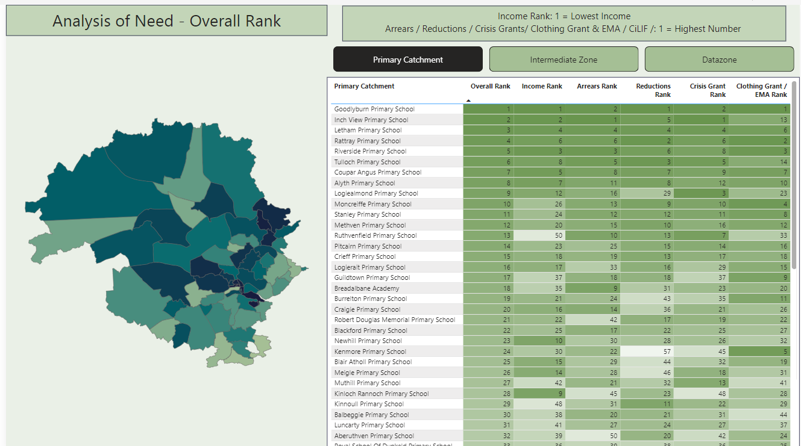

## Health and Work

|  |  |
| --- | --- |
| The Health and Work programme has broadened its offering to local businesses which led to enhanced partnership working, building capacity through fair work practices and promoting work as a route to good health and reduced financial hardship. | Address the key reasons for absence from work such as Mental Health and Musculoskeletal disorders |
| Fair Work | Supporting partners and employers to promote and deliver Fair Work actions on employment; payment of Real Living Wage and progression for low paid workers, flexible working, inclusive workplaces, healthy workplace policy and practice. |
| Access to and retention in work | Focusing support and interventions towards key groups and sectors experiencing greatest health inequalities to improve access to and retention in work. |
| Support the NHS as an Anchor | Contributing to a wellbeing economy including development and delivery of parental employment, supported employment and individual placement services. Support Fair Work conditionality in the local community |
| Building the evidence base | - Support gathering, recording and dissemination of evidence on health and work |

The engagement with workplaces identified the current economic pressures, effects on wages, staffing levels, morale, workload and the cost-of-living crisis are all contributing to increased levels of stress and anxiety across workplaces.

Other issues causing concern are the effects of in-work poverty, menopause and menstrual health, physical health conditions, Musculoskeletal health issues and bereavement.

Building strong collaborative working relationships to tackle these challenges has led to working on shared priorities with organisations such as Working Health Services, Business Gateway, Enable Works as well as the Local Employability Partnerships.

Over the year, a total of 27 training courses and workshops to 341 individuals were delivered, almost double that of the previous financial year. Post course evaluations indicate the value of the training for participants, with many stating that they have increased confidence, knowledge, and skills to address the topic in their area of work. They are also more likely to raise relevant health and wellbeing issues and to have supportive conversations with employees, initiate relevant workplace adjustments, and have greater awareness of existing tools and sources of support.

## Aberlour - Tayside Hardship Project

Perth and Kinross Welfare Rights Team established a partnership with [Aberlour](https://www.aberlour.org.uk/)and our Tayside counterparts to provide a comprehensive and enhanced welfare rights service to vulnerable families with dependent children.

Last year, through our formal referral agreement with Aberlour 11 families with children on the "edge of care" were referred to us for comprehensive benefits advice and assistance.

We made payments to the value of £3k from the Financial Insecurity Fund to these families and they benefited from almost £3k in additional income with an average household benefit gain of £272.

In addition, we are now delivering a programme of training sessions around Reducing Council Tax Liability in partnership with our colleagues in Aberlour to frontline agencies across Perth and Kinross. We kicked the programme off in March 2024 and these will continue throughout 2024/25.

Testimonial from Aberlour

**"PKC Welfare Rights have demonstrated exceptional expertise and passion in raising awareness of financial strategies aimed at alleviating the burden of debt and financial hardship on the families we support.**

**Their commitment to empowering individuals and families with practical knowledge on maximizing income and accessing available resources has been instrumental in our shared mission of providing holistic support. PKC Welfare Rights collaborative approach, coupled with their deep understanding of the challenges faced by vulnerable families, has undoubtedly made a significant impact on the lives of those we serve."**

## NHS Tayside Anchor Strategy

NHS Scotland’s Annual Delivery Plan Guidance for 2023/24 asked Health Boards to set out an approach to developing an Anchors strategic plan by October 2023.

To develop the local Anchor strategy this involved widespread stakeholder engagement and consultation across key NHS services and local community planning partners. The strategy was published in October 2023 and has since provided a positive platform for engagement with key partners around shared priorities. The Anchor Strategy has been presented to Dundee Partnership’s Inclusive Economic Growth SLG and to all 3 Local Employability Partnership Leads. This has directly led to Dundee LEP providing NHS Tayside with a part-time funded post for 2024/25 to accelerate and facilitate progress on aligned priorities (see appendix/attached) particularly around employability opportunities to those furthest away from the labour market.

* Delivery of NHS Tayside’s Community Benefit Gateway, enabling potential suppliers to match community benefit contributions to local need. This has included coordination of a Tayside wide steering and triage group. 12 needs on the gateway, 5 delivered.
* Support businesses to enhance their Fair Work credentials to improve their prospects of securing public sector contracts
* Increase referrals to employability services from NHS Tayside
* increase opportunities for employment to priority groups within NHS Tayside.
* Agreement of tailored set of indicators to quantify, understand and measure progress of the anchor strategy working across the pillars.
* Engagement with national Anchors strategic groups and networks to influence the national agenda, share learning and connect with others on shared priorities.

Actions and examples of good practice have been reported within the Anchors Strategy

[NHS Tayside Anchor Strategy 2023](https://www.nhstaysidecdn.scot.nhs.uk/NHSTaysideWeb/idcplg?IdcService=GET_SECURE_FILE&Rendition=web&RevisionSelectionMethod=LatestReleased&noSaveAs=1&dDocName=prod_371657)

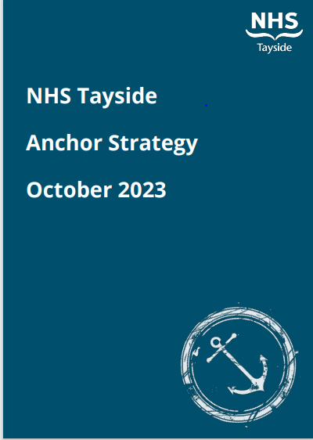

## The Big Hoose

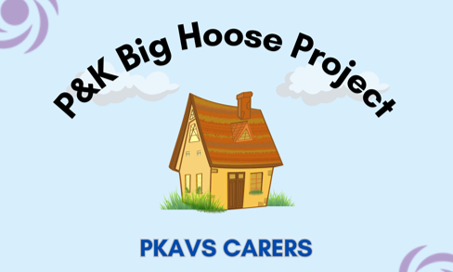The Big Hoose was founded in 2021 by the Cottage Family Centre and Amazon UK to distribute surplus everyday household essential products from Amazon and around 30 other local and multi-national businesses to families who need them most. The project originated in Fife but has, with financial support and premises from Perth and Kinross Council expanded to create a hub service Perth and Kinross. The project is hosted by PKAVS Carers.

So far, 52,067 items have been distributed to families with 2,662 children. The next steps are to make the project available across rural Perthshire by creating local access points in 5 or more locations. The group wants to increase the number of referring partners and to continue building good relationships with local businesses who donate goods to the Big Hoose inventory.

**Money Maximisation and Health Services**

NHS Tayside will continue to offer money maximisation support through the embedded pathways within health visiting, family nurse partnership and maternity services. Steps have been taken to introduce similar pathways for money maximisation and parental employability support within paediatrics. Targeted areas such as neonatal, CAHMs and complex needs centres and the NHS Care Experienced and Young Peoples Service will increase reach to priority families most vulnerable to the effects of poverty.

Training, grand rounds and new resources delivered to support the implementation of new or existing pathways. 25 midwives attended a public health training day which included training around health behaviour change approaches, financial inclusion and mental health.

The Advice Centre provides signposting and referrals to services that will support on a range of socio-economic issues including benefit entitlements, carers support, housing, food insecurity, fuel poverty and debt. Inpatients referred through the financial inclusion pathway included in secondary care nursing documentation is triaged by the Advice Centre. Whilst the number of people requesting information and advice through this service has steadily increased throughout the year since reopening in December 2022, there are still low referrals from wards with the majority of clients self-referring.

Service improvement work to be offered to acute services to increase the referral of patients experiencing money worries to NHS Tayside’s Advice Centre or partner advice providers such as CAB who will be offering onsite support from May 2024.

Learning from a recent Making Every Contact Count (MECC) pilot with vaccination teams, will inform service improvement work to overcome the barriers to raising the issue of money worries with inpatients and improve reach to those most likely facing health inequalities.

|  |  |
| --- | --- |
| **Advice Centre** | **MECC Vaccination pilot** |
| Average weekly brief advice, signposting and provision of information – 50 contacts, 92% of which are self- referrals. | 448 very brief interventions on alcohol, smoking and money worries offered within vaccination centre and home visits over 5 weeks. 268 agreed to answer question around money worries. |
| 70 referrals to CABs across Tayside with further referrals made to other services over the year including welfare rights, carers, housing services, food larders, mental wellbeing services, Age Scotland and more. | 13.8% of citizens accepted signposting to cost of living support |
| Training co-delivered with Social Security Scotland offered to ward staff – low uptake.  Offer bespoke ward training to increase reach across patient groups and confidence of staff to raise the issue | Training offered to small cohort of vaccinators. Roll out to health care assistants and staff across GP practices. |

**Letham Hub**

The Letham Hub is the result of a unique and productive collaboration between the local community and Perth and Kinross Council. Working together over the last 6 years this partnership has resulted in a community facility, which has been returned to community ownership.

The drive for this project came from the local community to address local inequalities and improve health and wellbeing. Now opened, The Hub is run and owned for the community by Letham4All SCIO, and it offers a wealth of opportunities for partner agencies to deliver range of services in the locality, by offering the use of hotdesking and confidential meeting spaces with the benefit of enabling engagement with local people who attend the many community-based activities delivered by Letham4All staff, volunteers and partners.

The building offers many free and very low-cost activities for local people. The Hub is open 7 days a week, offering access to the Community Fridge and Community Café making good food accessible with choice and dignity and at a very low cost. The affordable Community Gym is complemented by a Fitness Activity Co-ordinator to deliver a range sessions which are usually beyond the budgets of many people in the community.

There is a diary of local activity groups from Keep Fit, Sewing classes, Youth Work, Cycling Projects and Digital Skills, as well as local access to employability support, financial wellbeing services and much needed community space for local groups to access, including the sports hall. All this activity enables a sense of anonymity when people enter the building to see more confidential services for guidance and support. Letham4All now employs a team of 20 full and part time staff, providing valuable local employment and they are a Real Living Wage employer. 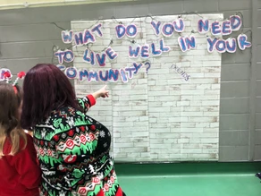Letham4All are looking forward to co-designing and producing new services with partners and the community, exploring new ways of working and delivering locally.

**Perth Citizen Advice Bureau (CAB) -** Pathways to Advice and Cash/Cash First Partnership

Last year Perth CAB achieved a client financial gain of £5,049,000 – of this they estimate over £2M went into the pockets of 1800 families with children. 7113 people were supported by Perth Cab in 2023/24.

Led by Perth CAB, the project secured funding from the Trussell Trust, the Whole Family Wellbeing Fund and more to ensure that support is getting to priority families and children in need. Lived experience data gathered identified that people find it difficult to know where to go to when in times of need.

The project offers access to holistic support to improve outcomes for individuals and families through a shared referral system, which will incorporate partners working in local authority and third sector settings across Perth & Kinross. The system will allow for easy access and a ‘no-wrong-door' entry to advice, support (including cash first approaches) and information for individuals/families in need, utilising local organisations who have established relationships with clients.

Current partners include Letham4All, P&K Central Arrears Housing Team, P&K Access Team, The Heat Project, PKAVS Carers, Buttons and Bows Baby bank, Broke Not Broken, Turning Point and more. The web-based tool includes directory pages for partners and links to the Whole Family Wellbeing directory and TSI Service Navigator for practitioner info.

The project will continue to grow the system with partners in targeted areas of employability support, criminal justice, youth services, wellbeing and more. The project hopes to extend the project by creating a shared Customer Relationship Management (CRM) database so that we are able to track client progress in a more in-depth way.

CAB Support for children and families
Pathway to advice and cash
No one left behind
Building resilient communities
Money talk plus

The partnership aims to capture the expertise and vast knowledge of organisations to help families and children in hardship as we recognise that we cannot tackle poverty alone.

The Pathways to Advice and Cash project aligns closely with other strands that CAB is already running or plan to develop in 2025 – including the support provided through Money Talk Plus; education and peer support through Building Resilient Families and Communities; and in-depth support provided to priority parents and families through No-one Left Behind identified through the incoming FORT referrals to the service. Families with complex needs will also be triaged through the Universal Whole Family Support service with whom we will be working closely.

# Appendix 1 – Child Poverty Delivery Plan 2022-2026

## Strategic Aims

* To raise awareness about the causes and consequences of child poverty.
* To foster social cohesion and reduce stigma surrounding poverty for children and families.
* To reduce the negative effects of living in poverty for children and families.
* To enable children and families to prepare themselves for a life free from poverty.

## Objectives

**Work -** Provide opportunities and support needed to enter, sustain and progress in work (Employability and skills, housing and economic opportunity, connectivity and childcare)

**Sharpening Focus -** Supporting parents into work that pays the Real Living Wage or more.

* Taking action to close the gender employment and pay gaps.
* Addressing the challenges presented by rurality.

**Dignified Living -** Maximise the support available to families to lead dignified lives and meet their basic needs. (Person-centred support, social security and income maximisation)

**Sharpening Focus**

* Addressing the rural poverty premium.
* Addressing the needs of the Gypsy Traveller community and other minority ethnic communities.
* Addressing stigma which prevents parents and families from seeking help and support.

**Survive and Thrive -** Supporting the next generation to survive and thrive. (Education and Children’s Services, Health and Social Care)

**Sharpening Focus**

* Closing the poverty-related attainment gap.
* Addressing the challenges faced by disabled young people entering further and higher education and the jobs market.
* Addressing mental health and wellbeing issues for parents and children affected by poverty.

## Our Approach

Deliver a whole system, whole-family, whole-community approach to connecting children and families to the help and support they need to mitigate and move beyond poverty.

**Sharpening Focus**

* Changing the way we work to use data-driven approaches to identify and connect with families affected by poverty.
* Offer no wrong door approaches to connecting families to the help and support they need and want.
* Developing multidisciplinary, cross-organisational working in teams at locality level to build inclusive communities which strengthen the web of support on offer to families and children affected by poverty.