**Perth & Kinross Council**

**Ash Dieback & Roadside Tree Strategy**

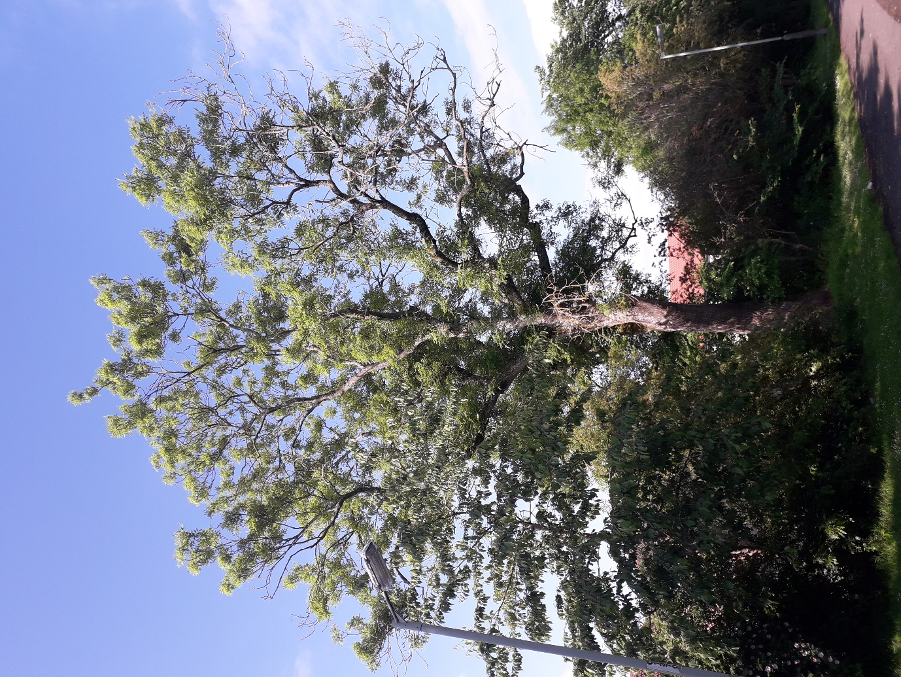

**June 2025**

**Community Greenspace**

**Perth & Kinross Council Ash Dieback & Roadside Tree Strategy 2025**

Contents

1.0 Ash Dieback & Roadside Tree Strategy Introduction 3

2.0 Ash and Ash Dieback 3

2.1 Importance of Ash in Perth & Kinross 3

2.2 Ash Dieback 3

2.3 Identification of Ash Dieback 4

3.0 Roadside Trees 5

4.0 Impacts of Ash Dieback 6

4.1 Health and Safety Impacts 6

4.2 Economic impacts 6

4.3 Legal implications 6

4.4 Environmental & Biodiversity Impacts 7

4.5 Private Landowners and Utilities 7

5.0 Delivery Plan 8

5.1 Delivery Plan Key Actions 8

5.2 Surveys of Roadside Trees and Landowner Notification 10

5.3 Surveys of Council Land 10

5.4 Recovery & Replacement Planting 11

5.5 Indicative Programme 11

Appendices 13

Appendix 1 – Estimated Numbers of Trees, Costs & References 13

Appendix 2 – Options for Action 16

# Ash Dieback & Roadside Tree Strategy Introduction

This strategy aims to identify, communicate and address the risks of Ash Dieback (ADB) disease, *Hymenoscyphus fraxineus,* within all land managed by the Council, as well as privately owned trees bordering the public roads network. It focuses on managing environmental risks (in particular landscape & biodiversity impacts) and risks to public safety from Ash trees. It also identifies the likely costs and resources required to effectively control ADB. The strategy confirms the Council’s responsibilities, which services will be involved and a recovery plan to address the loss of Ash on Council sites, and how this can be implemented, is included and will tie-in to the Council’s forthcoming tree planting policy. Further reading and references for information in this strategy can be found in Appendix 1.

# 2.0 Ash and Ash Dieback

## 2.1 Importance of Ash in Perth & Kinross

Ash is the third most common broadleaved tree in Britain and is widespread throughout Perth and Kinross. Ash is important for biodiversity and carbon sequestration, with over 1100 species of invertebrates, mammals and flora being dependent on Ash for their survival. Additionally, it is utilised in many manufacturing processes and is considered the best firewood. Ash is also important to flood prevention, being a common bankside species that functions as a stabilising element on waterside land. There are an estimated 9400 mature Ash trees either on Council land or adjacent to public roads (excluding trunk roads) in Perth & Kinross (Appendix 1), making it one of the more prevalent and noticeable trees in our local landscape.

## 2.2 Ash Dieback

Ash or ‘Chalara’ Dieback *Hymenoscyphus fraxineus* is a destructive fungal disease which affects all Ash species (*Fraxinus spp*), but in particular the native Common Ash (*Fraxinus excelsior*). As the disease progresses, the wood becomes brittle, branches and large limbs will drop from the trees and in severe cases of the disease, the tree will die. The brittle wood in trees with advanced ADB make traditional felling methods (e.g. felling at the base using a chainsaw) a risk to those felling them and costly to remove.

The disease was first detected in the UK in 1997 and has affected all areas, including Perth & Kinross. Current estimates are that up to 90% of Ash trees will die from the disease accounting for almost 30% of broadleaf tree cover in the UK.

## 2.3 Identification of Ash Dieback

Trees with ADB exhibit symptoms such as leaves with dark patches which eventually wilt and turn completely black, lesions on the bark where branches meet the trunk. Affected trees will usually show extensive dieback of shoots and branches.

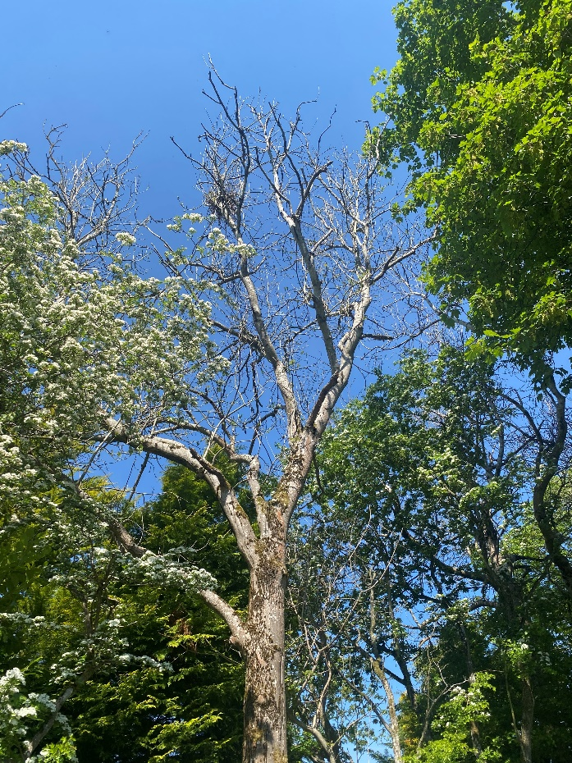 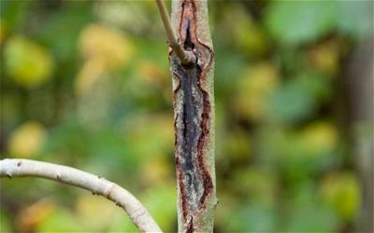

Figure 1 Ash tree with extensive dieback (left) and black lesions around branches - a common symptom of ADB (right)

Diseased Ash trees can be categorised into the below stages. ADB will typically progress between stages at differing rates, dependent on the age of the tree. Mature trees will take longer to progress to a stage where it needs to be felled, often as long as 5-10 years. However younger trees will succumb much sooner.

|  |  |  |
| --- | --- | --- |
| Stage of Dieback | % canopy loss | Description |
| Category 1 (T1) | 0-25 | Overall, a healthy tree although there may be some minor signs of the disease, e.g. leaf browning or early leaf fall. |
| Category 2 (T2) | 25-50 | A tree showing some signs of the disease. Noticeable reduced leaf coverage or crown density and other indicators such as lesions or leaf browning. |
| Category 3 (T3) | 50-75 | A tree with significantly reduced leaf coverage. Branches clearly showing dieback |
| Category 4 (T4) | 75-100 | A tree with extremely sparse or no leaf coverage. Large dead branches and fragmenting tree tips |

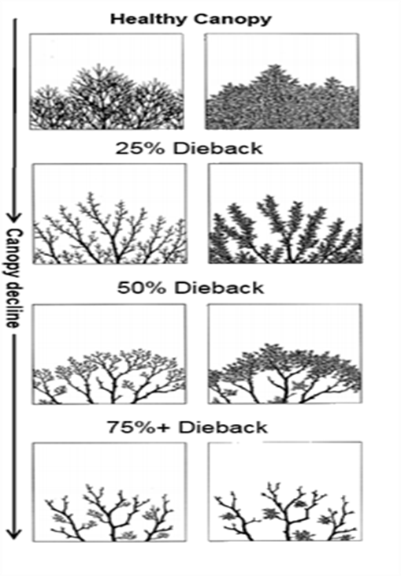

Figure 2 Stages of Ash Dieback – The Tree Council

3.0 Roadside Trees

Roadside trees will be some of the most obvious features when entering or travelling through Perth and Kinross. They are important to the character and history of the area, contributing significantly to the reputation of the area as ‘Big Tree Country’. They are also an essential component of the ‘green networks’ which enhance biodiversity by providing habitats and food for wildlife throughout the area.

Most roadside trees are privately owned and are the responsibility of the land manager including those along verge boundaries. Whilst it is expected that land managers deal with ADB on their land, the Council have powers under section 91 of the Roads (Scotland) Act 1984 to make safe or remove dangers near a road, including trees, for which the landowner may be liable for the cost. While the roads authority has powers to take action through the Roads (Scotland) Act 1984, it does not impose any liability associated with trees on private land to the Council.

The Council must also manage the risk of trees falling from Council land onto any adjacent railway lines to ensure the safety of rail users. While to an extent overhanging vegetation may be managed by Network Rail, the safety of trees remains the responsibility of the relevant landowners. In December 2023 a train collided with a tree fallen from Dundee City Council land adjacent to the railway line, after which Dundee City Council was found to have not effectively managed this risk, highlighting the need for comprehensive surveys of rail-side trees.

# 4.0 Impacts of Ash Dieback

## 4.1 Health and Safety Impacts

Whilst the current tree management policy is based on dealing with trees that pose the greatest risk to people and property, the spread of ADB will increase the number of trees that will require management action. ADB causes the wood to become more brittle as the disease takes hold increasing the risk of tree failures and to those operating on them. This may be less of an issue in a woodland environment away from paths, but will be an increasing problem in urban, park and roadside settings, as well as in school grounds or next to high-use paths.

## 4.2 Economic impacts

Additional resources will be needed to deal with ADB (Appendix 2), however these will increase the longer the diseased trees are allowed to remain. Delaying action may result in increased liabilities for damage or injury, higher contractor and waste disposal costs, and higher flood risks if trees are not replaced.

## 4.3 Legal implications

The Council have a common law duty of care under the Occupiers’ Liability (Scotland) Act 1960 to take reasonable steps to prevent or minimise the risk of personal injury or damage to property arising from trees on their ground. This includes regular Visual Tree Inspections, ideally on a scheduled basis of trees within their ownership as set out in the Council’s Tree Management Policy [Trees and Woodlands - Perth & Kinross Council](https://www.pkc.gov.uk/article/15280/Trees-and-Woodlands).

The Roads (Scotland) Act 1984 gives powers to the roads authority to remove trees and recharge incurred cost to the owners, if they are deemed to constitute a danger to road users. Most roadside trees, including those along the road or verge boundary, remain in private ownership and are the responsibility of the landowner to manage appropriately. If a tree or trees is/are considered to be a danger or hazard to road users, then the Council can serve a notice on the owner to remove the tree. If this notice is ignored, the Council may arrange for the offending tree or trees to be removed and recharge the owner for the work carried out.

The Council can also take action to ensure road signs, and the like are kept clear of woody vegetation within road verges. If action is required on any trees on Council owned land adjacent to railway lines, this may need to be coordinated with Network Rail.

The Council have a legal requirement to protect and enhance biodiversity when carrying out its functions under The Nature Conservation (Scotland) Act 2004. The Council are also obliged to ensure trees with potential bat roosts are properly surveyed prior to felling, as all bat species in the UK have full protection under The Conservation (Natural Habitats &C.) Regulations 1994. All wild birds in Great Britain are protected under the Wildlife and Countryside Act 1981 (as amended), and due care is needed to ensure that nesting birds are undisturbed.

## 4.4 Environmental & Biodiversity Impacts

The removal of significant numbers of mature Ash will undoubtedly have a substantial impact on biodiversity and the local environment. Reduced woodland cover, particularly in urban areas, will require a significant amount of replacement planting to offset the environmental loss. Targeted replanting on appropriate sites with suitable replacement species will need to be completed in line with current and future policies. In suitable areas, the timber from felled trees will be left on site to biodegrade naturally. In some circumstances trees would be pollarded i.e. branches would be removed and the main stem would be left as standing wood to benefit biodiversity. This procedure will ensure that the remains of the tree are left in a safe and secure state while still providing an ecological benefit.

## 4.5 Private Landowners and Utilities

It will be up to the managers of private land to deal with the effects of ADB on their own ground. Landowners will be notified if trees are identified that pose a threat to the safety and integrity of Council infrastructure. Enforcement measures will be put in place where appropriate. Where Council-owned trees pose a risk to utilities, the Council will work with utilities companies to make the trees safe and ensure that the services are maintained.

5.0 Delivery Plan

The Council’s Tree and Woodlands Management Policy ([Trees and Woodlands - Perth & Kinross Council (pkc.gov.uk)](https://www.pkc.gov.uk/article/15280/Trees-and-Woodlands). ensures trees with the greatest potential to cause harm, injury and damage to property are dealt on Council managed land. It also includes actions to deal with dangerous trees alongside the Council’s adopted road network, however, given the scale of ADB, this strategy has been developed to help address the additional impacts of the disease. To effectively manage ADB, the Council will:

* Adopt appropriate tool kits and systems for recording and efficiently managing trees including those with ADB.
* Identify problematic Ash trees through site surveys, Ranger inspections and public reporting. This will include surveys of all trees within falling distance of the Council’s adopted road network.
* Encourage greenspace volunteer groups to be involved in the reporting process through appropriate training and support through the Tree Officer or Greenspace Rangers.
* Prioritise the removal of high-risk trees on Council managed sites and contact landowners to do the same along roads.
* Where possible, identify, record and monitor individual trees with a genetic resistance to the disease.
* Slow the pace of landscape change and mitigate impacts on biodiversity by allowing replacement trees time to grow before Ash becomes scarce e.g. by allowing other suitable alternative species such as Sycamore, Norway Maple, Oak to self-seed
* Include planting of suitable native species as replacements for Ash in the Council’s Tree Planting Policy

# 

To manage ADB, several levels of action were considered (Appendix 1), and the proposed Scenario 3 delivery plan is considered the most appropriate and cost effective overall. This delivery plan will allow a prioritised, coordinated and efficient approach to managing ADB. A five-year programme is considered the optimum timescale and includes surveying and recording the location and extent of diseased trees on all Council managed land and adopted public roads. It also covers the role of stakeholders and contractors.

## 5.1 Delivery Plan Key Actions

All actions on Council managed land, unless otherwise specified, will be undertaken by the Council’s Community Greenspace service and their appointed contractors. Actions on trees affecting adopted roads will be taken in conjunction with the Roads Maintenance Partnership (RMP) and Legal Services where required.

* Survey
  + Acquire/develop an efficient and reliable GIS system for plotting and mapping tree work and replanting linked to works instructions.
  + 2 Graduate Trainees, or similar level officers, equipment and a vehicle to assess and record diseased trees over 12 months.
  + An Assistant Tree & Woodlands Officer to manage the day-to-day co-ordination of the surveyors, procurement of contractors for 24-36 months
  + Full training for relevant Council staff and volunteers to identify diseased trees both in foliage and bare twig examples.
* Works Programme
  + Develop prioritised tree works programmes including tree replacements.
  + Develop specifications and contract documents.
  + Procure and award tree works packages to contractors with appropriate specialist equipment as required for the safe removal of dead Ash
  + Manage contractors and ensure works are to a satisfactory standard.
  + Adhere to a limit of scope of works to one tree length from pathways with alternative diversions to minimise impact on public accessibility if any path closures are necessary.
  + Projected timeline may be accelerated if additional external funding is secured
* Roadside (and railway-side) trees
  + Take immediate action to remove or make safe any trees identified as immediately dangerous or at Stage 4 of Ash Dieback
  + Contact relevant landowners where a dangerous roadside tree has been identified requesting that they take necessary actions to make trees safe
  + Remove dangerous trees where landowners have failed to act, and recoup costs incurred from the landowner
  + Survey trees on public open space adjacent to railways to identify and remove dangerous trees and overhang
* Public communication and engagement
  + Public communication to manage messaging on ADB and roadside trees and the likely impacts that will be seen in Perth & Kinross
  + Promote citizen science through public communications (PKC website and social media platforms) to encourage reporting of ADB and other dangerous trees on Council grounds and by public roads
  + Communicate with landowners through organisations such as the National Farmers Union (NFU)
  + Advertising in local & national papers to increase public awareness
  + Support and utilise existing volunteer base (e.g. path groups, tree wardens & bloom groups) to report ADB

## 5.2 Surveys of Roadside Trees and Landowner Notification

Roadside trees will be surveyed by a passenger of a vehicle while another officer drives. All survey vehicles will be chapter 8 compliant, clearly displaying chevrons with a combination of day and night conspicuity markings and an orange beacon light to ensure visibility on the road. Vehicles will be driven at slower speeds to allow the surveyor to effectively spot and identify Ash, ADB or any other hazardous tree. Multiple passes of some sections of road may be required, or for the surveyor to leave the vehicle where safe to do so. All trees within falling distance of the carriageway will be considered.

Any Ash identified will be recorded on a tablet with GPS co-ordinates of the tree’s location, an estimate of ADB stage and approximate size of the tree. Photos will be taken where possible, and any other potentially dangerous trees will be recorded in the same manner. Where there is a block of Ash, this may be recorded with an estimate of the number of trees, rather than counting individual trees.

Where dangerous trees have been identified, the Council will attempt to contact the landowner to notify them of the hazard. Where a tree is seen to be particularly hazardous the Council may decide to give a notice of enforcement under the Roads (Scotland) Act 1984, giving the landowner 28 days to deal with the issue. If no action is taken after 28 days, the Council may undertake works to the tree and invoice the landowner for any costs incurred, including for any traffic management which may be required. If the landowner appeals the enforcement notice, a decision will need to be made by the sheriff court. If the sheriff court decides to uphold the enforcement, the landowner has 28 days from the decision to take the required action. If the sheriff court rejects the enforcement, no further action is required from the landowner or the Council.

## 5.3 Surveys of Council Land

Surveys of trees on Council land will be undertaken on foot, and all Council land will be surveyed, including Public Open Space, School Grounds, Council Housing and any other Council grounds. Council grounds leased out to another occupier will remain the responsibility of the tenant, but support can be given to tenants where required. GPS-coordinates, estimated ADB stage, size of tree and number of affected trees will be recorded for every site. Where any trees are to be removed, an assessment of the suitability and the capacity of the site for any replacement tree planting will be given. Trees within dense woodland areas, away from paths, property or infrastructure, may not need to be surveyed or removed if affected by ADB as the risks to the public from such trees are significantly reduced.

## 5.4 Recovery & Replacement Planting

To manage the impact from the loss of significant numbers of trees across the area, a proactive approach will be taken.

Key actions:

* Identify healthy or resistant Ash that can be retained and monitor to assess level of resistance. Consider limb removal or pollarding rather than felling where possible.
* Identify suitable alternative native species that can be utilised for replacement planting.
* Identify a realistic and sustainable replanting ratio and resources for this (Council plant stock, planting grants, community schemes.)
* Identify areas that will regenerate through natural self-seeding and put in place protection measures (e.g. tree guards).

Replanting will be done in accordance with the forthcoming Perth & Kinross Council Tree Planting Strategy. Where possible, replacement planting will take place at the same location as removed trees, however some sites will not be suitable for replacement planting. A mix of saplings and mature trees will be planted, using a range of species to enhance biodiversity and ecological resilience. While the Council cannot mandate that landowners replace any removed trees, they will be encouraged to do so. It may be possible to provide landowners with free trees via additional funding such as the Nature Restoration Fund.

## Indicative Programme

|  |  |
| --- | --- |
| **Year** | **Actions** |
| 2025-26 | * Recruitment of 2 graduate trainees for 12 months * Recruitment of 1 assistant tree officer for 24-36 months * Ash surveys of all Council-owned land and roadside trees * Make safe all immediately dangerous (stage 4 ) trees between 3-6 months of initial survey start * Start making safe trees identified as stage 3 * Notify landowners of any roadside trees at Stage 3 or lower |
| 2026-27 | * Make safe trees previously identified as stage 3 * Immediately make safe any trees now found to be at stage 4 * Start tree replanting in suitable areas * Take enforcement actions for roadside trees identified as stage 3 |
| 2027-28 | * Make safe trees previously identified as stage 2 (predicted to be stage 3 at this point) * Immediately make safe any trees now found to be at stage 4 * Continue replanting in suitable areas * Continue enforcement action for privately-owned roadside trees |
| 2028 onwards | * Continue making safe trees previously identified as stage 2 * Immediately make safe any trees now found to be at stage 4 * Assess trees previously identified as stage 1 and take action as required |

**Conclusion**

The widespread loss of Ash trees in the UK to ADB is of great concern generally and not least in Perth and Kinross. There is little that can be done to prevent the spread of the disease but through proactive management and recovery plans it is hoped that the impacts can be mitigated to some extent. This Ash Dieback Strategy demonstrates the Council’s commitment to dealing effectively with the problem and desire to see the area’s reputation as Big Tree Country maintained.

The proposed strategy proposes a cost-effective approach to managing Ash Dieback on both Council land and beside the adopted road network.

# Appendices

## Appendix 1 – Estimated Numbers of Trees, Costs & References

**Estimation of number of Ash Trees**

Based on sample surveys from the Greenspace Rangers and the Tree & Woodland Officer conducted in 2024, there are estimated to be approximately 1900 mature Ash trees that will pose a risk to the public in public open spaces and 7500 on roadside.

In Community Greenspace managed parks and open spaces, 50% of trees are showing signs of the disease. This increases in dense woodland areas, where up to 70% of trees are showing signs of infection.

Of the estimated 7,500 Ash trees on ABC&U Roads, approximately 850 are Council-owned. The remaining 6,650 trees will be within private ownership, but many will still present a risk to users of public roads. Based on a sample drive-by of Highland & Eastern, it is estimated that around 60% of roadside Ash are infected.

**APSE Findings**

APSE (Association for Public Service Excellence) published papers and survey results (links below) which outline estimated costs to local authorities to deal with Ash Dieback. APSE found that nearly a quarter of the local councils surveyed expect their total costs for dealing with Ash Dieback to amount to over £10m

**Key findings**

Of the local authorities surveyed:

* Over 75% of respondents expect their Ash population to fall by 60 –95%, most reporting figures at the higher end of this scale.
* 29% estimate the eventual total costs for dealing with the impacts of Ash Dieback to be >£1.1m, with nearly a quarter expecting losses to be >£10m.
* There is less demand in the coming two years to fell and remove diseased tree than in the coming 3-10 years; from 2.5% in the next two years to 33% in the next 6-10 years.
* Between 10% – 40% of highway verges have trees suffering Ash Dieback.
* 86% feel the Government is not providing sufficient funding to local authorities to address the problem.

Speaking about the findings, Paul O’Brien, APSE Chief Executive, said, *“At a time when there is a national drive to increase tree numbers to combat climate change and carbon emissions, talk of the UK losing at least 75% of its Ash population to Ash Dieback will have a hollowing effect on the carbon reduction objectives of tree planting strategies.*

*From the results of the survey, it is clear there will be a large expense involved in dealing with Ash Dieback, and it is unlikely local authority budgets alone will be able to deal with these costs. Therefore, over the coming years it will be anticipated that Government will need to step in, not only to promote the planting of new trees to address climate change, but also to help deal with the felling and removal of dead and dying Ash trees.*

*Dealing with Ash Dieback may very much be like trying to hold back waves, as the disease is now so entrenched in the UK’s Ash tree population. But that does not mean we cannot learn lessons, such as having the correct biosecurity measures in place to prevent the future importing of tree and plant diseases, if we are to ensure we can guarantee the future health of our trees and woodlands.”*

## 

**References**

**APSE**

<https://www.apse.org.uk/sites/apse/assets/File/Sophie%20Birchall%20Rogerson.pdf>

<https://www.apse.org.uk/index.cfm/apse/news/articles/2022/ash-dieback-costs-risk-further-hollowing-out-council-budgets-a-new-apse-survey-of-local-authorities-warns/>

**BBC News**

[Fallen tree warning given too late to stop crash - BBC News](https://www.bbc.co.uk/news/articles/cgm9nrvwmkjo)

**Government Legislation**

[Occupiers’ Liability (Scotland) Act 1960](https://www.legislation.gov.uk/ukpga/Eliz2/8-9/30#:~:text=An%20Act%20to%20amend%20the,connected%20with%20the%20matter%20aforesaid.)

[Roads (Scotland) Act 1984](https://www.legislation.gov.uk/ukpga/1984/54/contents)

[Nature Conservation (Scotland) Act 2004](https://www.legislation.gov.uk/asp/2004/6/contents)

[The Conservation (Natural Habitats, &c.) Regulations 1994](https://www.legislation.gov.uk/uksi/1994/2716/contents)

[Wildlife and Countryside Act 1981](https://www.legislation.gov.uk/ukpga/1981/69)

[Health and Safety at Work Act 1974](http://www.legislation.gov.uk/ukpga/1974/37/contents)

**Perth & Kinross Council**

[Trees and Woodlands - Perth & Kinross Council (pkc.gov.uk)](https://www.pkc.gov.uk/article/15280/Trees-and-Woodlands)

[pkc.gov.uk/media/35719/Tree-Management-Policy/pdf/Tree_Management_Policy_Feb2017.pdf?m=1486036705760](https://www.pkc.gov.uk/media/35719/Tree-Management-Policy/pdf/Tree_Management_Policy_Feb2017.pdf?m=1486036705760)

**The Tree Council**

[treecouncil.org.uk/wp-content/uploads/2021/06/Ash-Dieback-Action-Plan-Toolkit-for-Scotland-June-2021.pdf](https://treecouncil.org.uk/wp-content/uploads/2021/06/Ash-Dieback-Action-Plan-Toolkit-for-Scotland-June-2021.pdf)

## Appendix 2 – Options for Action

There is significant pressure on Local Authorities and very little budget available, particularly given the estimated costs to sufficiently deal with Ash Dieback. For this reason we propose three different approaches with differing budget requirements.

**Scenario One**

Limited action is taken. Only reactive work is taken where a tree has been reported as dangerous by a member of the public or highlighted in Greenspace Ranger inspection and inspected by a Greenspace Ranger. Only trees posing an imminent risk of death or injury to persons, or risk of major damage to property will be addressed. There will be no proactive surveys to identify affected trees.

This approach will still have an impact the existing budget to manage Council trees but will have the least initial impact on Council budgets. However, this approach does carry substantial risk that tree failures from trees not identified result in death or injury, damage to property, and damage to corporate reputation. Long-term costs of this may exceed those in proposed scenarios 2 & 3 as trees become more dangerous and costly to work on as the dieback progresses, coupled with the potential for more frequent incidences of damage to property/insurance claims against Council and associated increased insurance costs. A reactive policy therefore carries a risk of greater expenditure than a proactive one.

Perth & Kinross Council have removed a total of 87 infected Ash Trees in the last 24 months. Based on a 4-man team, this equates to £28,275 based on a rate of £325 per tree. However, as the disease progresses, we will be increasingly dependent on machinery, which will increase the price of tree removal and this figure is a conservative estimate.

**Scenario Two**

In addition to reactive works from reports received of dangerous trees, we carry out a survey program and identify those trees liable to cause the greatest threat to persons and property. A reactive program of works is then made to remove or make safe those trees identified, leaving as much arising material as possible on site. We estimate that 2750 affected trees will need to be removed over a 3-year period.

This will require an increase in investment for a designated GIS survey system which would allow us to have real time access to the survey information and easily exchange information with contractors to show work outstanding, work issued, and work completed all carried out on the same system. External surveying resource (as seen in Dundee and Angus councils), resource to serve notice to owners of highway side trees, liaising with Education and Roads to assist identifying areas of concern. Checking on TPO and Conservation Area status. Bringing in minimal contractor resource to carry out additional work. Carry out a thorough re-planting scheme where suitable.

* GIS Survey software and equipment **£5,000**
* Employment of two Graduate surveyors for a period of 12 months **£110,000**
* Assistant Tree & Woodlands Officer **£150,000** (£50,000 p/a x 3 years)
* Vehicle hire **£4,000** for 12 month survey period.
* Removal of priority dangerous trees within PKC owned and maintained land over a 3-year period. **£894,000** (Based on an estimated 2,750 trees to be removed at an average cost of £325 per tree)
* Replanting at a near 3:1 ratio where possible £**41,000**

**Total Estimated Cost £1,200,000**

**Scenario Three**

Carrying out a comprehensive survey of all Council Ash sites using GIS survey and external surveying resource, identifying landowners on all highway sites and serving notice to them.

Offering a comprehensive free package of road licence management to assist private landowners in delivering required tree removal and offering a more supportive approach to enable cooperation between ourselves (Council) and our stakeholders.

Conducting TPO and Conservation Area checks and building a robust and resilient tree removal programme that includes product removal and ecological recycling with relevant ratio replanting within Council governed areas, while assisting third parties in achieving the same goals. Putting work out to tender and taking on more contractors to ensure work is carried out as quickly as possible, using more advanced and capable state of the art machinery and methods.

Removing the majority (75%) of diseased trees with all arisings being removed for safe off-site disposal.

Planning a 3:1 ratio replanting scheme to in line with carbon policy and biodiversity targets.

* GIS Survey software and equipment **£5,000**
* Employment of two Graduate surveyors for a period of 12 months **£110,000**
* Assistant Tree & Woodlands Officer **£150,000** (£50,000 p/a x 3 years)
* Vehicle hire **£4,000** for 12 month survey period.
* Removal of all risk Ash trees within all PKC public areas **£1,890,000**

**(**Includes the removal of all arisings and disposal in bio safe areas. Bringing in a wider contractor resource to carry out operations in a shorter timescale. Carrying out more resilience work in woodland areas to ensure core paths are without tree falling range. Subsidising Traffic / Road management to assist private landowners with diseased tree removal.)

* Replanting at a near 3:1 ratio where possible £**41,000**

**Total Estimated Cost £2,200,000**